Prediction of Protein Subcellular Locations by Incorporating Quasi-Sequence-Order Effect
Kuo-Chen Chou
Biochemical and Biophysical Research Communications 278, 477-483 (2000)
Abstract
The ambiguity between the results of a 3-D structure alignment obtained by different algorithms and that determined by domain experts reveals that simply finding the best rmsd is not enough to match biologically meaningful features. A new algorithm is presented that utilizes a combinatorial extension of the optimal path. A path that is further refined by the use of protein properties relevant to structural and functional features.
- Introduction
A new algorithm is reported which builds an alignment between two protein structures. The algorithm involves a combinatorial extension (CE) of an alignment path defined by aligned fragment pairs (AFPs) rather than the more conventional techniques which use dynamic programming and Monte Carlo optimization. AFPs, as the name suggests, are pairs of fragments, one from each protein, which confer structure similarity.

- Method
The alignment between two protein structures A and B of length nA and nB, respectively, is considered the longest continuous path P of AFPs of size m in a similarity matrix, S, of size (nA/m)*(nB/m) representing all possible AFPs that conform to the criteria for structure similarity. One of the following three conditions should be satisfied for every two consecutive AFPs I and I+1 in the alignment path:
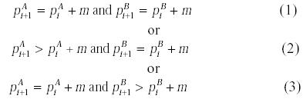
where 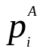 is the AFP’s starting residue position in protein A at the ith position in the alignment path.
There are several alternative alignment strategies that differ in computation time and accuracy. In the course of this study we limit the evaluation of similarity to the following three distance measures:
(i)
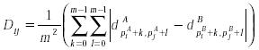(ii)
or rmsd (iii)
Distance measure (i) is used to evaluate combination of two AFPs, one already in the alignment path and one to be added, and distance measure (ii) is to evaluate a single AFP,i.e., how well two protein fragments forming an AFP match each other. Distance measure (iii) is used as the last step in selecting the few best alignments and for optimizing gaps in the final alignment.
The following three major path extension strategies can be used when adding the next AFP to the alignment path: (1)Consider all possible AFPs which extend the path and satisfy the similarity criteria. (2)Consider only the best AFP which extends the path and satisfies the similarity criteria. (3)Use some intermediate strategy.
The first strategy defines an exhaustive combinatorial search for the optimal path, while the second strategy defines a limited search among the best paths. It is shown that the second strategy is sufficient to reveal structure similarities when combined with some path evaluation heuristics.
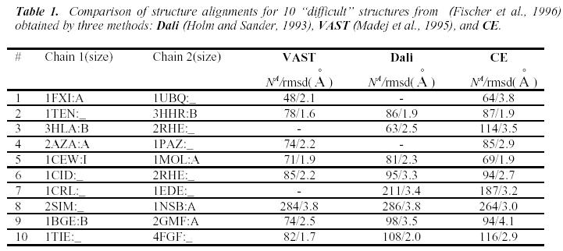
Adding Composite Properties for Comparison of Structures
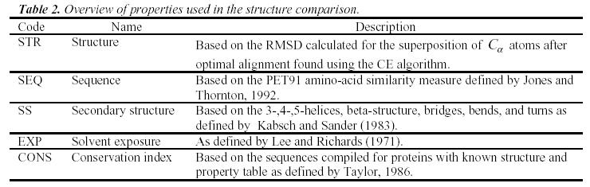

- Result
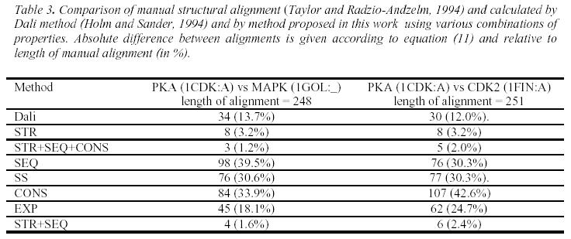

Created by : Yung-Hsing Peng
Date : Sept. 25, 2003

