Hybrid Genetic Algorithm for DNA
Sequencing with Errors

JACEK BLAZEWICZ AND MARTA KASPRZAK
Journal of Heuristics, Vol. 8, pp. 495-502,2002
- Introduction

In the paper, a new hybrid genetic algorithm solving the DNA sequencing problem with negative and positive errors is presented. The algorithm has as its input a set of oligonucleotides coming from a hybridization experiment. The aim is to reconstruct an original DNA sequence of a known length on the basis of this set.

Example1:

Let the original sequence to be found is ACTCTGG, n = 7. In the hybridization experiment we can use, for example, the complete library of oligonucleotides of length l = 3. It is composed of the following 43 = 64 oligonucleotides: {AAA, AAC, AAG, AAT, ACA , . . . ,TTG, TTT}. As a result of the hybridization experiment performed without experimental errors, one gets the ideal spectrum for this sequence, containing all 3-letters substrings of the original sequence: {ACT, CTC, CTG, TCT, TGG}. The reconstruction of the sequence consists in finding such an order of the spectrum elements, that each pair of neighboring elements overlap on l . 1 = 2 letters. The only possible solution for the example is presented in figure 1.
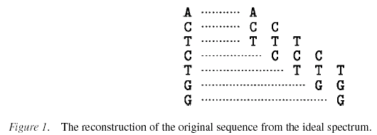

Example 2.

To make the problem of the DNA sequencing on the basis of the spectrum from Example 1 computationally hard, we introduce to the spectrum some errors. Let the negative error be CTC, and the positive errors be CAA and TTG. Then, the spectrum would have the following components: {ACT, CAA, CTG, TCT, TGG, TTG }.

2.Criterion Function

The goal is to maximize the number of elements from a spectrum composing a solution being a sequence of nucleotides not longer than n.
The criterion function is justified by the fact that most of the information from the hybridization experiment is correct.

3.The Algorithm

The initial population is randomly generated according to the uniform distribution. Next, to each individual the normalized fitness value is assigned. The individual of the greatest value of the criterion function is stored. The best ones are selected The next population is constructed from the best individuals, randomly paired, using the greedy crossover.
The greedy crossover is defined as follows. The first oligonucleotide in a chromosome is set randomly.
Next, with the probability 20% we choose for a given oligonucleotide in the chromosome the best successor among the remaining oligonucleotides (the ones not yet used to build the chromosome). As the best successor we understand the oligonucleotide which overlaps the previous one on the highest number of nucleotides.
With the probability 80% the following move is chosen: we take as the successor for a given oligonucleotide the one with a better overlap in the parents of the chromosome, otherwise we take a random oligonucleotide among the remaining ones. In all the cases, if there is more than one best choice, the first found is chosen. The moves are done until all chromosomes of the population are constructed.

Created by : Wei-Tin Liu
Date : Oct. 17, 2003

