Prediction of Protein Subcellular Locations by Incorporating Quasi-Sequence-Order Effect
Kuo-Chen Chou
Biochemical and Biophysical Research Communications 278, 477-483 (2000)
Abstract
How to incorporate the sequence order effect is a key and logical step for improving the prediction quality of protein subcellular location, but meanwhile it is a very difficult problem as well. This is because the number of possible sequence order patterns in proteins is extremely large, which has posed a formidable barrier to construct an effective training data set for statistical treatment based on the current knowledge.
- Introduction
In this paper, based on the physicochemical distance between amino acids, a set of sequence-order-coupling numbers was introduced to reflect the sequence order effect, or in a rigorous term, the quasi-sequence-order effect.

- Method
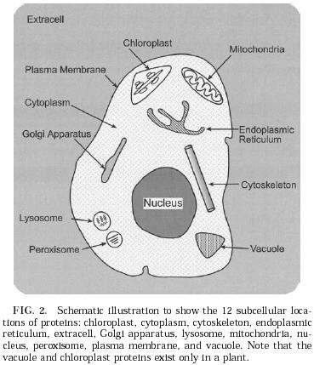
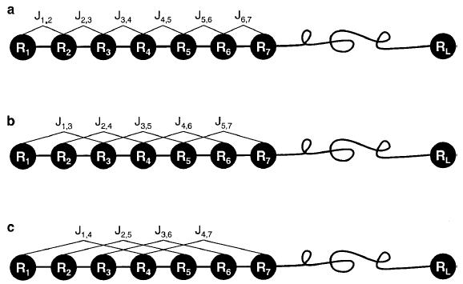
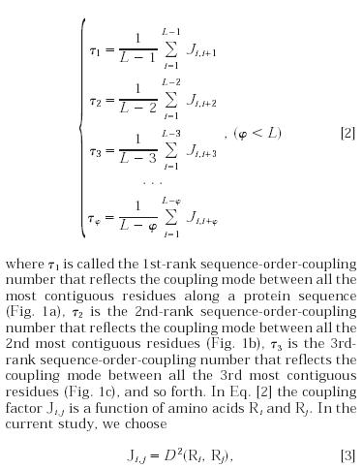
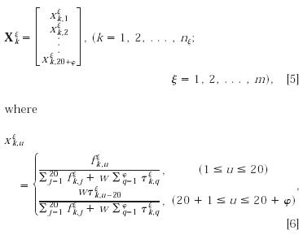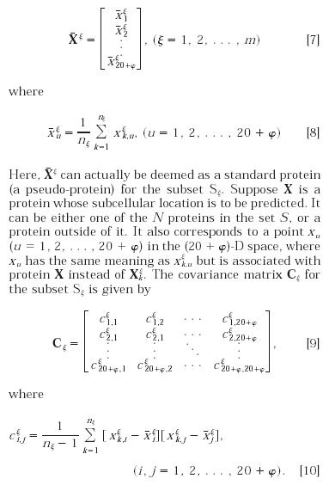
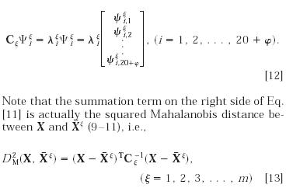
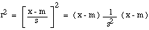
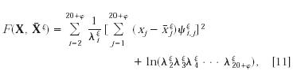
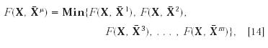

Created by : Yung-Hsing Peng
Date : Oct. 17, 2003

