Prediction of Protein Function Using Protein-Protein Interaction Data

Minghua Deng, Kui Zhang, Shipra Mehta, Ting Chen, Fengzhu Sun
Proceedings of the First IEEE Computer Society Bioinformatics Conference: 197-206, 2002
Abstract
Assigning functions to novel proteins is one of the most important problems in the post-genomic era. We develop a novel approach that applies the theory of Markov Random Fields to infer a protein’s functions using protein-protein interaction data and the functional annotations of its interaction protein partners. We predict the probability that the protein has that function using Bayesian approaches. We give a probability of a protein having the function.
- Introduction
With the completion of genome sequencing of several model organisms, the functional annotation of the proteins is of most importance. The classical way to find the functional role of these unannotated proteins is to find homologies between proteins (e.g. FASTA and PSI-BLAST) and then predict functions based on sequence homologies.
It should be note that proteins interact with one another in many biological functions and many cellular processes and biochemical events. So it is possible to deduce functions of a protein through the functions of its interaction partners.
- Method
Objective: assign a given function to the unannotated proteins based on functions of the annotated proteins and the protein interaction network.

- Markov Random Fields (MRF)
  - Protein interaction network
  - 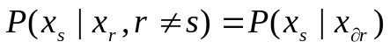

- Gibbs Distribution
  - Prior distribution of the function labeling
  - 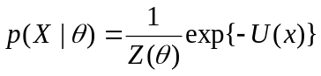─ prior probability distribution
    - 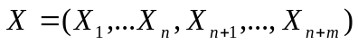
    - 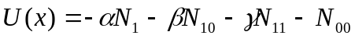
    - 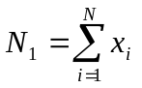, 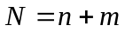
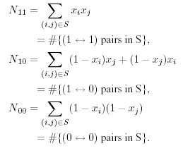

- Gibbs Sampler
  - Posterior probability estimation
  - For a given protein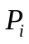, conditional on the functional labeling of all the other proteins, we can use the conditional probability 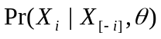 to generate samples to update the functional labeling of protein. Repeat this procedure many times will generate samples for the functional labeling of all the unannotated proteins.
- Parameter Estimation
  - Quasi-likelihood approach
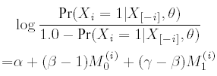

Overall algorithms
  - Estimate the probability,π, that a protein has the function.
  - Estimate the parameters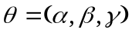.
  - Randomly set 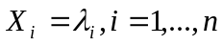 with probabilityπ.
  - For each protein , update the value of 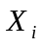using 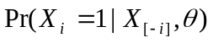.
  - Repeat last step until the posterior probabilities 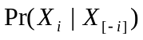 are stabilized.
- Results
- Data in YPD(Yeast Protein Database)
- Specificity (SP) and Sensitivity (SN)
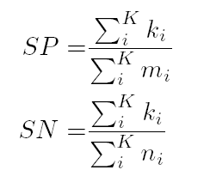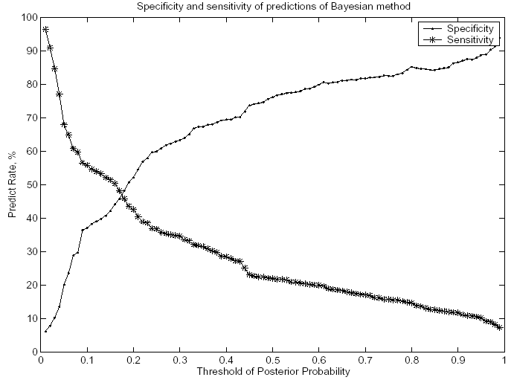

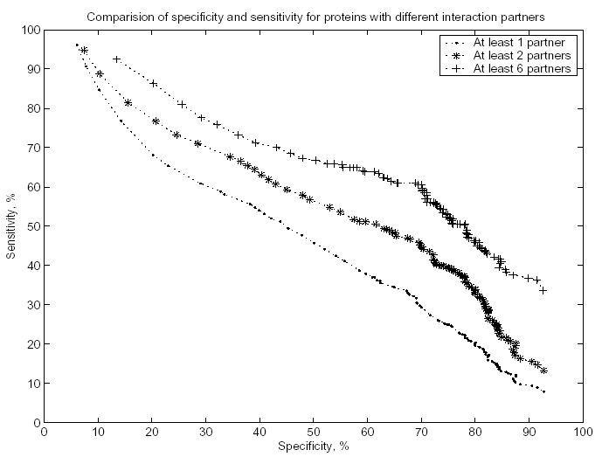
- Discussion
- A global approach that considers the protein interaction network and the functions of the annotated proteins.
- Protein-protein interaction network
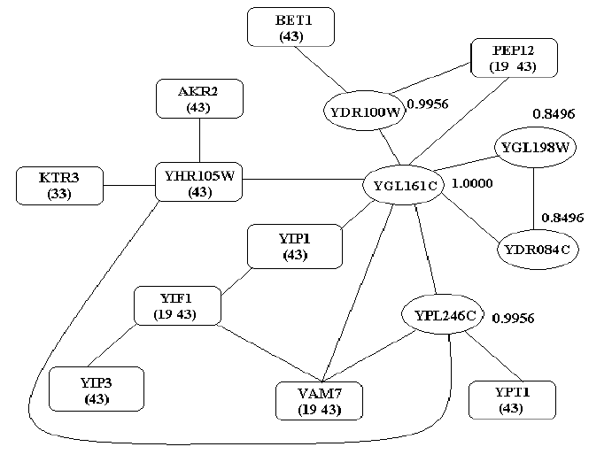
- Limitations:
  - Both the interaction network and the functional annotations are incomplete.
  - Each function is treated independently and separately.

Created by: Yi-Yao Huang
Date: Oct. 24, 2003

