An Algorithm for Finding Novel Gapped Motif in DNA Sequences
Emily Rocke and Martin Tompa
RECOMB98: Proceedings of the Second Annual International Conference on Computational Molecular Biology, New York, March 1998, 228-233
- Introduction
- The Gibbs Sampler of Lawrence et al.
- Method
- We replace steps 3 and 4 of the algorithm is to compute, for each position i in the genome, a multiple alignment of t sequences of length w.
- Such as a pairwise alignment, though, requires an appropriate scoring function
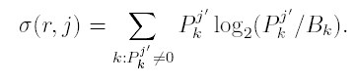
- Consider the (W+1) * (G+1) dynamic programming table that computes the optimal pairwise aligment of A and entire genome. (This is similar to an ”end-space free” alignment).
- Rewindow
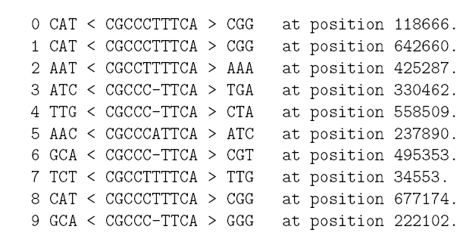

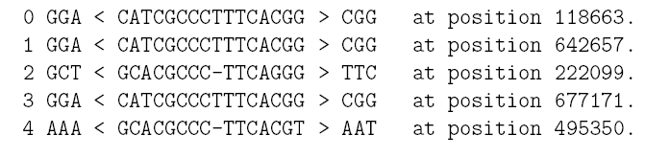
Created by : Jian-Bien Chen
Date : Oct. 31 , 2003

