Selecting Targets for Structural Determination by Navigating in a Graph of Protein Families
Elon Portugaly, Ilona Kifer and Michal Linial
BIOINFORMATICS, Vol. 18, No. 7, Pages 899–907, 2002
Abstract
- Introduction
The number of proteins that are being solved to high resolution by x-ray and NMR technologies increased significantly and was doubled during the last 3 years. However, only a small fraction of all structures that were solved in recent years have been identified as new folds. According to the PDB statistics, this number has been fluctuated around 10% in the last 5 years. Using the most stringent definition for new fold, according to SCOP, the fraction of new folds is even lower.
Our approach proposes choosing targets form a protein family in which none of the representatives are solved. And amongst all families in which no protein is solved, we prefer families that are distant from families with solved proteins.
- Methods and Results
- Creating Target Lists for Structural Determination
  - Database and Mapping Procedure
    - ProtoMap─an automatically generated hierarchical classification of all protein sequences in Swissprot.
    - SCOP provides the structural data.
    - In order to associate SCOP records with Swissprot records, we performed a strict sequence similarity test, allowing each SCOP record to associate with at most one Swissprot record.
  - Properties of the ProtoMap graph, with respect to SCOP
    - Based on the hypothesis, neighbouring clusters tend to share common structural families and superfamilies.
    - An example of the nature of the ProtoMap graph
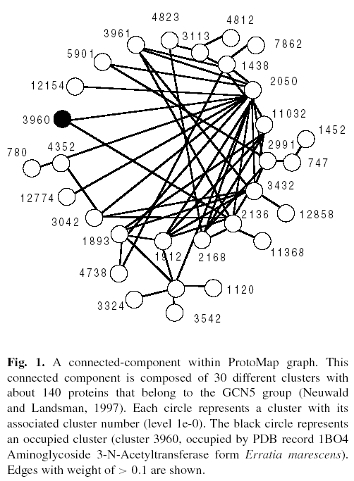
  - Pre-processing ProtoMap data
    - The threshold of weighted edges is 0.1.
  - VSV (Vacant Surrounding Volume) of a cluster
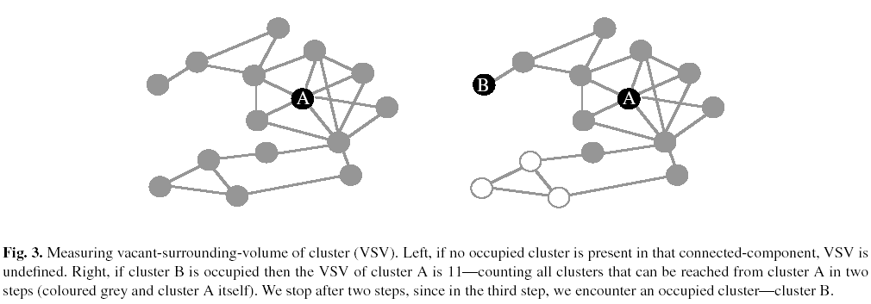

    - Based on our working hypothesis, we said that if protein A belongs to a cluster with a higher VSV than protein B, then A is more likely to belong to a new superfamily than B.
    - Compose a list of clusters, sorted by their VSV from large to small.
    - The prediction is that the higher the protein is in the list, the better the chance that it belongs to a new superfamily.
- Validation Tests
  - Self-Validations
    - Using major versions of SCOP (1.37, 1.41, 1.48 and 1.50)
    - Sequence test set and structure test set
A set of k pluses and l minuses that symbolize new and known superfamilies in the test sample, respectively.
    - Scoring the order
Score our order according to its distance from the perfect order.
    - Finding the P-value
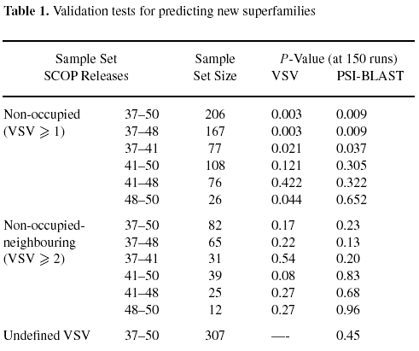
- Discussion

Created by: Yi-Yao Huang
Date: Nov. 14, 2003

