Approximation Algorithms for Local Alignment with Length Constraint
International Journal of Foundations of Computer Science, Vol. 13, No. 5, pp.751-767, 2002
Abdullah N. Arslan and Ömer Egciohglu
Abstract
The common notion of local alignment suffers from some well-known anomalies which result from not taking into account the lengths of the aligned subsequences. We introduce the length restricted local alignment problem. We propose an efficient approximation algorithm using which we can find a solution satisfying the length bound, and whose score is within difference Δ of the optimum score for any given positive integer Δ in time Ο(nmT/Δ) using Ο(mT/Δ) space.
- Introduction
A local alignment with score 1,000 and length 10,000 (long alignment) may be chosen over a local alignment with score 998 and length 1,000 (short alignment).
This deficiency causes two forms of anomalies: “mosaic effect” and “shadow effect”.
Mosaic effect: When a very poor region is sandwiched between two regions with high similarity scores.
Shadow effect: When a biologically important short alignment is not detected because it overlaps with a significantly longer yet biologically inadequate alignment with only a slightly higher score.
The length restricted local alignment (LRLA): We search for substrings I and J that maximize the score s(I, J) among all substrings I and J with |J| <= T where T is a given upper limit on the length of J.
The normalized local alignment problem: The goal is to find substrings I and J that maximize s(I, J)/(|I| + |J|) among all substrings I and J with |I| + |J| >= t, where s(I, J) is the score, and t is a threshold.

- Method
Definitions
Given two strings X = x1x2…xn and Y=y1y2…ym with n >= m, the alignment graph Gx,y is used to represent all possible alignment between X and Y.
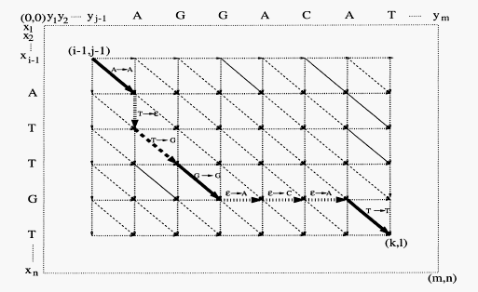

An alignment path for substrings xi…xk, and yj…yl is directed path from the vertex (i-1, j-1) to (k,l) in Gx,y where i <= k and j <= l.
The following is the classical dynamic programming formulation to compute the maximum local alignment score Si, j ending at each vertex (i, j):
The local alignment (LA) problem seeks for substrings 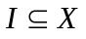 and  with the highest similarity score. The optimal value LA*(X,Y) for this problem is given by:
The normalized local alignment problem (NLAt) is:

Given a limit T, we define the length restricted local alignment (LRLA) score between X and Y as
Approximation Algorithms for LRLA

We first give a simple 1/2-approximation algorithm HALF for the LRLA problem. We assume T < m. Let 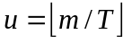 and put
For 1 <= j <= u with Yu=y(j-1)T+1…yu. Thus Y=Y1Y2…Yu and Yj partition Y into blocks of length T each.
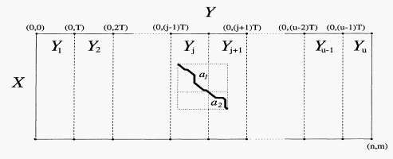

We give next an approximation algorithm APX-LRLA, which computes a local alignment score S’ <= LRLA* within a prescribed difference 2Δ form LRLA*.
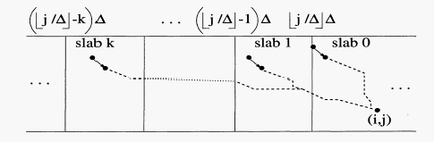
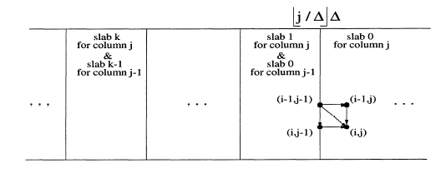
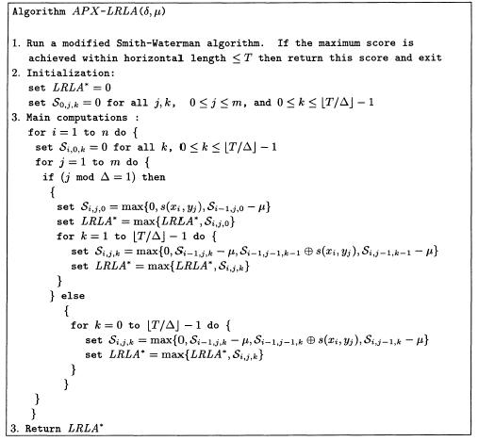
Si-1,j-1,k ⊕ s(xi, yj) = Si-1,j-1,k + s(xi, xj) if Si-1,j-1,k > 0 or k = 0; and 0 otherwise.
- Conclusion
LRLA can be solved by extending the dynamic programming formulation of local alignment problem. However the result time complexity is O(Tnm), which may not be practical for large value of n, m and T. The first algorithm is a simple 1/2-approximation algorithm which has the same time and space complexity as the ordinary local alignment algorithm. The second algorithm APX-LRLA obtains a score with in difference 2Δ form optimum for any given positive integer Δ, and runs in time O(nmT/Δ).
Created by: Liang-Tai Wei
Date: Dec. 26, 2003

