Mapping Protein Family Interactions: Intramolecular and Intermolecular Protein Family Interaction Repertoires in the PDB and Yeast
Jong Park, Michael Lappe and Sarah A. Teichmann
J. Mol. Biol. 307, pp. 929-938, 2001

- Introduction
This paper view protein interactions in terms of whole protein families that interact with each other.
- Results and Discussion
  - The protein family interaction map
- We use the protein families that are classified by as superfamilies in the Structural Classification of Proteins (SCOP) database.
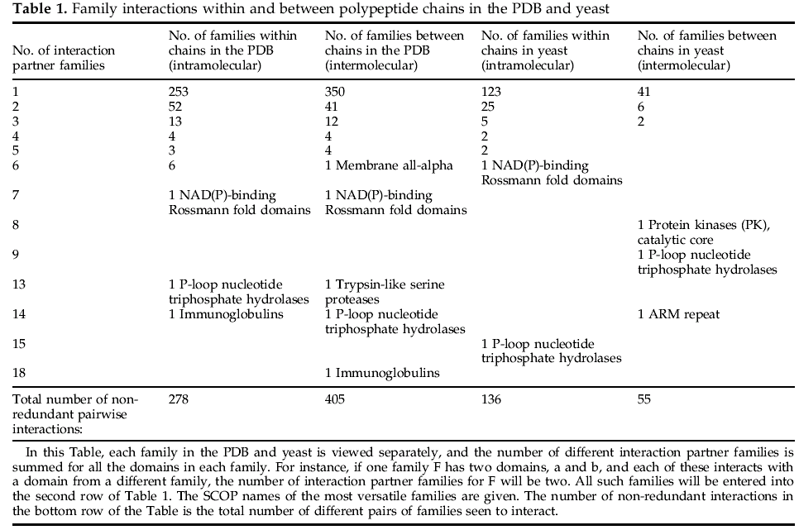
  - The interactions common to the intermolecular and intramolcular family interaction repertories
- The main difference between intramolecular and intermolecular interactions between domains is functional: Domains on the same chain are always expressed together as well as being localized together.
- The extent to which the two repertories overlap for the combined set of yeast and PDB interactions encompasses 103 types interactions: this is 31% of the 330 family interactions within and 24% of the 435 family interactions between polypeptide chains.
- Of these 103 interactions, 60 are between domains from the same family, and 33 are between domains of enzymes in small-molecule or macromolecular metabolism.

  - Oligomers: interactions between domains from the same family
- Domains of the same family can interact with each other within a protein in cases of internal duplication, or between proteins in homomultimers or multimers of different proteins from the same family.
  - Possible applications of structural assignments to interacting proteins
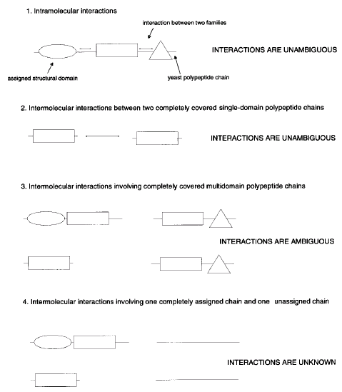
    - target selection for structural genomics
    - prediction
- The interactions can be used to predict the structure and function.
    - homology modeling
- Conclusions
- The analysis of experimentally derived interactions between yeast proteins identified at least 51 reliable new interactions between superfamilies, which are potential targets for crystallisation and experimental investigation of the domain interfaces.

- Materials and Methods
- Protein families in the SCOP database
- Interactions between families in the PDB
The coordinates of each domain were parsed to check whether there are five or more contacts within 5 Å to another domain.
- Interactions between families in the yeast genome
The interactions between protein families within polypeptide chains were calculated by assuming that assigned structural domains adjacent to each other on one polypeptide chain interact if there are less than thirty amino acid residues between the structural domains
Created by : Chu-Ting Tseng
Date : Dec. 30, 2003

