Mean Eccentricities of de Bruijn Networks
Jean-Bermond¹, Zhen Liu², Michel Syska¹
pp.187-203
Abstract
Provides bounds for the mean eccentricity of a vertex X in de Bruijn networks.
- I. Introduction
 | 001 |  |  | 011
000 |  | 010 | 101 |  | 111
 | 100 |  |  | 110
Example of a de Bruijn digraph B(2,3)

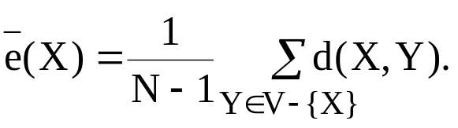
Corollary For any d≥2 and D≥2, and for all X∈B(d,D),

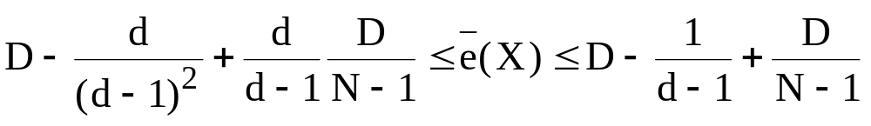
In particular, when d=2,
