A Reliable Cube-Connected Cycles Structure
Nian-Feng Tzeng
JOURNAL OF PARALLEL AND DISTRBUITED COMPUTING, VOL. 19, 1993, pp. 64-71
Abstract
The paper proposes a new reliable structure for the Cube-Connected Cycles (CCC) and which is aimed at maintaining the rigid CCC configuration even in the presence of faults. Due to the specific interconnecting style of CCC, this proposed design keeps its reconfiguration process simple and area overhead low.
- Introduction

- Proposed Reliable CCC Structure
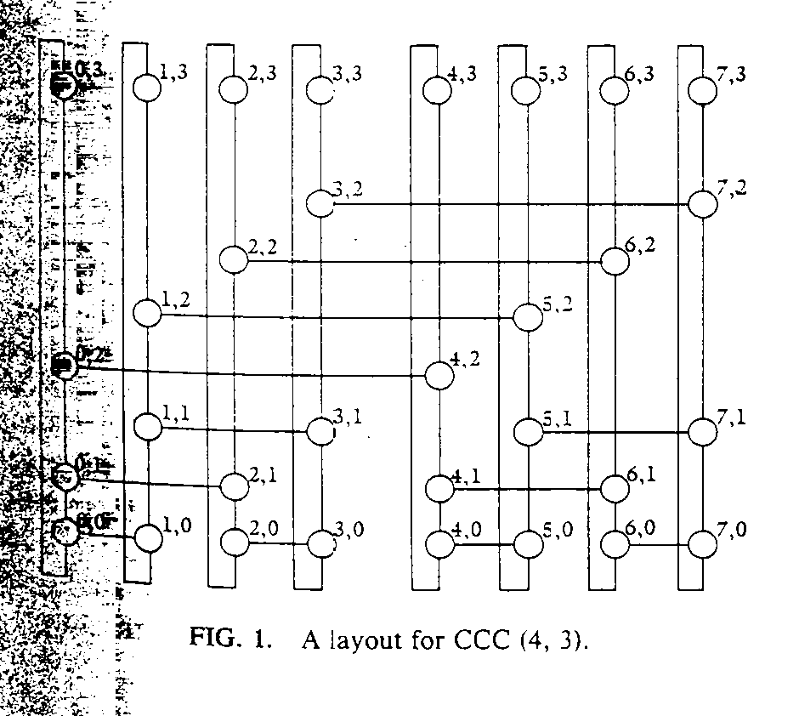
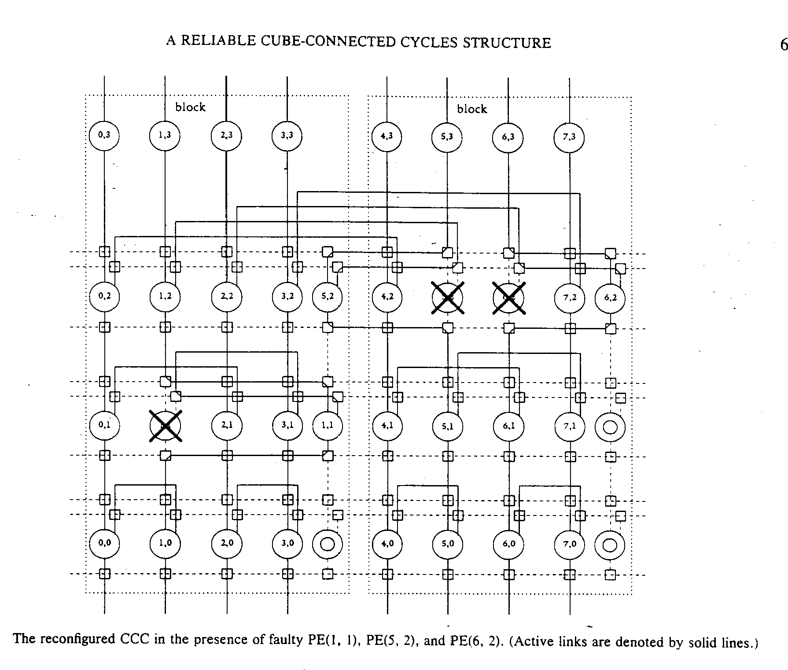
- Reliability Evaluation
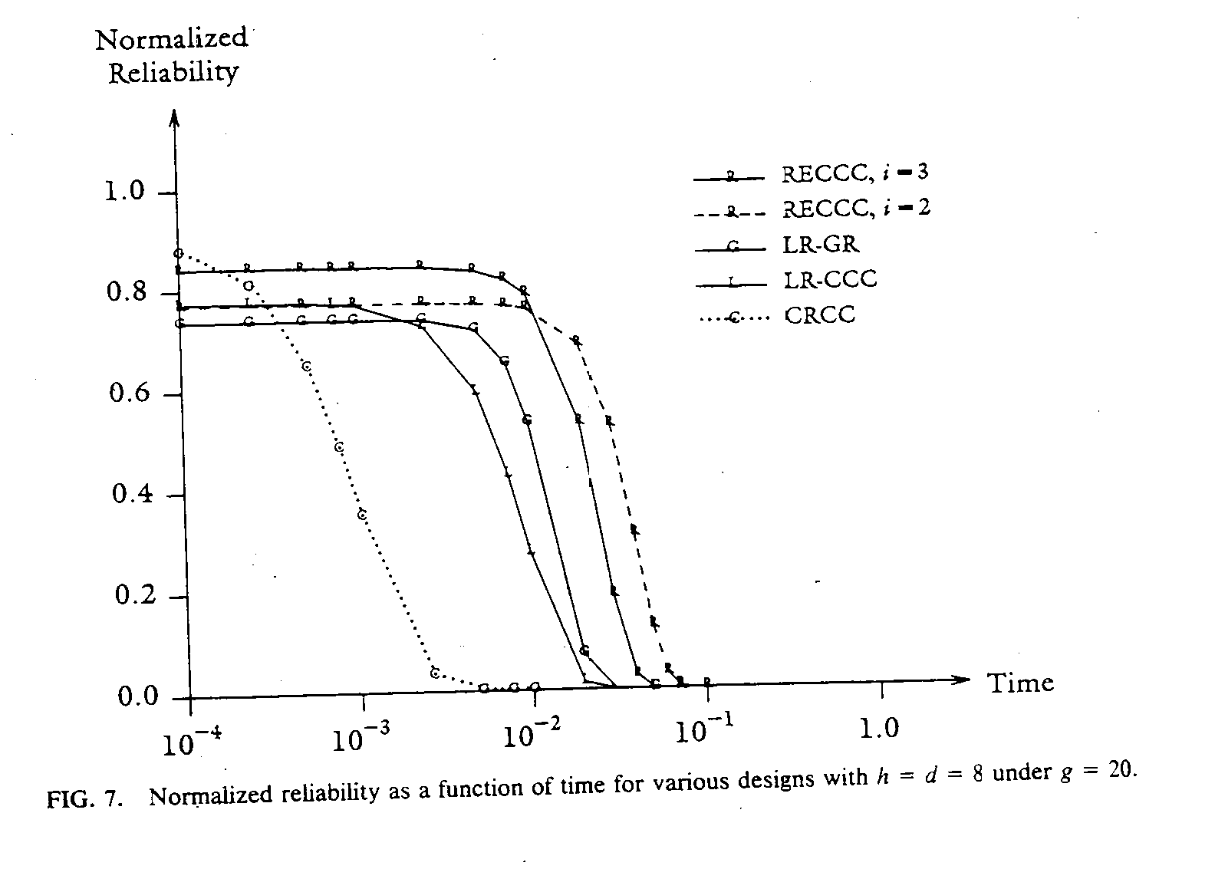
- Concluding Remarks
Created by : Kwo-Tsung Tseng
Date : Jan. 13, 2000

