§The Searching Strategies

e.g. satisfiability problem
x₁ | x₂ | x₃
F | F | F
F | F | T
F | T | F
F | T | T
T | F | F
T | F | T
T | T | F
T | T | T

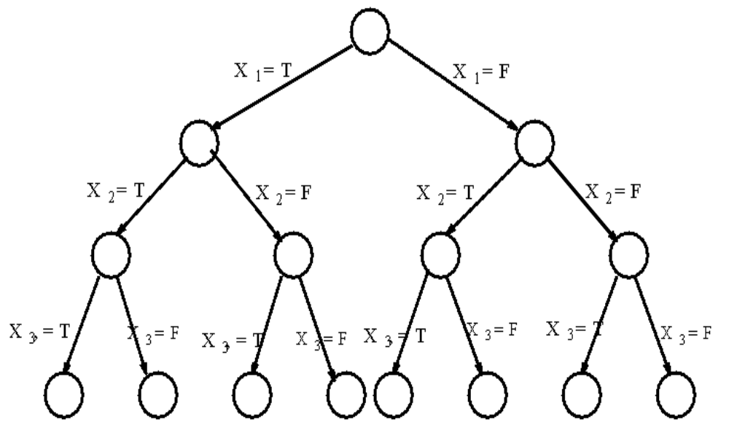
Fig. 6-1 Tree Representation of Eight Assignments.

If there are n variables x₁, x₂, …,x_{n}, then there are 2^{n} possible assignments.
an instance:
-x₁……..………(1)
x₁…………….(2)
x₂ v x₅……….(3)
x₃…………….(4)
-x₂…….……….(5)

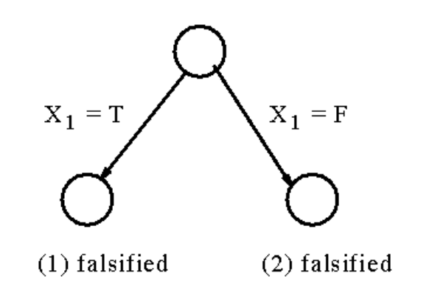
Fig. 6-2 A Partial Tree to Determine the Satisfiability Problem.

We may not need to examine all possible assignments.

- g. the Hamiltonian circuit problem

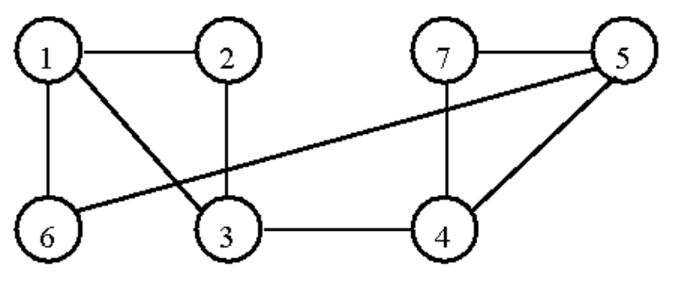
Fig. 6-6 A Graph Containing a Hamiltonian Circuit

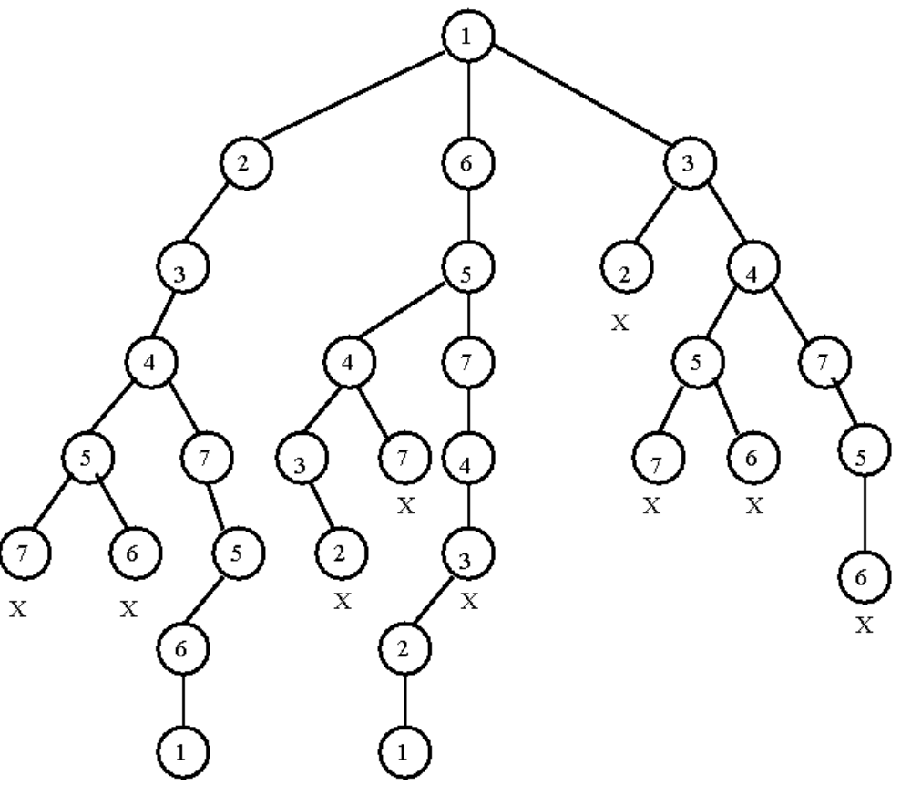
Fig. 6-8 The Tree Representation of Whether There Exists a Hamiltonian Circuit of the Graph in Fig. 6-6
- The breadth-first search

e.g. 8-puzzle problem
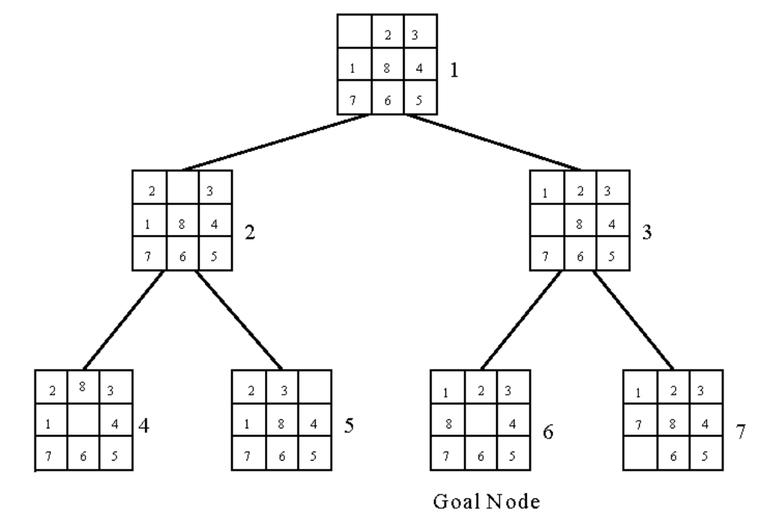Fig. 6-10 A Search Tree Produced by a Breadth-First Search

The breadth-first search uses a queue to holds all
expanded nodes.
- The depth-first search

e.g. sum of subset problem
S={7, 5, 1, 2, 10}
∃ S’ ⊆ S ∋ sum of S’ = 9 ?
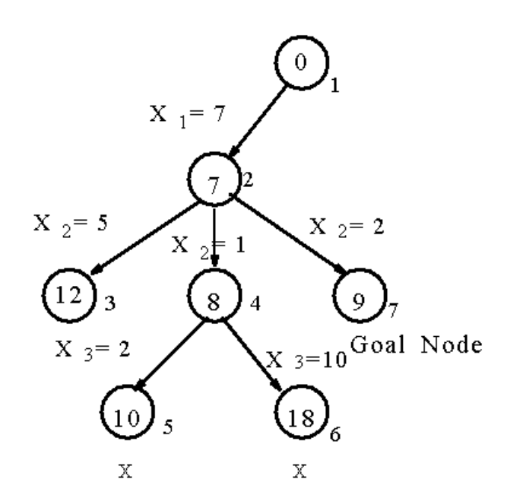
Fig. 6-11 A Sum of Subset Problem Solved by Depth-First Search.

A stack can be used to guide the depth-first search.

- Hill climbing
a variant of depth-first search
The method selects the locally optimal node to
expand.

e.g. 8-puzzle problem
evaluation function f(n) = d(n) + w(n)
where d(n) is the depth of node n
w(n) is # of misplaced tiles in node n.

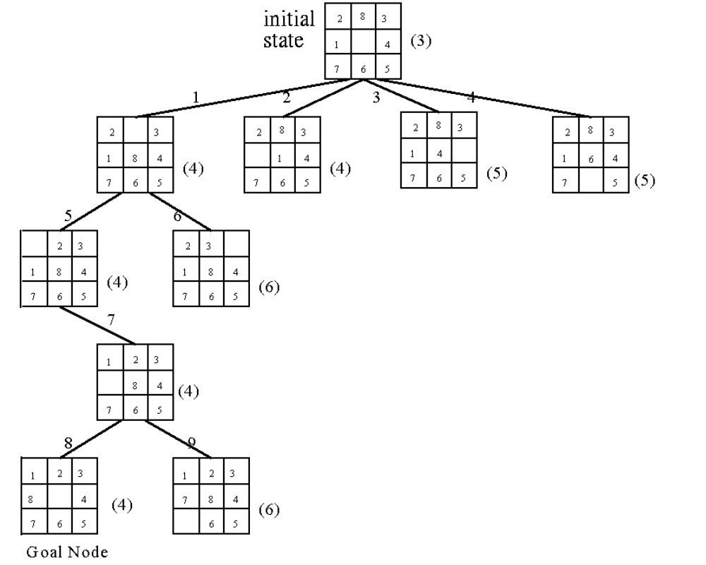
Fig. 6-15 An 8-Puzzle Problem Solved by a Hill
Climbing Method

- Best-first search strategy
Combing depth-first search and breadth-first
search
Selecting the node with the best estimated cost
among all nodes.
This method has a global view.
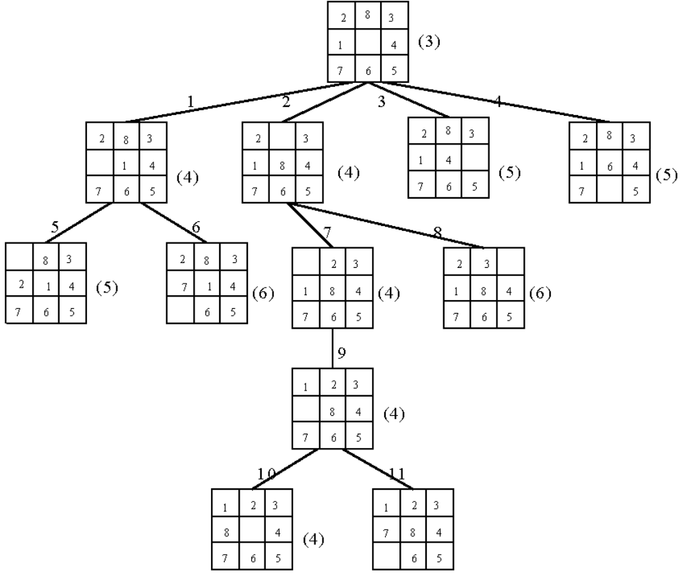 Goal Node
Fig. 6-16 An 8-Puzzle Problem Solved by a Best-First Search Scheme
Best-First Search Scheme

Step1:Form a one-element list consisting of the root node.
Step2:Remove the first element from the list. Expand the first element. If one of the descendants of the first element is a goal node, then stop; otherwise, add the descendants into the list.
Step3:Sort the entire list by the values of some estimation function.
Step4:If the list is empty, then failure. Otherwise, go to Step 2.

- The branch-and-bound strategy
This strategy can be used to solve optimization problems. (DFS, BFS, hill climbing and best-first search can not be used to solve optimization problems.)

e.g.
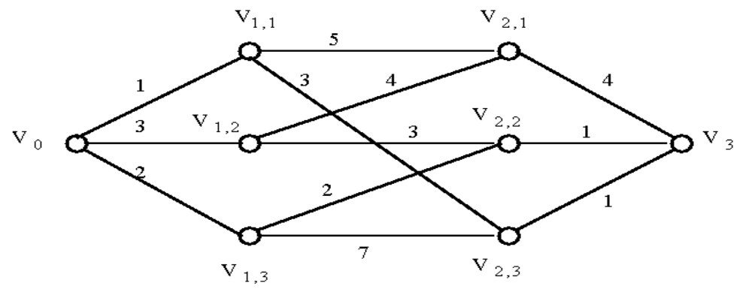
Fig. 6-17 A Multi-Stage Graph Searching Problem.
Solved by branch-and-bound:
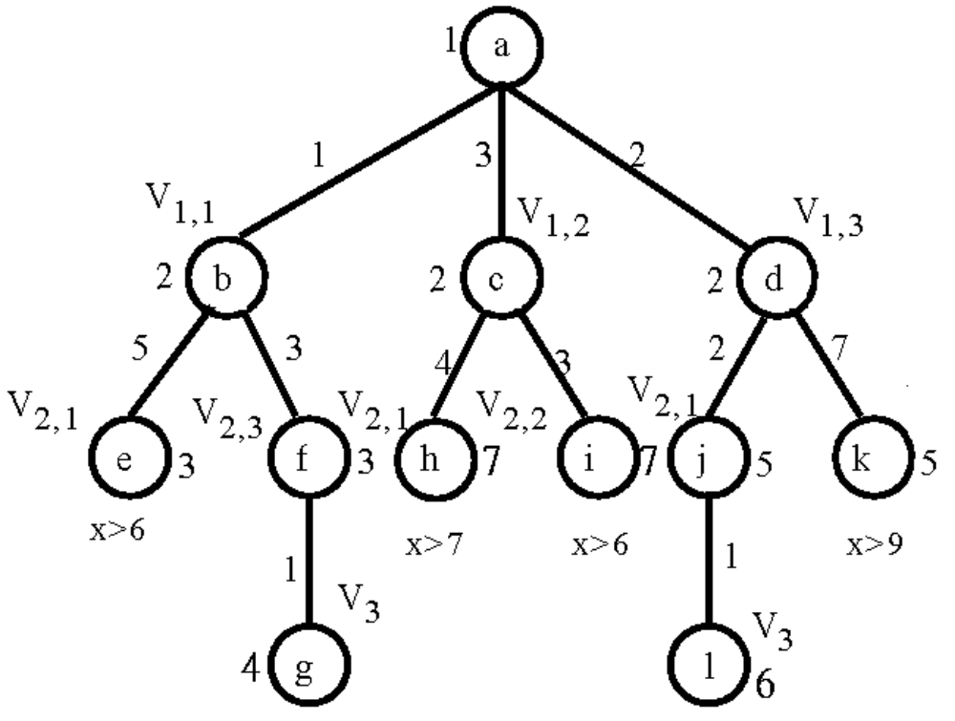
- The personnel assignment problem
a linearly ordered set of persons P={P₁, P₂, …, P_{n}} where P₁<P₂<…<P_{n}
a partially ordered set of jobs J={J₁, J₂, …, J_{n}}
Suppose that P_{i} and P_{j} are assigned to jobs f(P_{i}) and f(P_{j}) respectively. If f(P_{i}) ≤ f(P_{j}), then P_{i} ≤ P_{j}. Cost C_{ij} is the cost of assigning P_{i} to J_{j}. We want to find a feasible assignment with the min. cost. i.e.
X_{ij} = 1 if P_{i} is assigned to J_{j} and X_{ij} = 0 otherwise.
Minimize ∑_{i,j} C_{ij}X_{ij}

e.g.
J₁ |  | J₂
↓ | ↘ | ↓
J₃ |  | J₄
Fig. 6-21 A Partial Ordering of Jobs

After topological sorting, one of the following topologically sorted sequences will be generated:

J₁, | J₂, | J₃, | J₄
J₁, | J₂, | J₄, | J₃
J₁, | J₃, | J₂, | J₄
J₂, | J₁, | J₃, | J₄
J₂, | J₁, | J₄ | J₃

one of feasible assignments:
P₁→J₁, P₂→J₂, P₃→J₃, P₄→J₄
cost matrix:
Jobs  Persons | 1 | 2 | 3 | 4
1 | 29 | 19 | 17 | 12
2 | 32 | 30 | 26 | 28
3 | 3 | 21 | 7 | 9
4 | 18 | 13 | 10 | 15
Table 6-1 A Cost Matrix for a Personnel Assignment Problem

reduced cost matrix:
subtract a constant from each row and each column respectively such that each row and each column contains at least one zero.

Jobs  Persons | 1 | 2 | 3 | 4
1 | 17 | 4 | 5 | 0 | (-12)
2 | 6 | 1 | 0 | 2 | (-26)
3 | 0 | 15 | 4 | 6 | (-3)
4 | 8 | 0 | 0 | 5 | (-10)
 |  | (-3)
Table 6-2 A Reduced Cost Matrix

total cost subtracted: 12+26+3+10+3 = 54
This is a lower bound of our solution.

Enumeration tree:
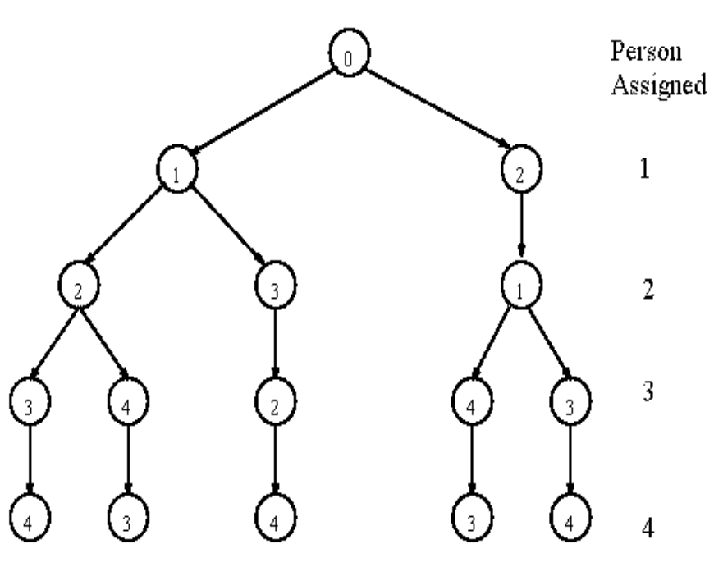

bounding of subsolutions:
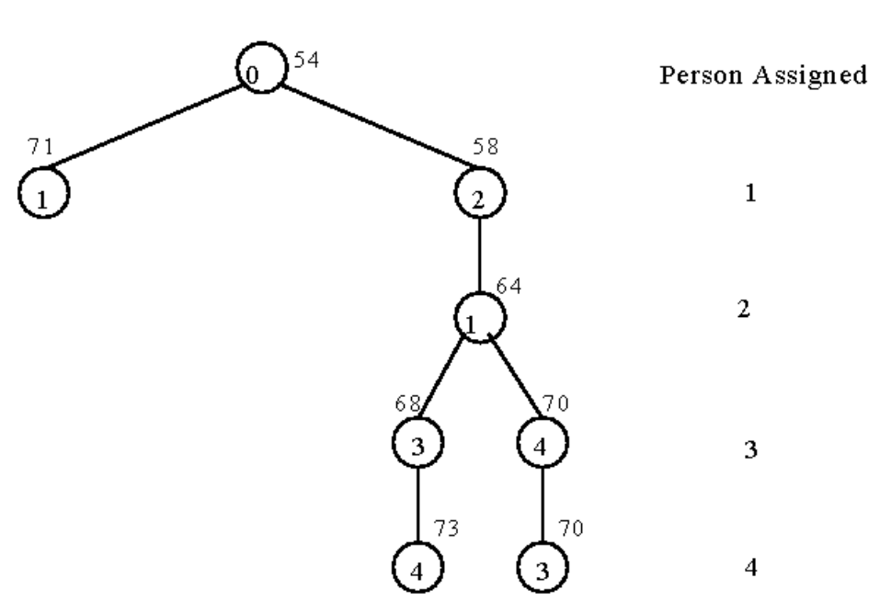

- The traveling salesperson optimization problem
It is NP-complete

e.g. cost matrix:
j  i | 1 | 2 | 3 | 4 | 5 | 6 | 7
1 | ∞ | 3 | 93 | 13 | 33 | 9 | 57
2 | 4 | ∞ | 77 | 42 | 21 | 16 | 34
3 | 45 | 17 | ∞ | 36 | 16 | 28 | 25
4 | 39 | 90 | 80 | ∞ | 56 | 7 | 91
5 | 28 | 46 | 88 | 33 | ∞ | 25 | 57
6 | 3 | 88 | 18 | 46 | 92 | ∞ | 7
7 | 44 | 26 | 33 | 27 | 84 | 39 | ∞
Table 6-3 A Cost Matrix for a Traveling Salesperson Problem.

Reduced cost matrix:
j  i | 1 | 2 | 3 | 4 | 5 | 6 | 7
1 | ∞ | 0 | 90 | 10 | 30 | 6 | 54 | (-3)
2 | 0 | ∞ | 73 | 38 | 17 | 12 | 30 | (-4)
3 | 29 | 1 | ∞ | 20 | 0 | 12 | 9 | (-16)
4 | 32 | 83 | 73 | ∞ | 49 | 0 | 84 | (-7)
5 | 3 | 21 | 63 | 8 | ∞ | 0 | 32 | (-25)
6 | 0 | 85 | 15 | 43 | 89 | ∞ | 4 | (-3)
7 | 18 | 0 | 7 | 1 | 58 | 13 | ∞ | (-26)
 |  |  |  |  |  |  | reduced:84
Table 6-4 A Reduced Cost Matrix.
j  i | 1 | 2 | 3 | 4 | 5 | 6 | 7
1 | ∞ | 0 | 83 | 9 | 30 | 6 | 50
2 | 0 | ∞ | 66 | 37 | 17 | 12 | 26
3 | 29 | 1 | ∞ | 19 | 0 | 12 | 5
4 | 32 | 83 | 66 | ∞ | 49 | 0 | 80
5 | 3 | 21 | 56 | 7 | ∞ | 0 | 28
6 | 0 | 85 | 8 | 42 | 89 | ∞ | 0
7 | 18 | 0 | 0 | 0 | 58 | 13 | ∞
 |  |  | (-7) | (-1) |  |  | (-4)
Table 6-5 Another Reduced Cost Matrix.

total cost reduced: 84+7+1+4 = 96 (lower bound)

decision tree:
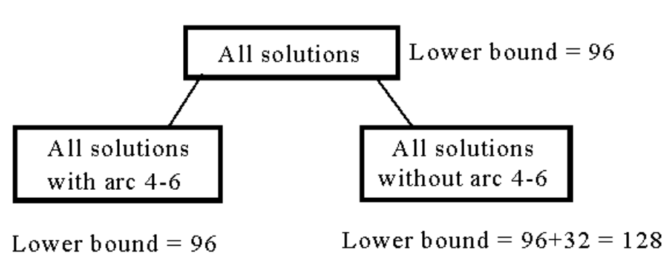
Fig. 6-25 The Highest Level of a Decision Tree.

If we use arc 3-5 to split, the difference on the lower bounds is 17+1 = 18.

j  i | 1 | 2 | 3 | 4 | 5 | 7
1 | ∞ | 0 | 83 | 9 | 30 | 50
2 | 0 | ∞ | 66 | 37 | 17 | 26
3 | 29 | 1 | ∞ | 19 | 0 | 5
5 | 3 | 21 | 56 | 7 | ∞ | 28
6 | 0 | 85 | 8 | ∞ | 89 | 0
7 | 18 | 0 | 0 | 0 | 58 | ∞
Table 6-6 A Reduced Cost Matrix. If Arc 4-6 is Included.

The cost matrix for all solution with arc 4-6:
j  i | 1 | 2 | 3 | 4 | 5 | 7
1 | ∞ | 0 | 83 | 9 | 30 | 50
2 | 0 | ∞ | 66 | 37 | 17 | 26
3 | 29 | 1 | ∞ | 19 | 0 | 5
5 | 0 | 18 | 53 | 4 | ∞ | 25 | (-3)
6 | 0 | 85 | 8 | ∞ | 89 | 0
7 | 18 | 0 | 0 | 0 | 58 | ∞
Table 6-7 A Reduced Cost Matrix for that in Table 6-6.

total cost reduced: 96+3 = 99 (new lower bound)
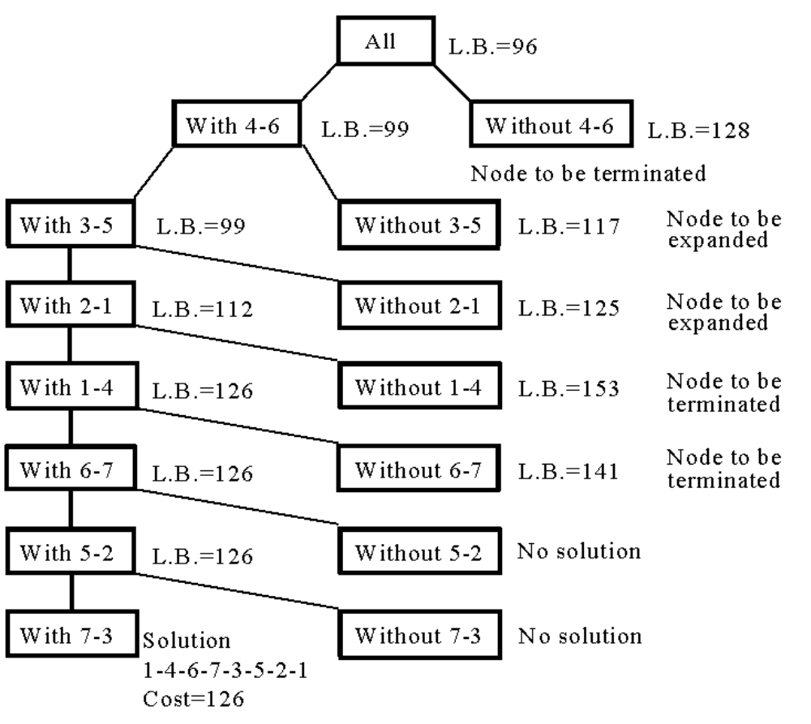Fig 6-26 A Branch-and-Bound Solution of a Traveling Salesperson Problem.
- The 0/1 knapsack problem
positive integer P₁, P₂, …, P_{n} (profit)
W₁, W₂, …, W_{n} (weight)
M (capacity)
maximize 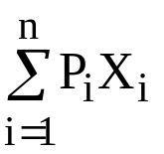
subject to 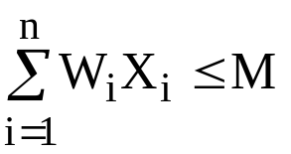 X_{i} = 0 or 1, i =1, …, n.
The problem is modified:
minimize 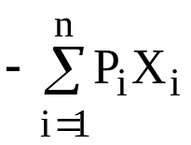
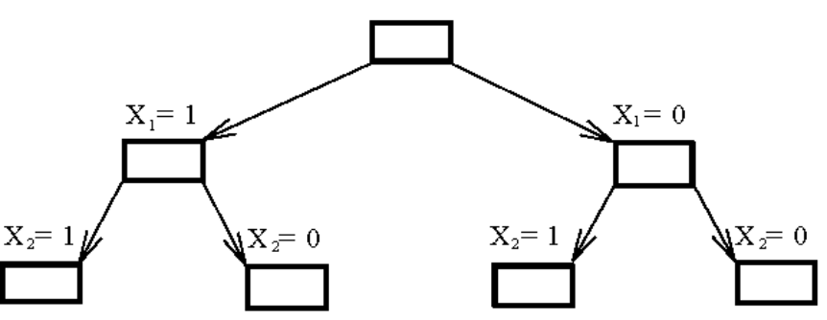
Fig. 6-27 The Branching Mechanism in the Branch-and-Bound Strategy to Solve 0/1 Knapsack Problem.
e.g. n = 6, M = 34
i | 1 | 2 | 3 | 4 | 5 | 6
P_{i} | 6 | 10 | 4 | 5 | 6 | 4
W_{i} | 10 | 19 | 8 | 10 | 12 | 8
(P_{i}/W_{i} ≥ P_{i+1}/W_{i+1})
a feasible solution: X₁ = 1, X₂ = 1, X₃ = 0, X₄ = 0,
X₅ = 0, X₆ = 0
-(P₁+P₂) = -16 (upper bound)
Any solution higher than -16 can not be an optimal solution.
Relax our restriction from X_{i} = 0 or 1to 0 ≤ X_{i} ≤ 1 (knapsack problem)

Let be an optimal solution for 0/1 knapsack problem and 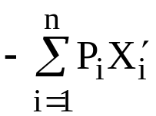 be an optimal solution for knapsack problem. Let Y=,
Y’ = .
⇒ Y’ ≤ Y

We can use the greedy method to find an optimal solution for knapsack problem:

X₁ = 1, X₂ =1, X₃ = 5/8, X₄ = 0, X₅ = 0, X₆ =0
-(P₁+P₂+5/8P₃) = -18.5 (lower bound)
-18 is our lower bound. (only consider integers)

⇒ -18 ≤ optimal solution ≤ -16
optimal solution: X₁ = 1, X₂ = 0, X₃ = 0, X₄ = 1, X₅ = 1, X₆ = 0
-(P₁+P₄+P₅) = -17

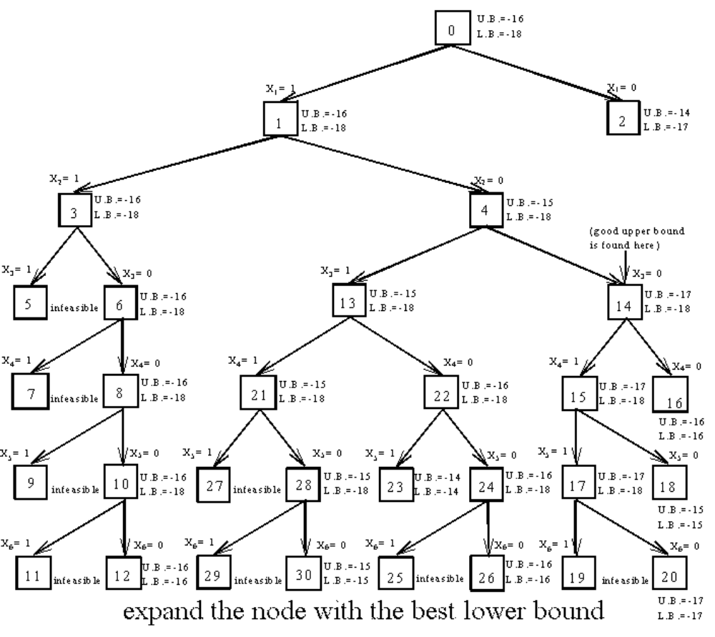Fig. 6-28 0/1 Knapsack Problem Solved by Branch-and-Bound Strategy

- The A* algorithm
used to solve optimization problems.
using the best-first strategy.
If a feasible solution (goal node) is obtained, then it is optimal and we can stop.

cost function of node n: f(n)
f(n) = g(n) + h(n)
g(n): cost from root to node n.
h(n): estimated cost from node n to a goal node.
h*(n): “real” cost from node n to a goal node.

h(n) ≤ h*(n)

⇒ f(n) = g(n) + h(n) ≤ g(n)+h*(n) = f*(n)

e.g.
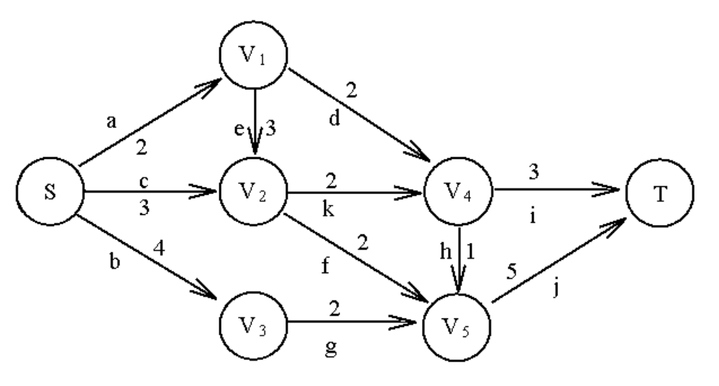
Fig. 6-36 A Graph to Illustrate A* Algorithm.
Step 1.
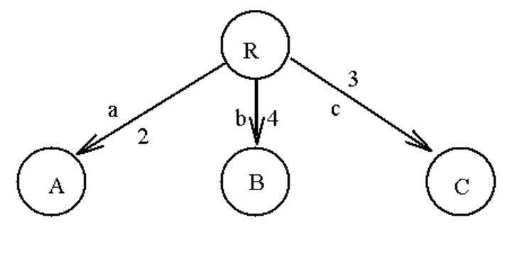
g(A)=2 | h(A)=min{2,3}=2 | f(A)=2+2=4
g(B)=4 | h(B)=min{2}=2 | f(B)=4+2=6
g(C)=3 | h(C)=min{2,2}=2 | f(C)= 3+2=5

Step 2. Expand A
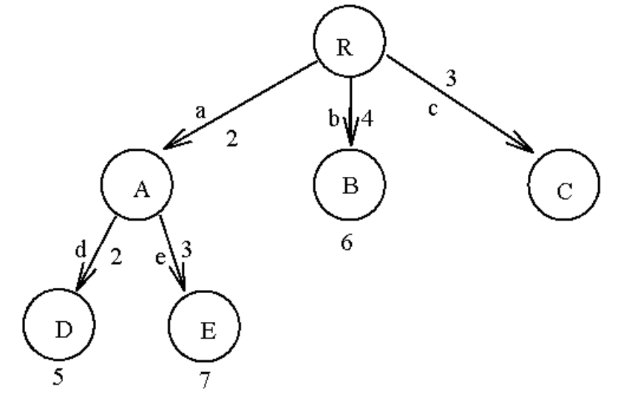
g(D)=2+2=4 | h(D)=min{3,1}=1 | f(A)=4+1=5
g(E)=2+3=5 | h(E)=min{2,2}=2 | f(B)=5+2=7
Step 3. Expand C
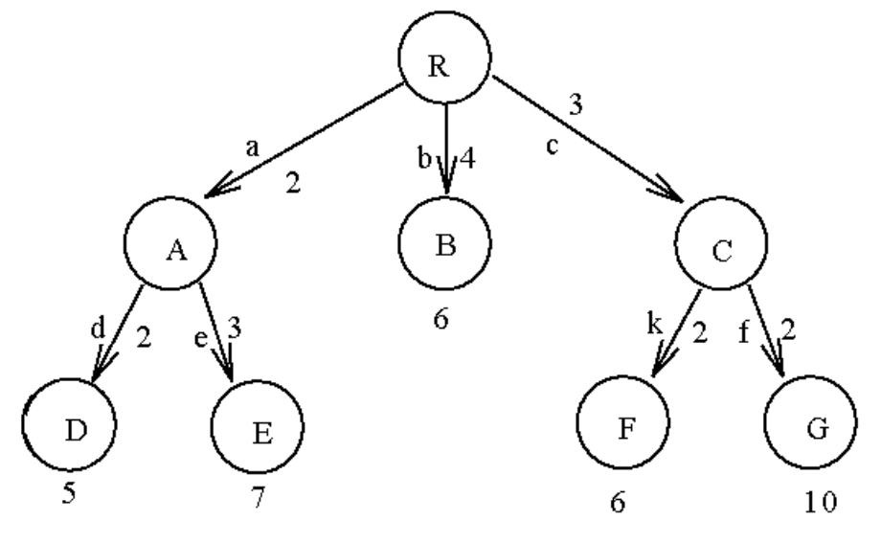
g(F)=3+2=5 | h(F)=min{3,1}=1 | f(F)=5+1=6
g(G) =3+2=5 | h(G)=min{5}=5 | f(G) =5+5=10

Step 4. Expand D
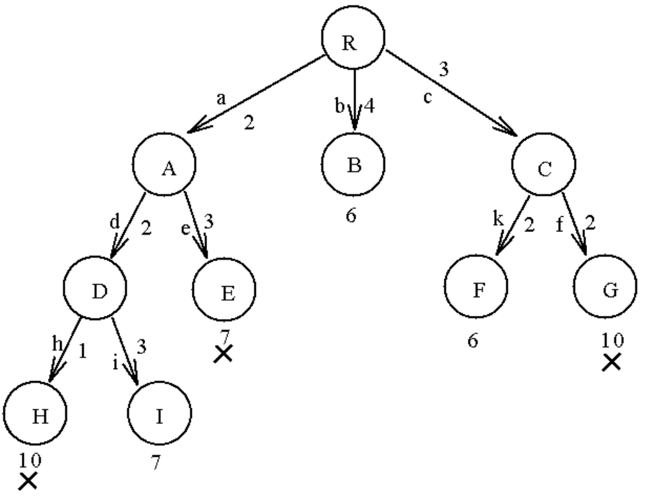
g(H)=2+2+1=5 | h(H)=min{5}=5 | f(H)=5+5=10
g(I)=2+2+3=7 | h(I)=0 | f(I)=7+0=7
Step 5. Expand B
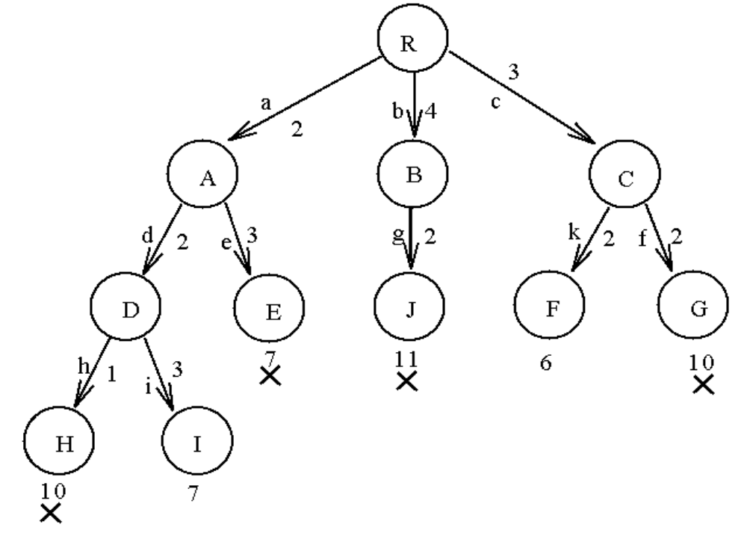
g(J)=4+2=6 | h(J)=min{5}=5 | f(J)=6+5=11

Step 6. Expand F
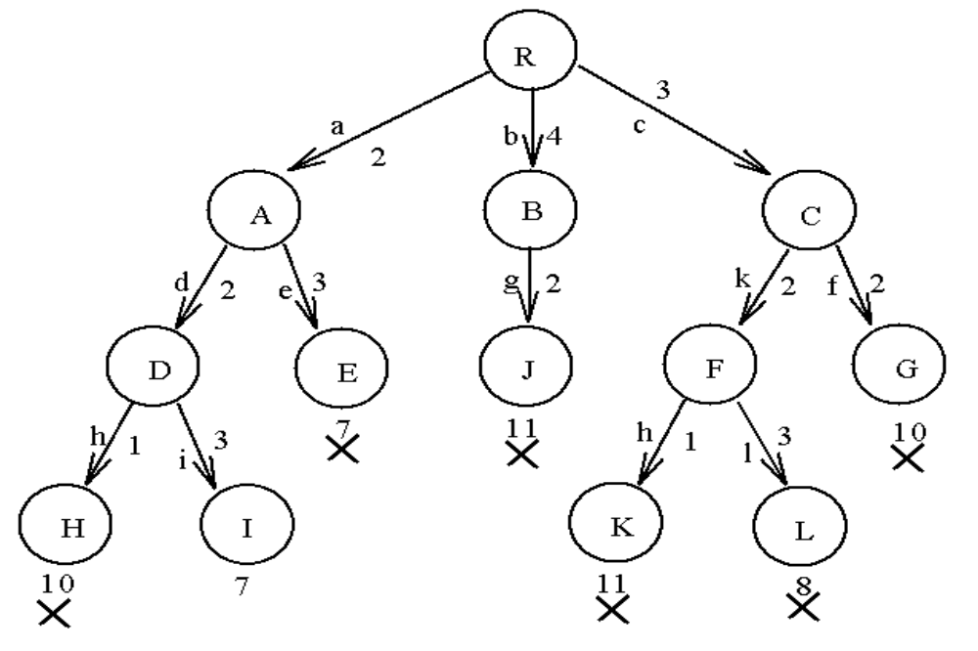
g(K)=3+2+1=6 | h(K)=min{5}=5 | f(K)=6+5=11
g(L)=3+2+3=8 | h(L)=0 | f(L)=8+0=8
- The channel routing problem

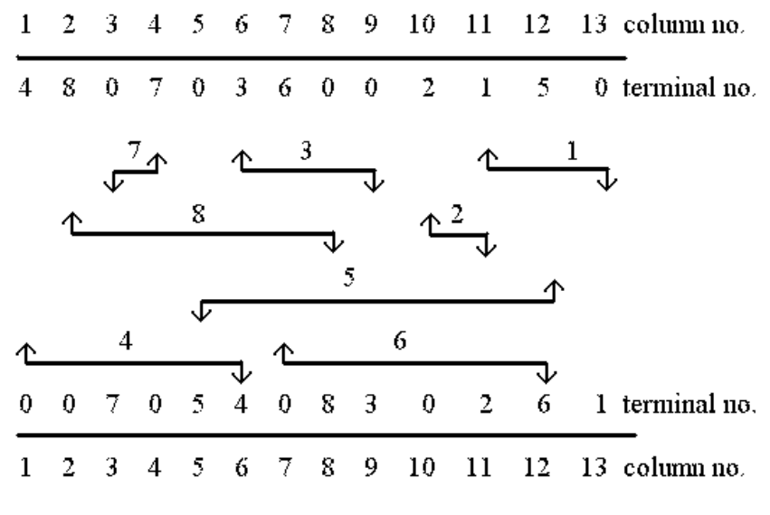
Fig. 6-40 A Channel Specification

illegal wirings:
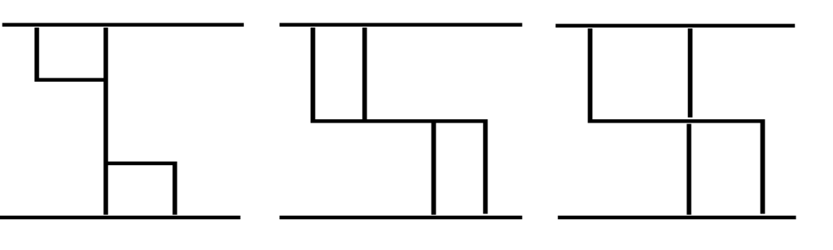We want to find a layout which minimizes the number of tracks.
a feasible layout:
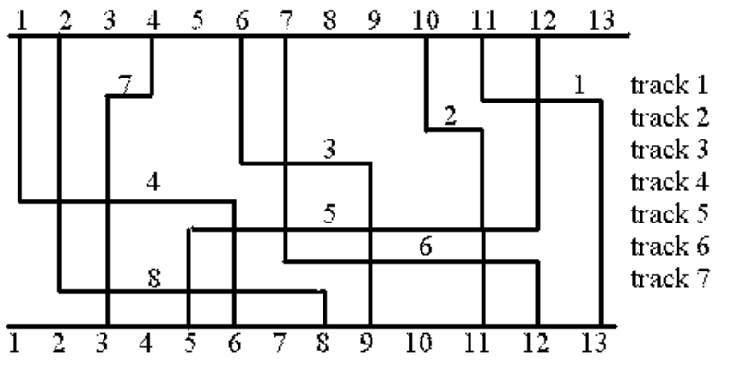
an optimal layout:
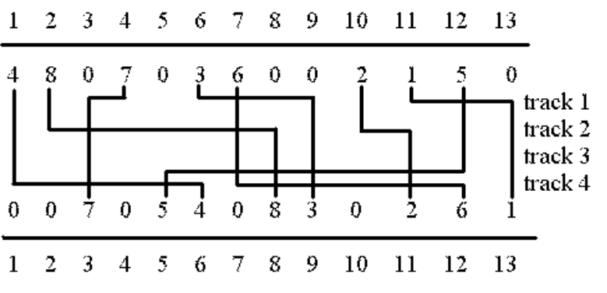
This problem is NP-complete.

horizontal constraint graph(HCG)
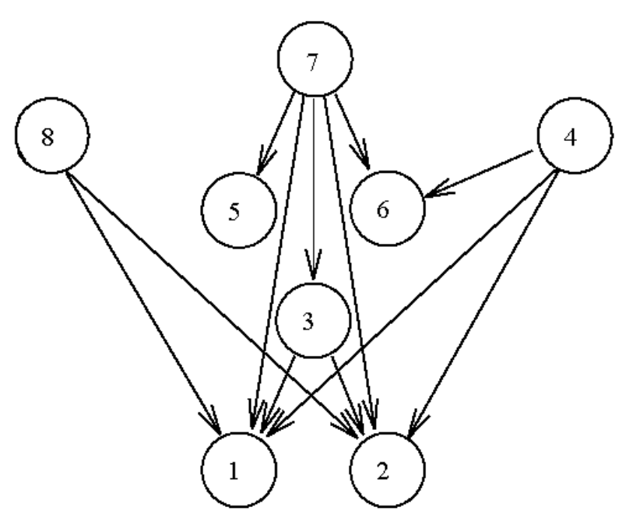

e.g. net 8 must be to the left of net 1 and net 2 if
they are in the same track.
vertical constraint graph:
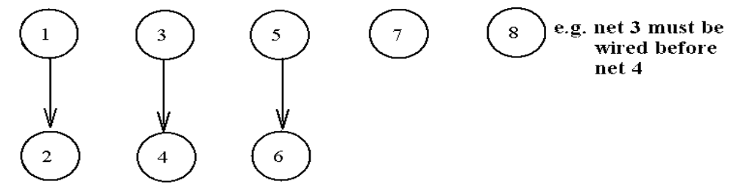max. cliques in HCG: {1,8}, {1,3,7}, {5,7}
Each max. clique can be assigned to a track.
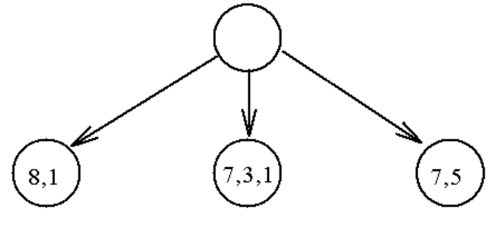
Fig. 6-46 The First Level of a Tree to Solve a Channel Routing Problem

f(n) = g(n) + h(n), g(n): the level of the tree
h(n): maximal local density
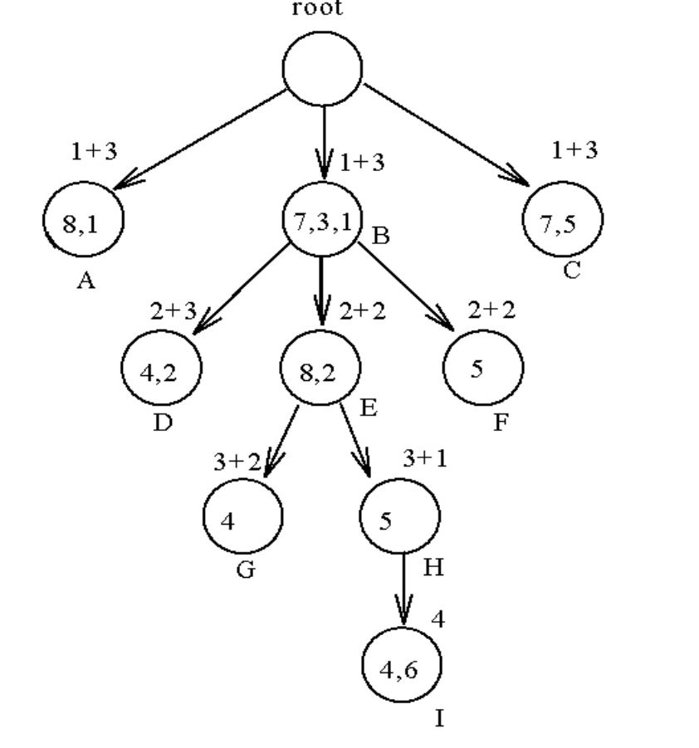
Fig 6-48 A Partial Solution Tree for the Channel Routing Problem by Using A* Algorithm.

