Combining Fractal Image Compression and Vector Quantization
Raouf Hamzaoui and Dietmar Saupe
IEEE TRANSACTIONS ON IMAGE PROCESSING, VOL. 9, NO. 2, Feb. 2000, pp. 197-208
Abstract
The conventional fractal image compression method is time- consuming. In this paper, we show how a few fixed vectors designed from a training images by a clustering algorithm accelerate the search for the domain block and improve both the quality of the image and the decoding speed of a pure fractal coder, when they used as a supplementary vector quantization codebook.
- Introduction
- Fast Encoding with Clustering
- Classification
- Domain pool reduction
- Nearest neighbor search
- Multiresolution approaches
- Fast Fourier Transform method

- A. Classification by Mean and Variance
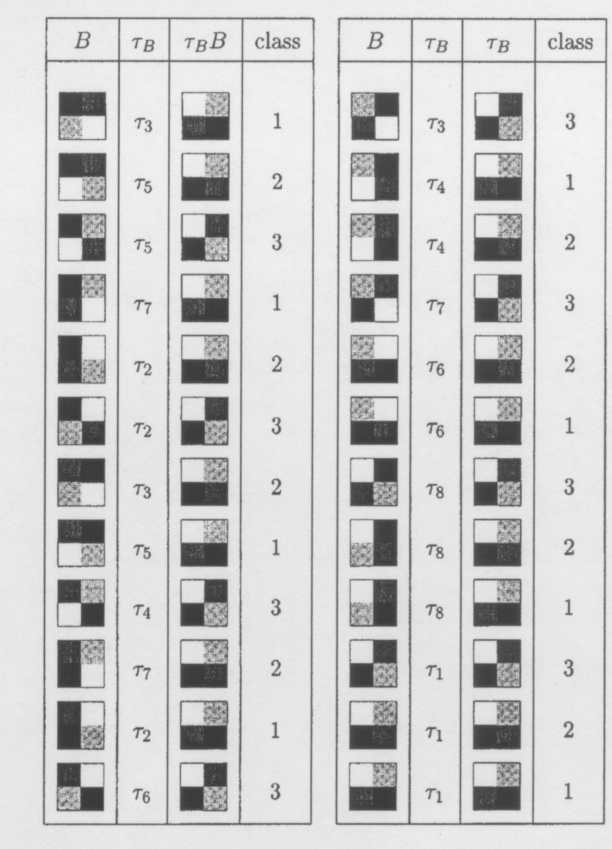
- B. Nearest Neighbor Search
- C. Distance-Based Clustering
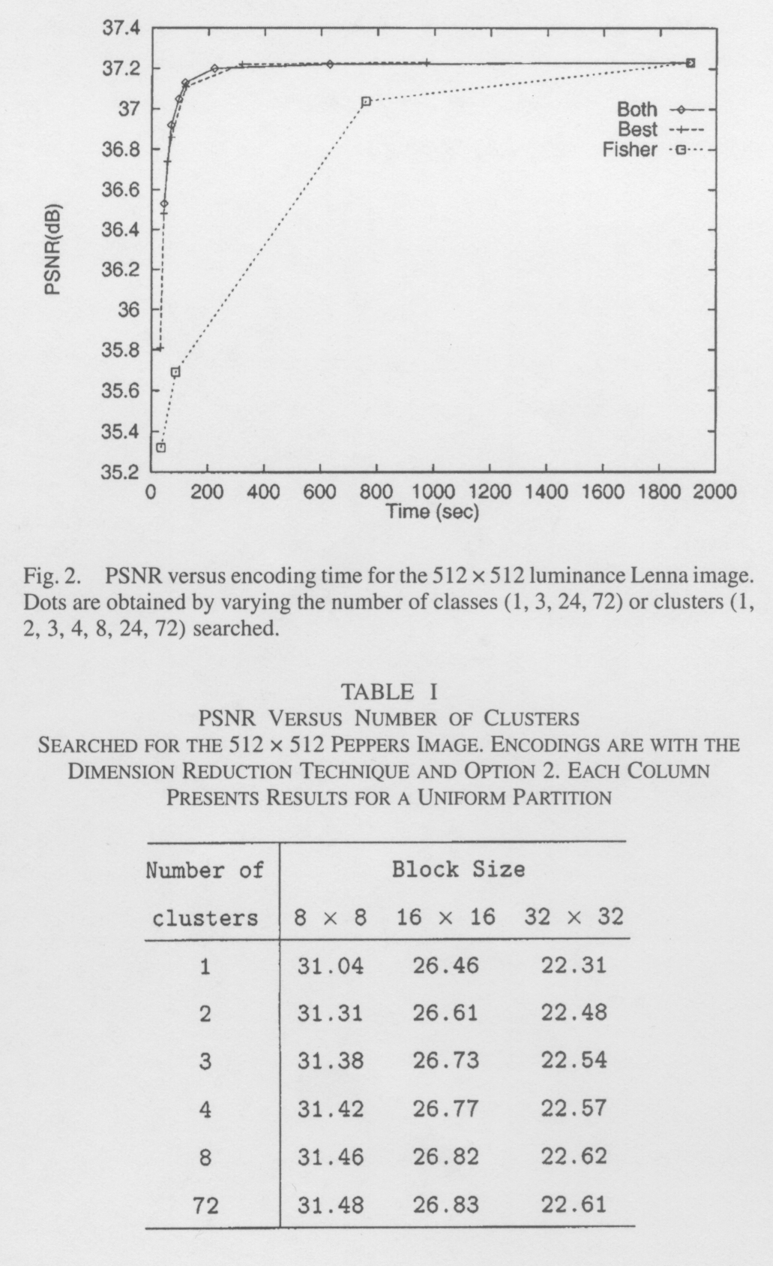 | 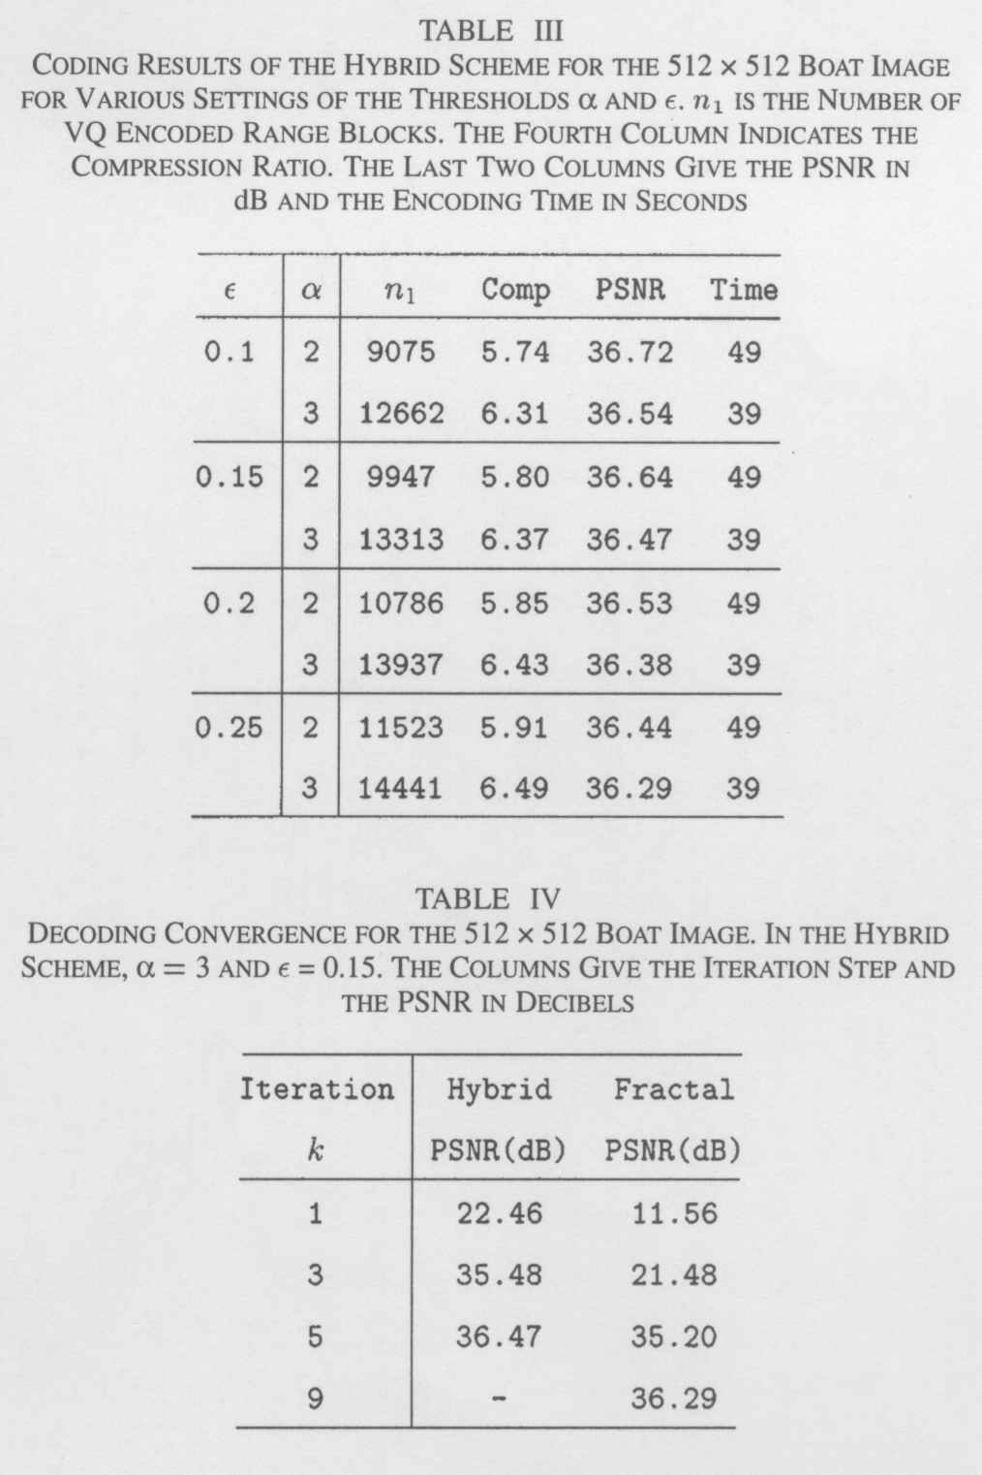

- The Hybrid Scheme
- Optimal Hybrid Coding
- Summary and Discussion
- Conclusions
Created by : Kwo-Tsung Tseng
Date : Feb. 10, 2000

