A Fault-Tolerant Connected-Cycle-Based Mesh Architecture
Jyh-Ming Huang
Department of Information Engineering, Feng-Chia University
E-mail:jmhuang@pine.iecs.fcu.edu.tw
Abstract
In this paper, we present two reconfiguration schemes with connected-cycle based module base in order to construct an architecture which is fault-tolerant and to eliminate the spare substitution domino effect. Simulations show that both schemes provide for increase in reliability over the interstitial redundancy scheme and the multi-level fault tolerance mesh, at the same redundant spare ratio.
- Introduction
- Description of CCBM Structure
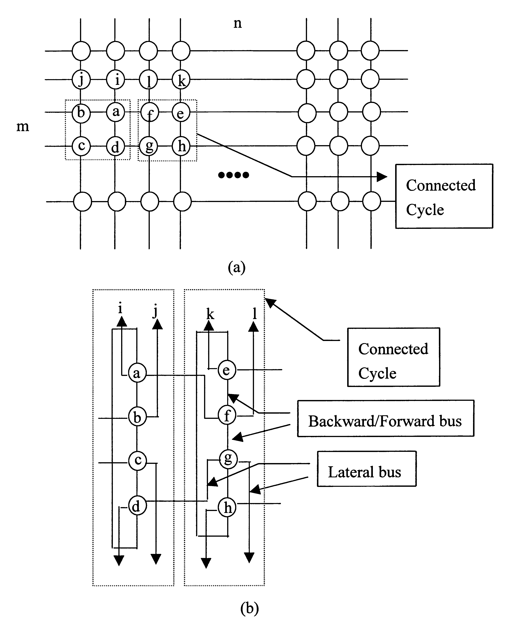
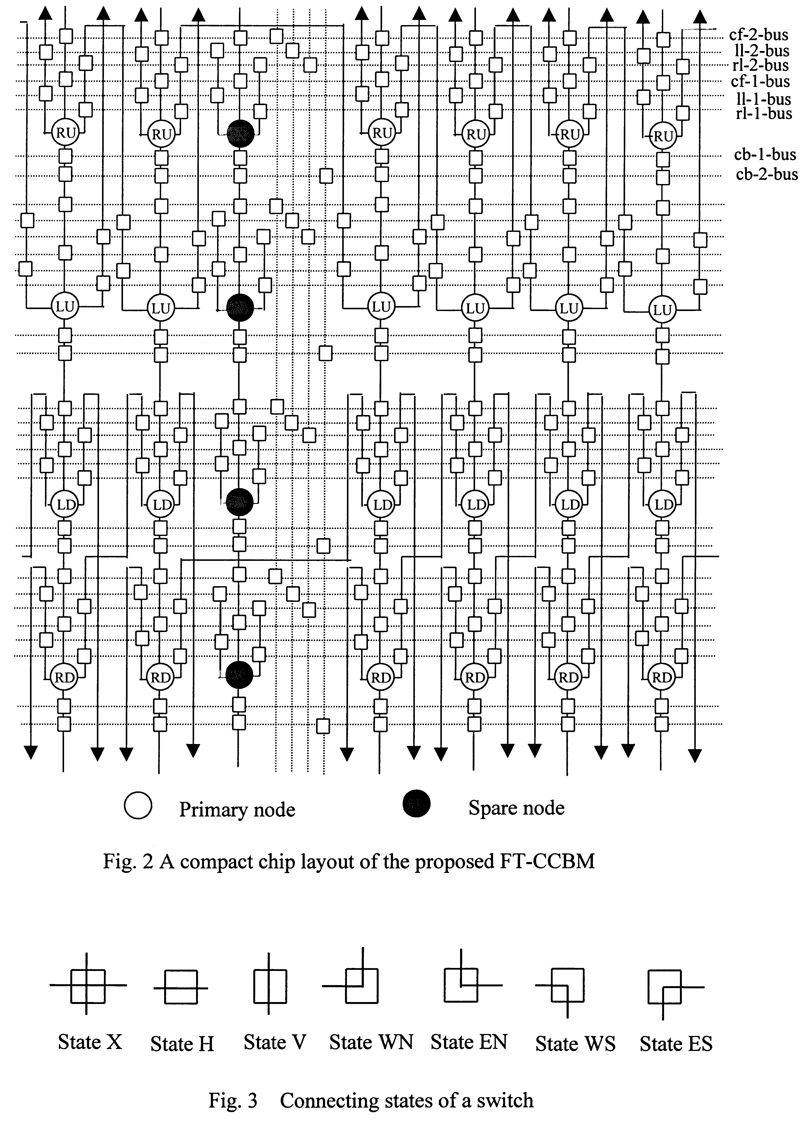
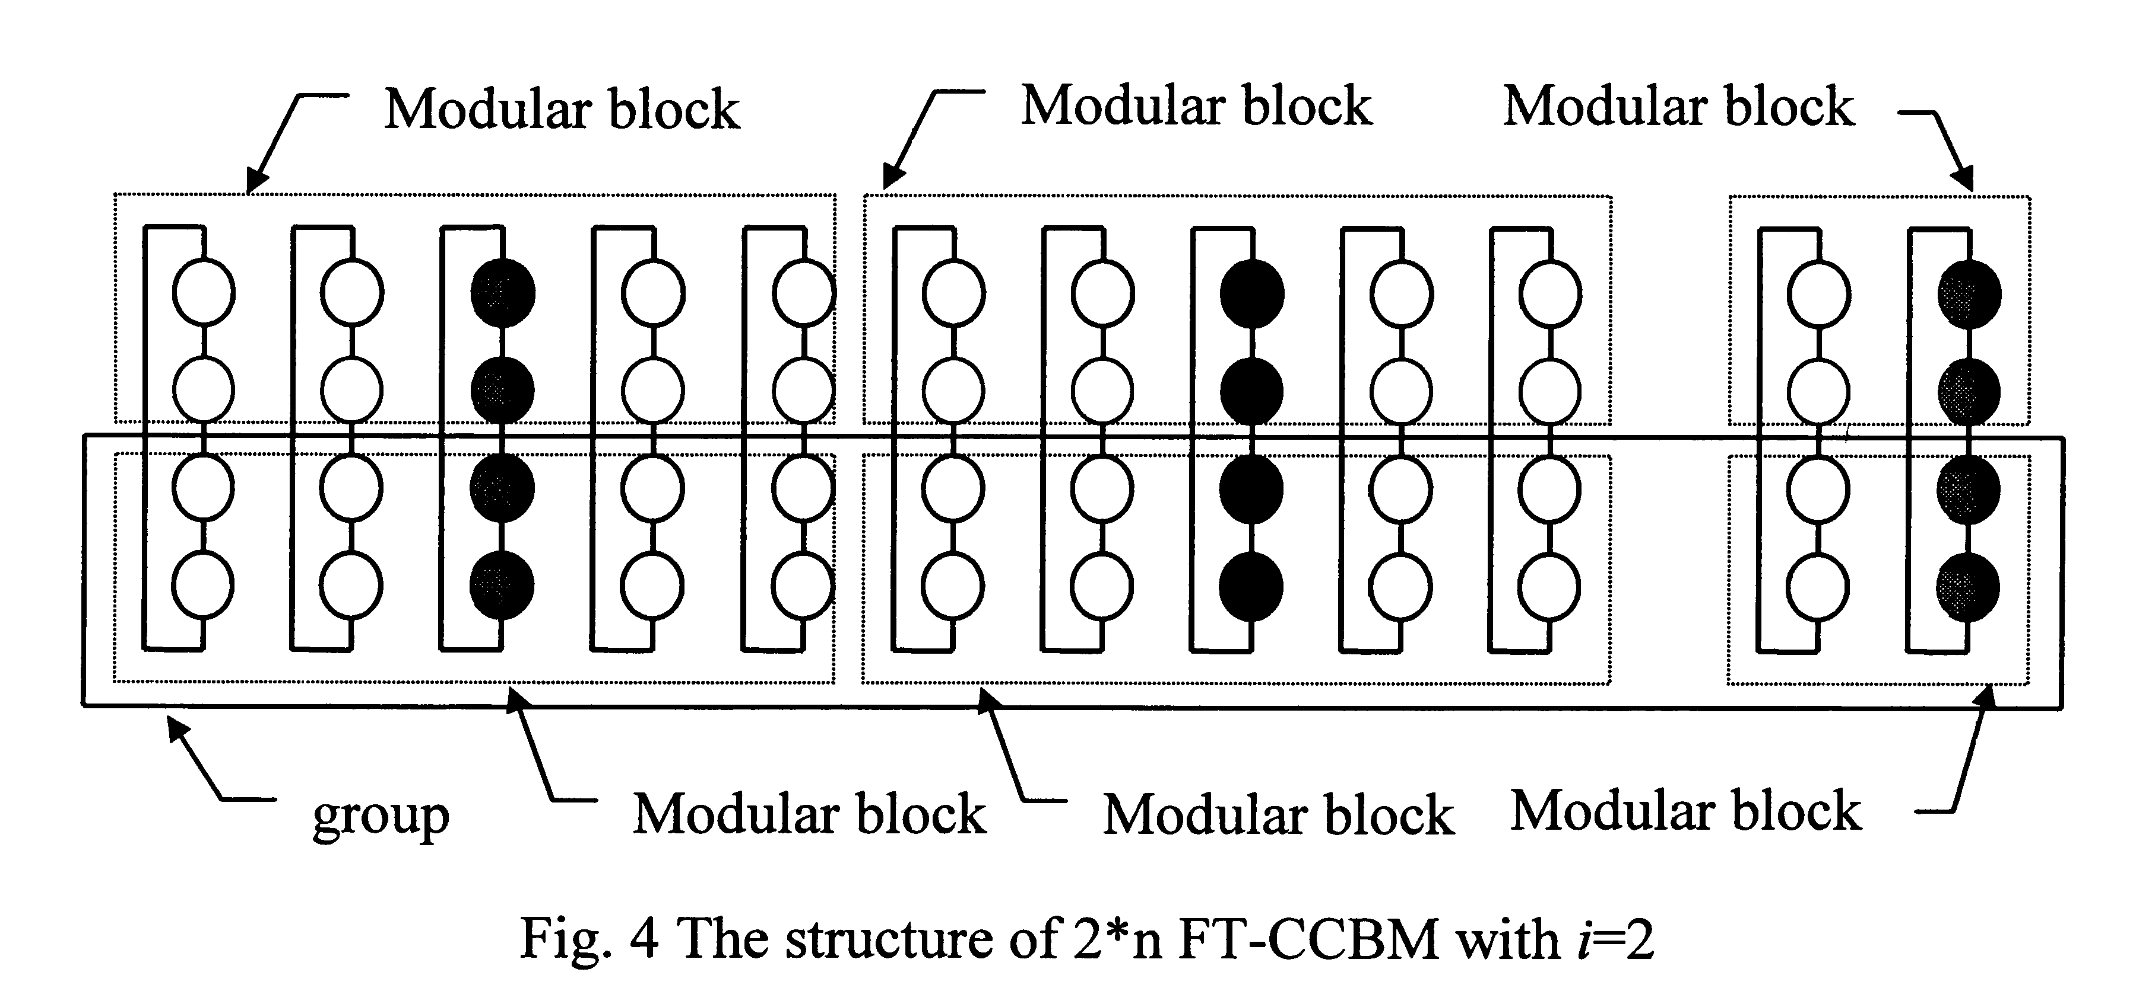
- Reconfiguration Schemes
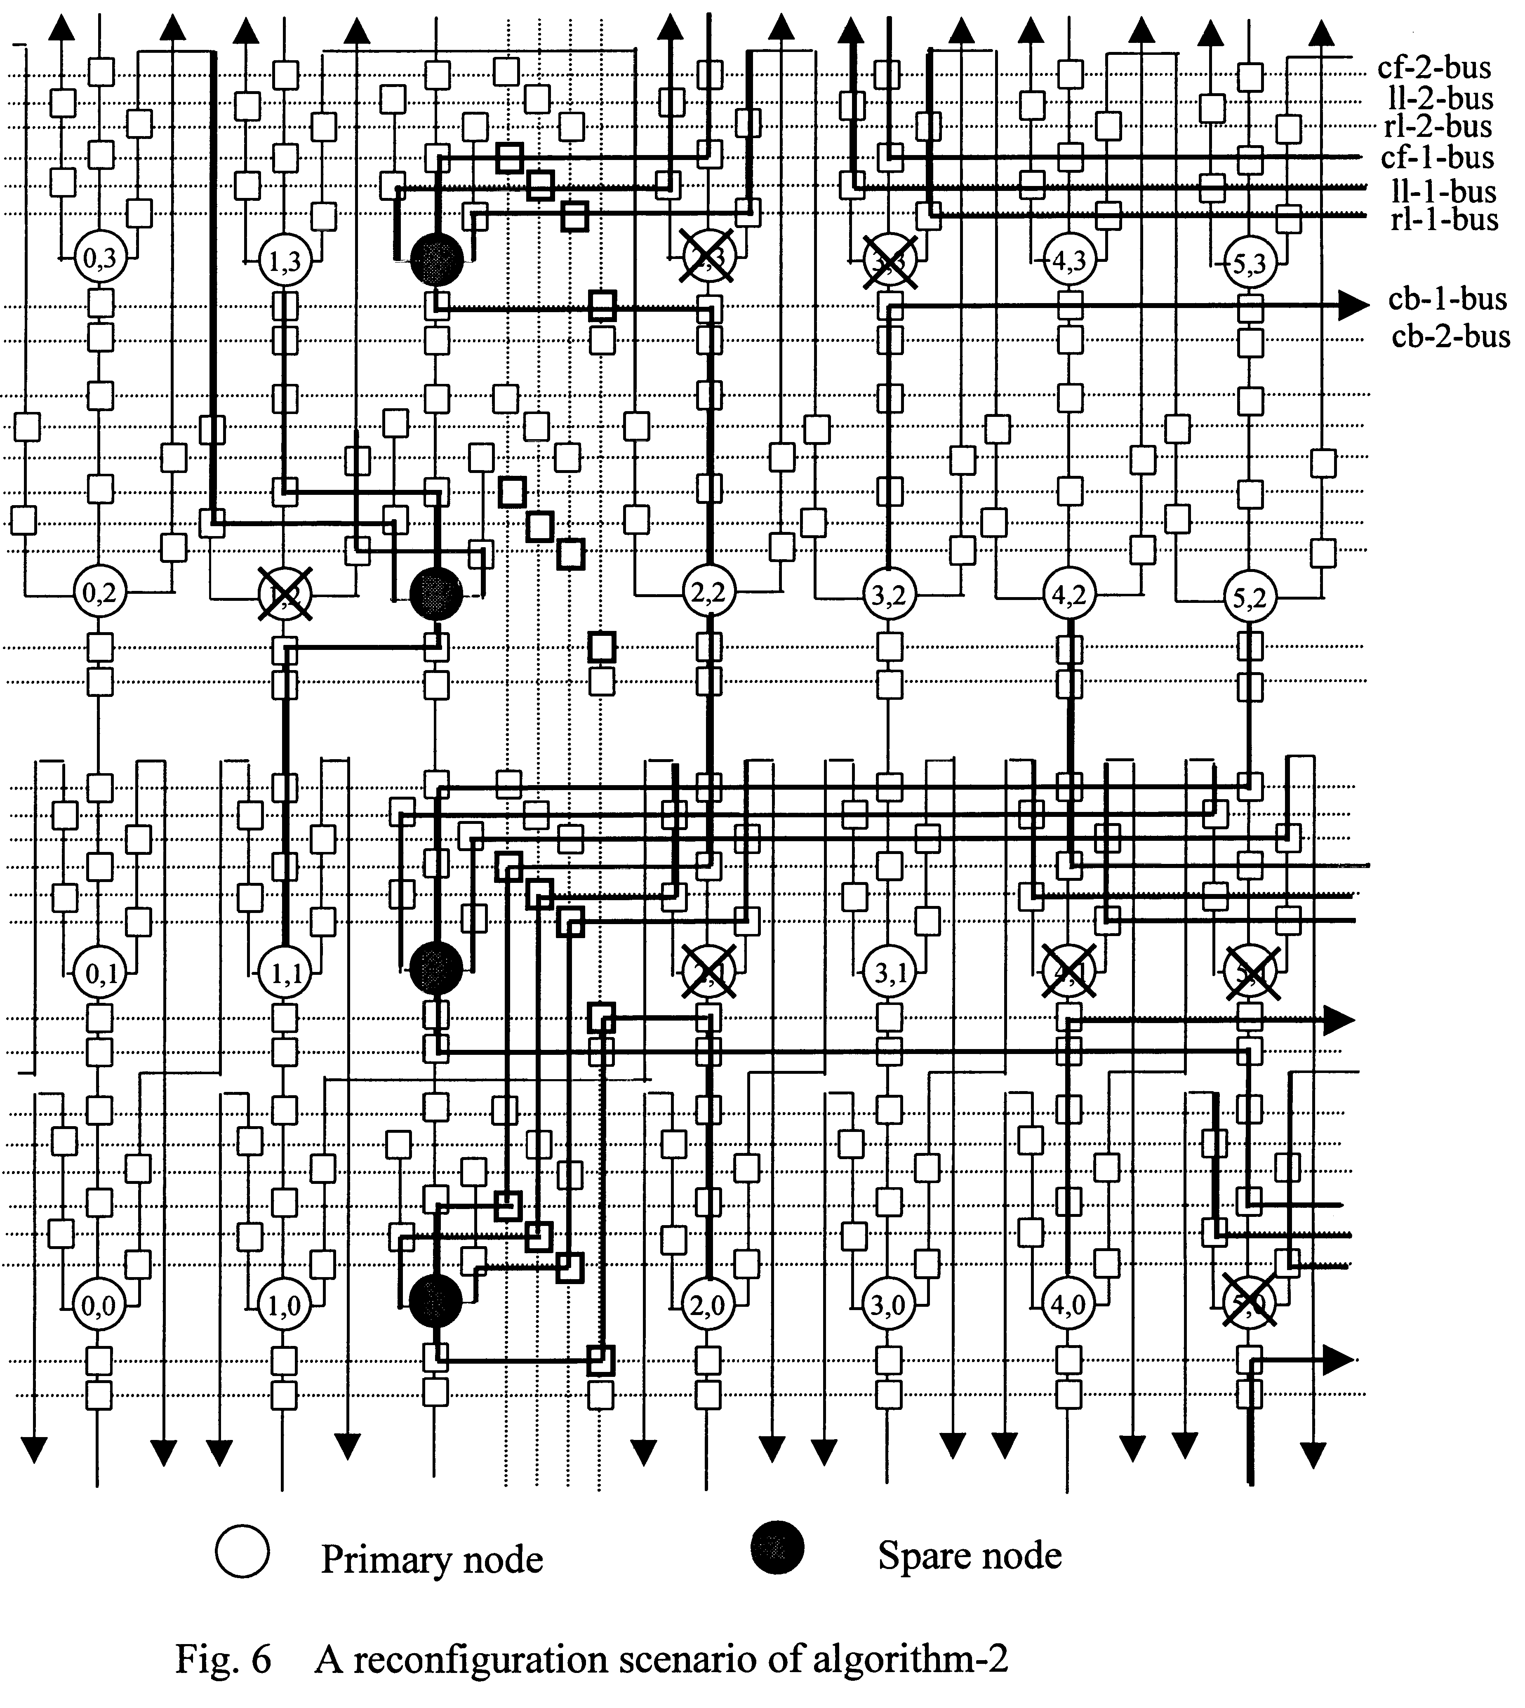
- Reliability Analysis
- Simulation and Coparison
- Conclusions
Created by : Kwo-Tsung Tseng
Date : Nov. 6, 1999

