Fast and Fair Mutual Exclusion Algorithms Using Fetch&Store Primitive
Ting-Lu Huang
1998 ICS Workshop on Algorithms, Dec. 17-19, 1998, pp. 28-35
Abstract
The results show that we were able to maintain the same level of performance with or without compare&swap. However, fairness is degraded from bounded bypass to lockout freedom without the support.
- Introduction
- Definitions and Models
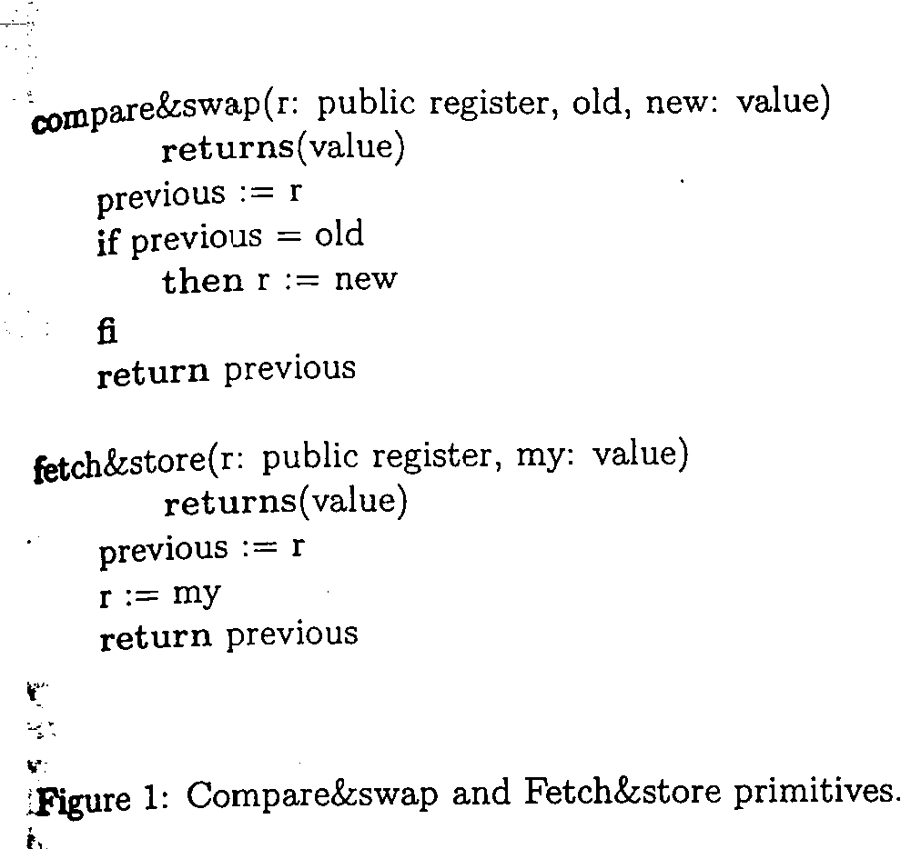 | 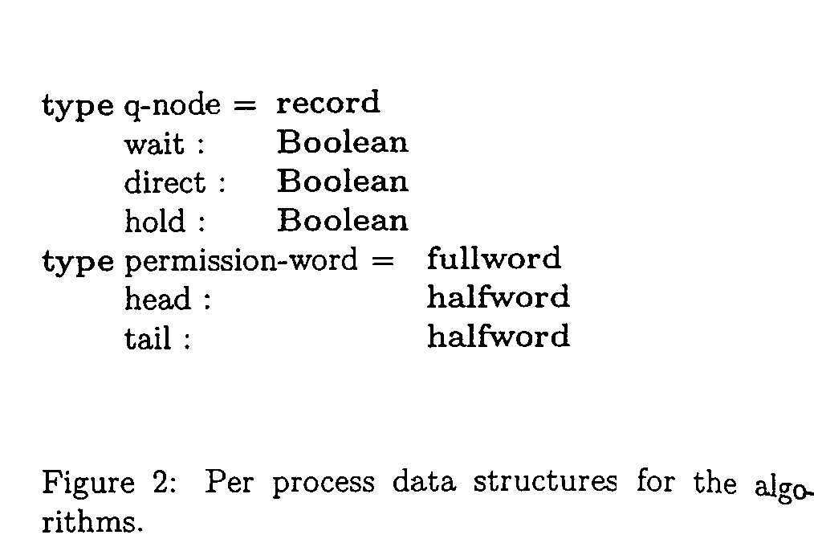
- The Fast Mutual Exclusion algorithms using Fetch&Store only
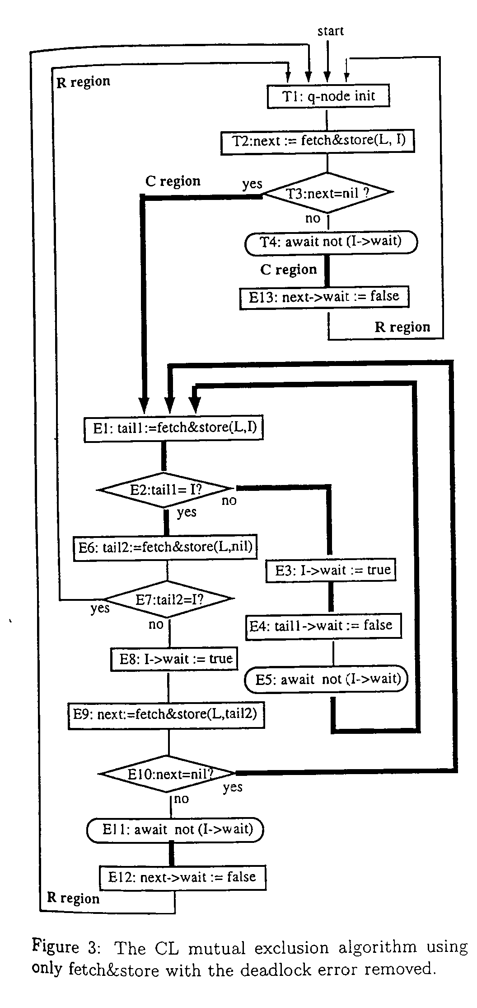 | 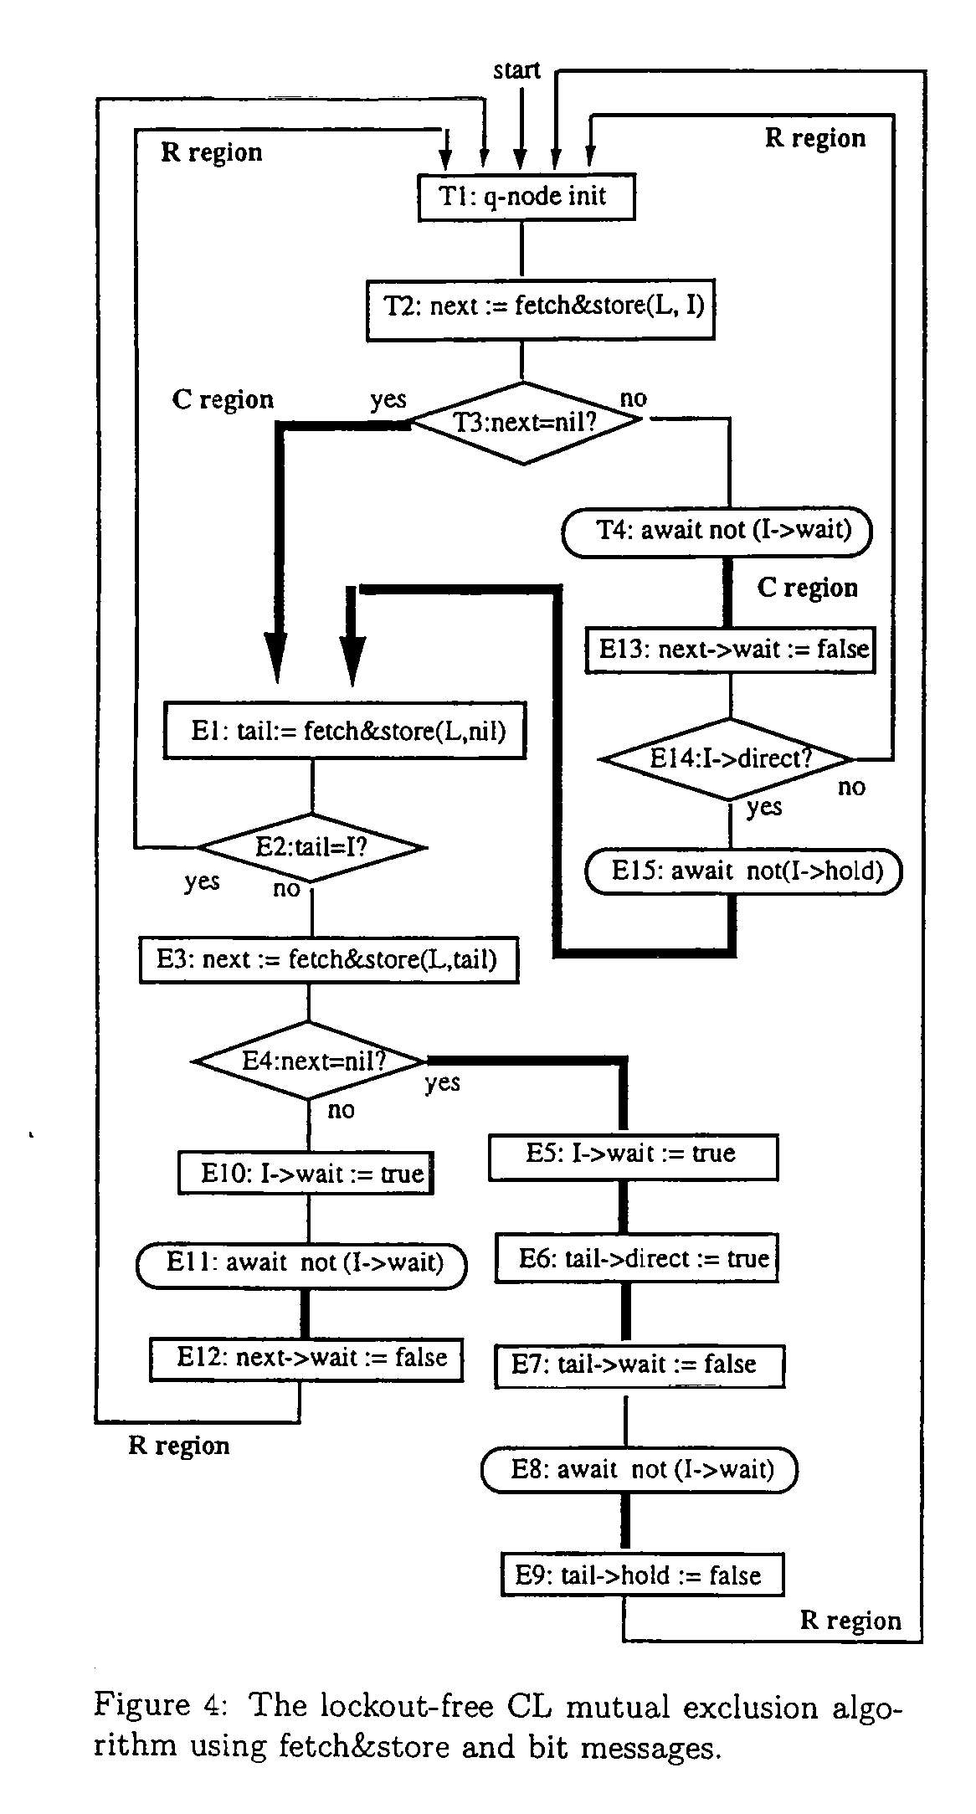

- Conclusions

Created by : Kwo-Tsung Tseng
Date : Jan. 29, 1999

