Hierarchical Quorum Consensus: A New Algorithm for Managing Replicated Data
Akil Kumar
IEEE TRANSACTIONS ON COMPUTERS, VOL 40, NO 9, SEPTEMBER 9, pp996-1004
Abstract
A new algorithm for managing replicated data.
- Introduction
- 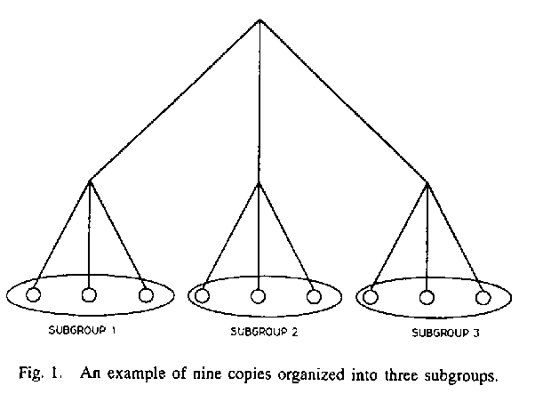
- Basic Concepts
- q_{r} + q_{w} > n, and
- 2q_{w} < n.
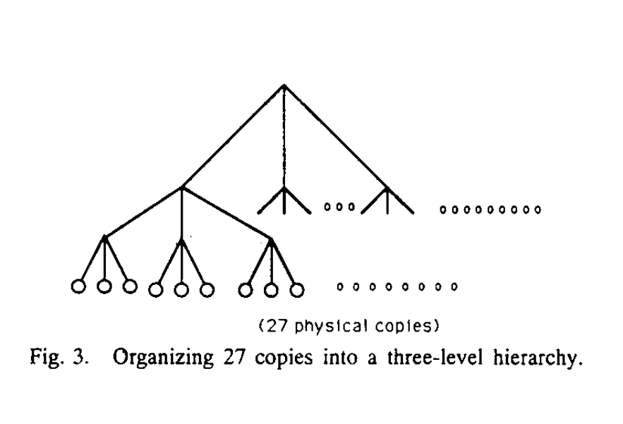
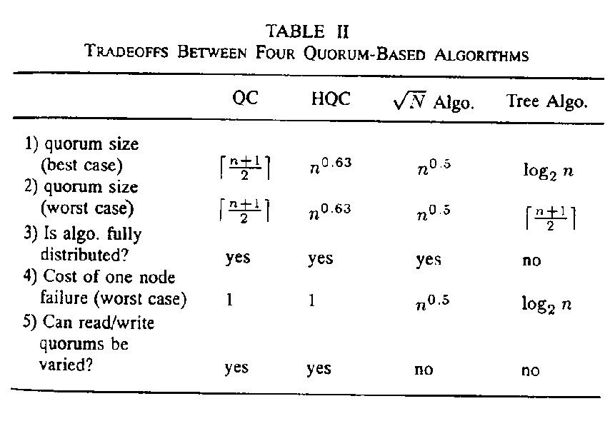
Created by : Kwo-Tsung Tseng
Date : Mar. 11, 1998

