Hybrid image coding based on partial fractal mapping
Zhou Wang, David Zhang, Yinglin Yu
Signal Processing: Image Communication, VOL. 15, 2000, pp. 767-779
Abstract
In this paper, we demonstrate that the fractal image coding algorithm is compatible with other image coding methods. In other words, we can encode only part of the image using fractal technique and model the remaining part using other algorithms. Experiments show that the proposed system performs better than quadtree-based fractal image and the JPEG image compression standard at high compression ratios larger than 30.
- Introduction
- Basic Fractal Mapping
- Partial Fractal Mapping
- A general framework for hybrid fractal-based image coding systems
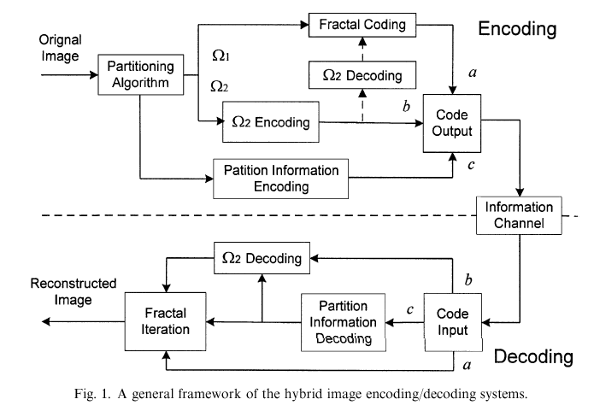
- A hybrid image coding system
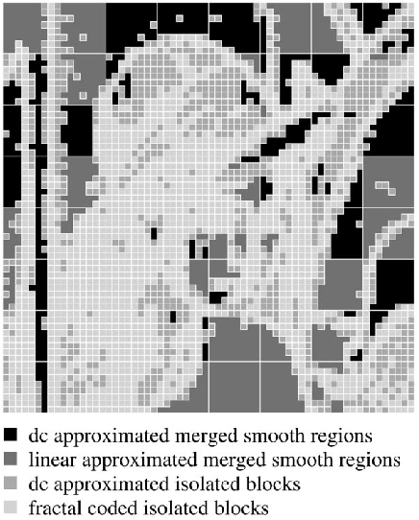
- Simulations and conclusions
 | Quadtree |  | Jpeg |  |  | Hybrid
 | Compression ratio | PSNR | Compression ratio | PSNR |  | Compression ratio | PSNR
Lena | 35.6 | 28.6 | 36.6 |  | 29.5 | 37.9 |  | 30.4
Pepper | 34.3 | 28.7 | 34.0 |  | 29.7 | 35.0 |  | 30.5
Created by : Kwo-Tsung Tseng
Date : Sep. 14, 2000

