Incrementally Extensible Folded Hypercube Graphs
Rong-Jaye Chen, and Hung-Yi Chang
Journal of Information Science and Engineering
Paper Number: JISE-PDC-04
Abstract
In this paper, we propose the incrementally extensible folded hypercube (IEFH) graph as a new class of interconnection networks for arbitrary number of nodes. We show the system is optimal fault tolerant and almost regular. The diameter of this topology is half of that of the incomplete hypercube (IH), the supercube, or the IEH graph. We also devise a simple routing algorithm for the IEFH graph and embed cycles, complete binary trees into this graph optimally.
- Introduction
- Preliminaries
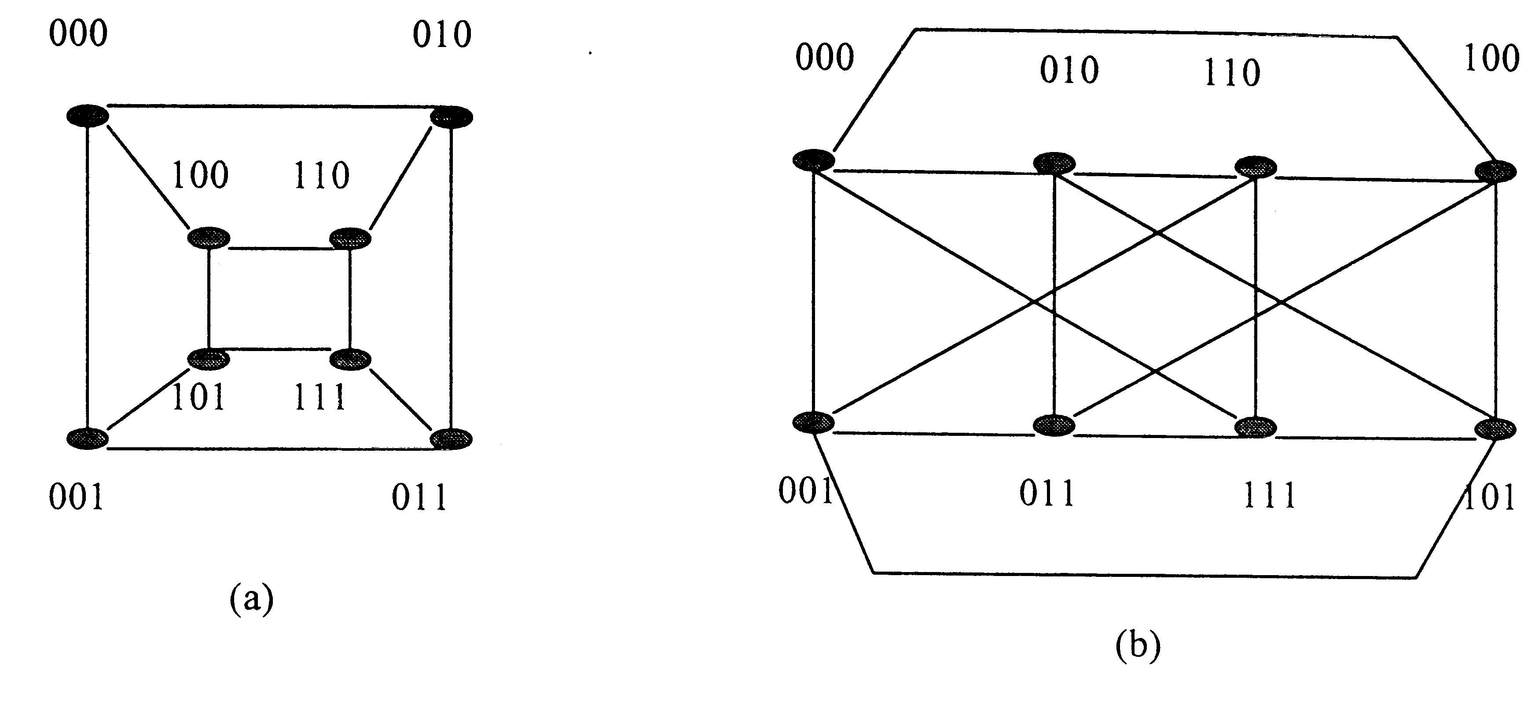
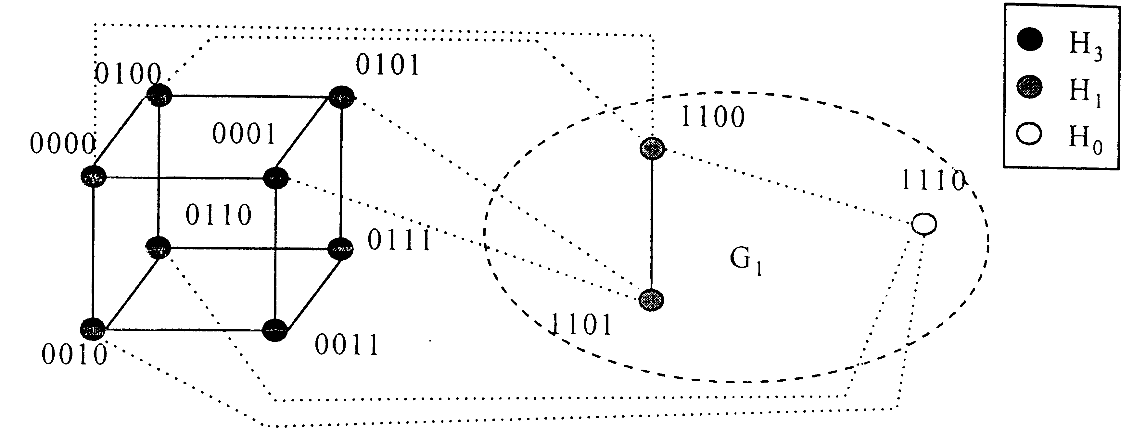
- The IEFH Graph and its Properties
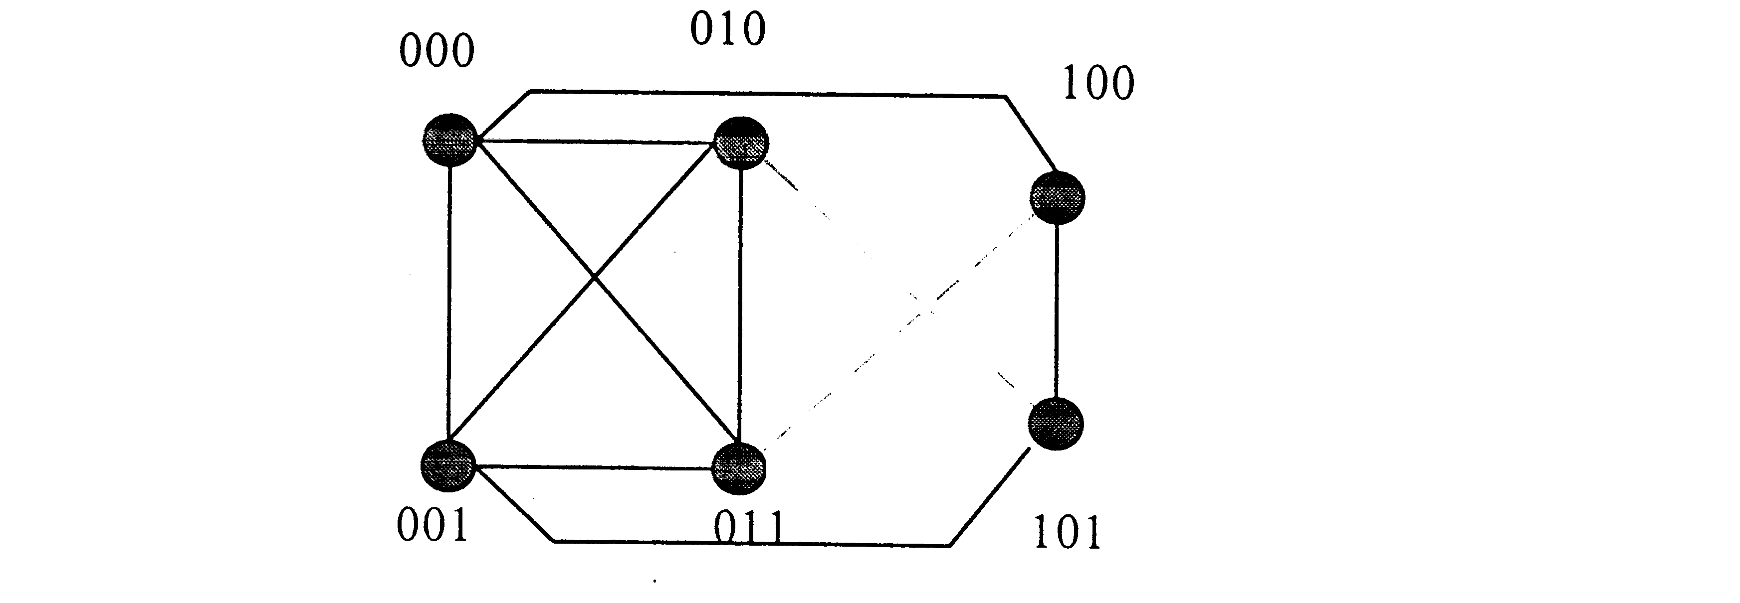
Theorem 1. The IEFH (N) graph is almost regular for 2^{n} < N ≤ 2^{n+1}. Further, the degree of each node is either n+1 or n+2.
Theorem 2. The node connectivity of an IEFH (N) graph is n+1 for 2^{n} < N ≤ 2^{n+1}. ⇒ The IEFH graph is optimal fault tolerant.
- A Simple Routing Algorithm
Theorem 4. The diameter of an IEFH (N) graph is at most ⎡n/2⎤+1 for N = ( c_{n}, …, c₁, c₀)₂.
- Embedding Graphs into IEFH Graphs
Theorem 5. The IEFH graph is Hamiltonian.
Theorem 6. A CBT_{h} can be embedded into an IEFH graph with dilation 1, congestion 1, and expansion 1.
- Conclusion
Created by : Kwo-Tsung Tseng
Date : May 11, 1999

