Constant Time Algorithms for the Transitive Closure and Some Related Graph Problems on Processor Arrays with Reconfigurable Bus Systems
Biing-Feng Wang and Gen-Huey Chen
IEEE TRANSACTIONS ON PARALLEL AND DISTRIBUTED SYSTEMS, VOL. 1, NO. 4, Oct. 1990, pp. 500-507
Abstract
In this paper, on PARBS (the processor array with a reconfigurable bus systems), two O(1) time algorithms are proposed for computing the transitive closure of an undirected graph. On is designed on three dimensional n×n×n PARBS and the other is designed on two dimensional n²×n² PARBS.
- Introduction
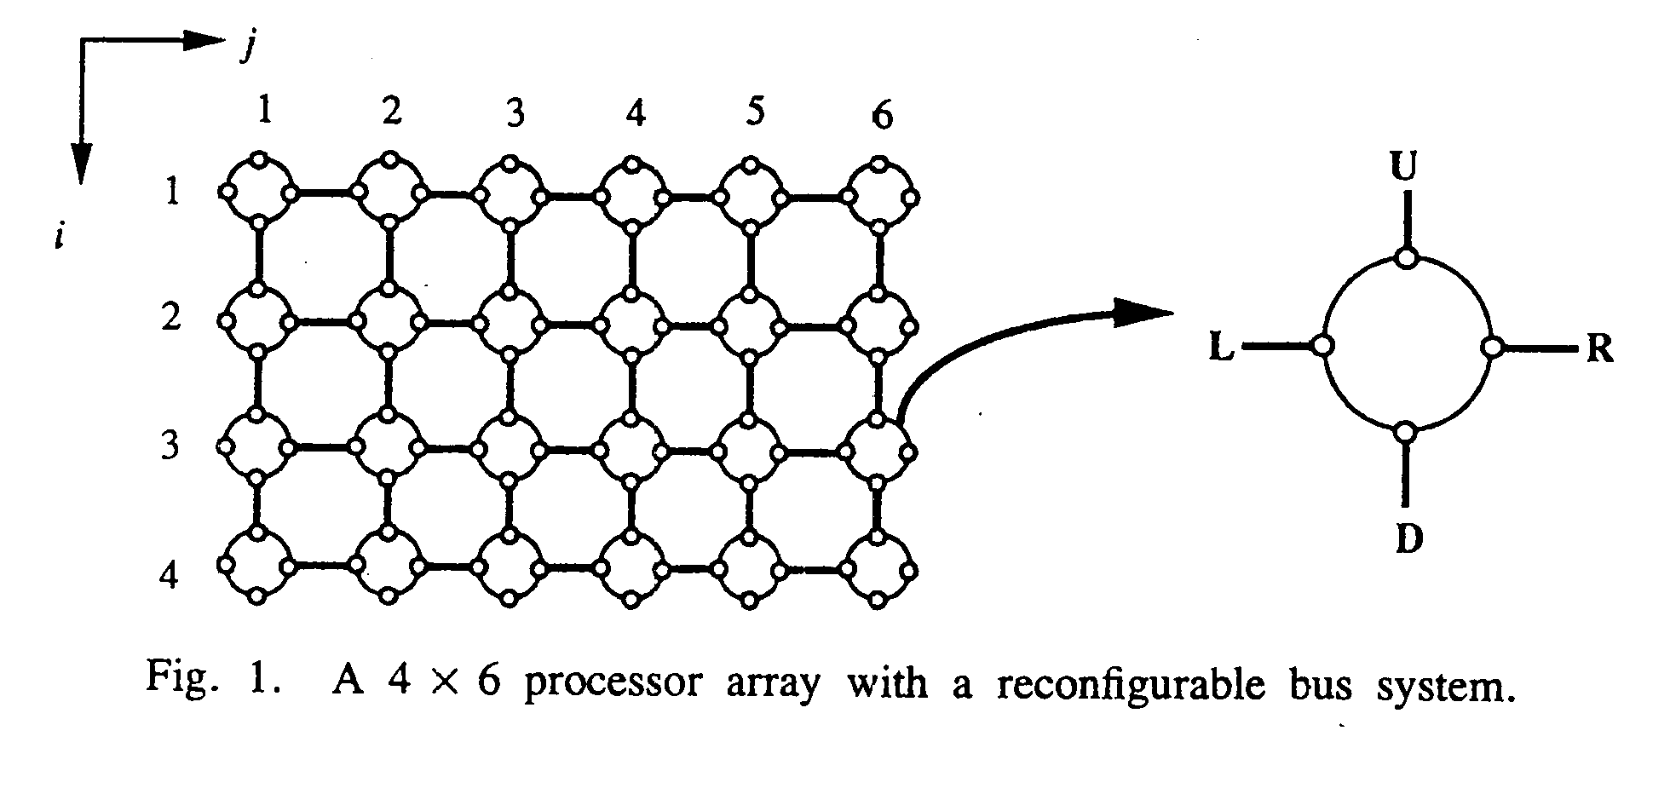
- Notations and Definitions
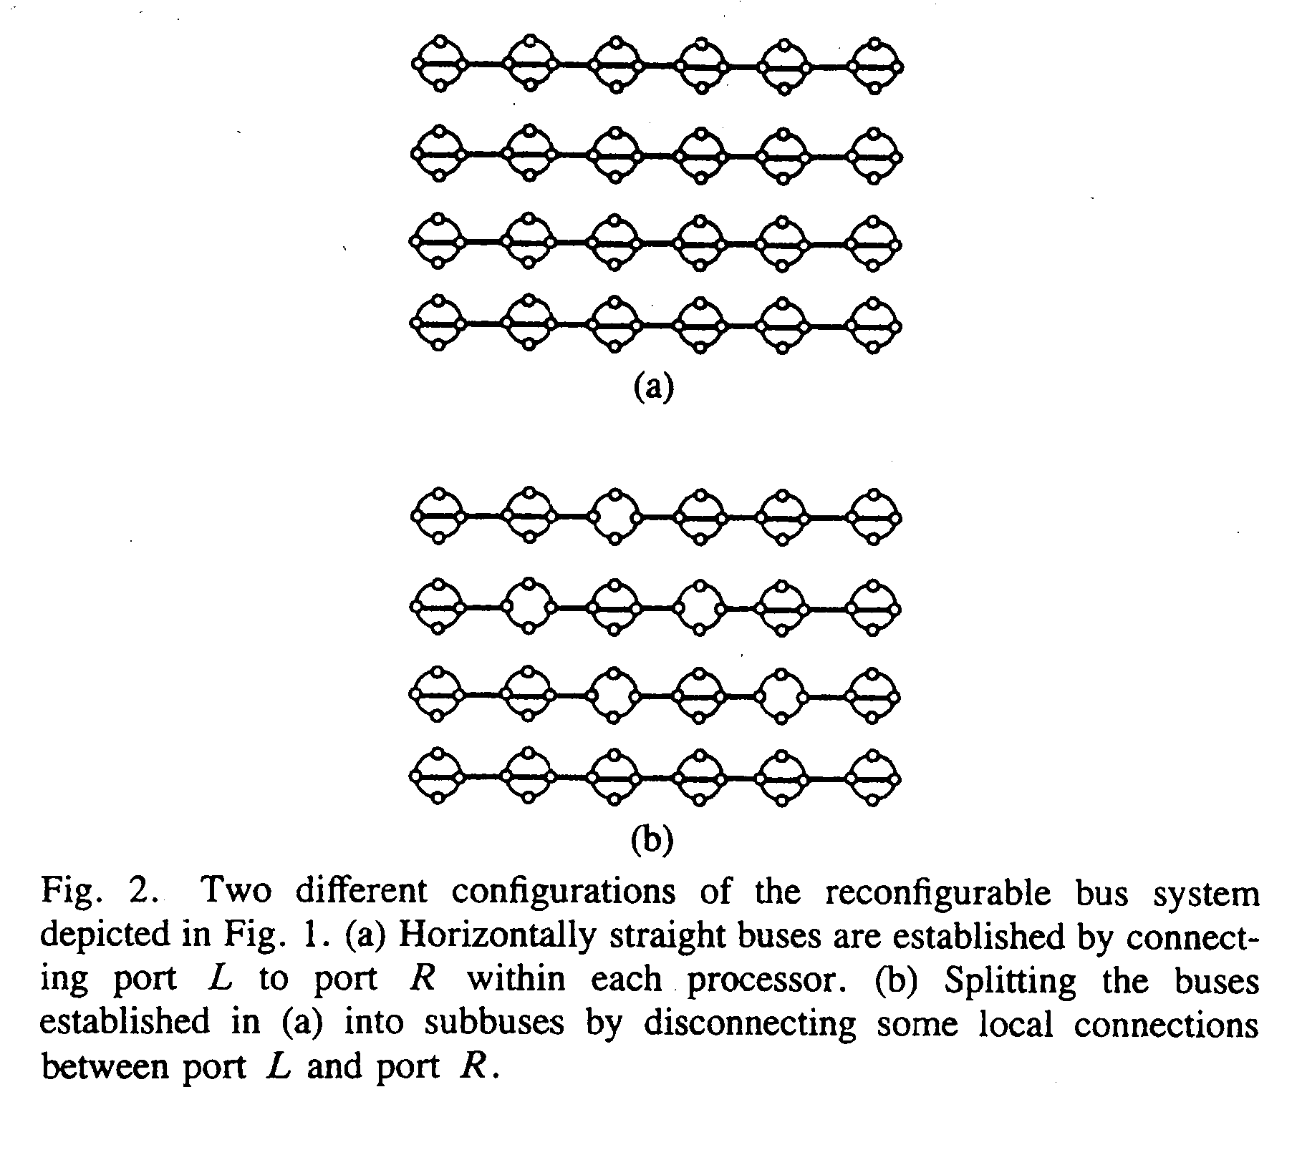
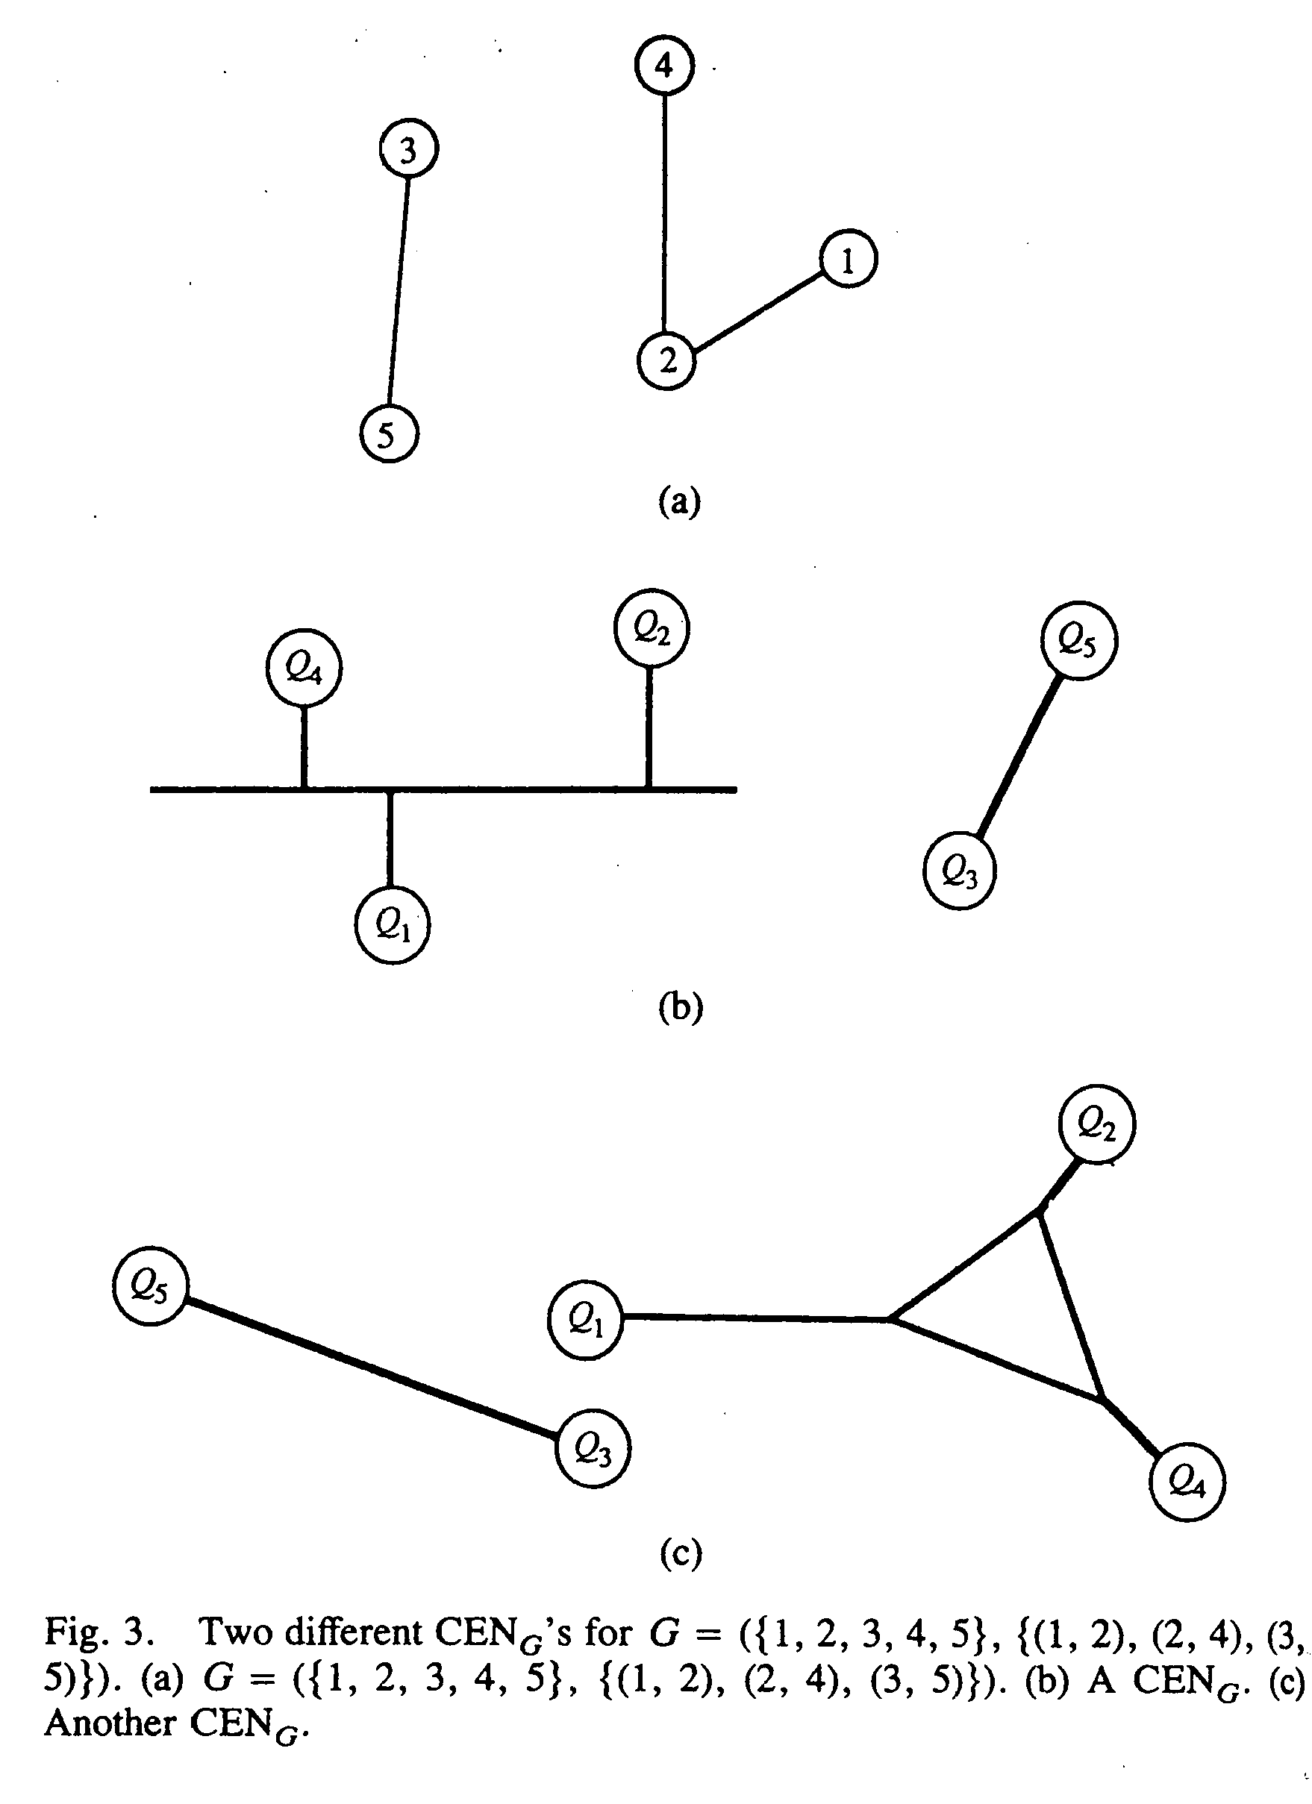
- PARBS
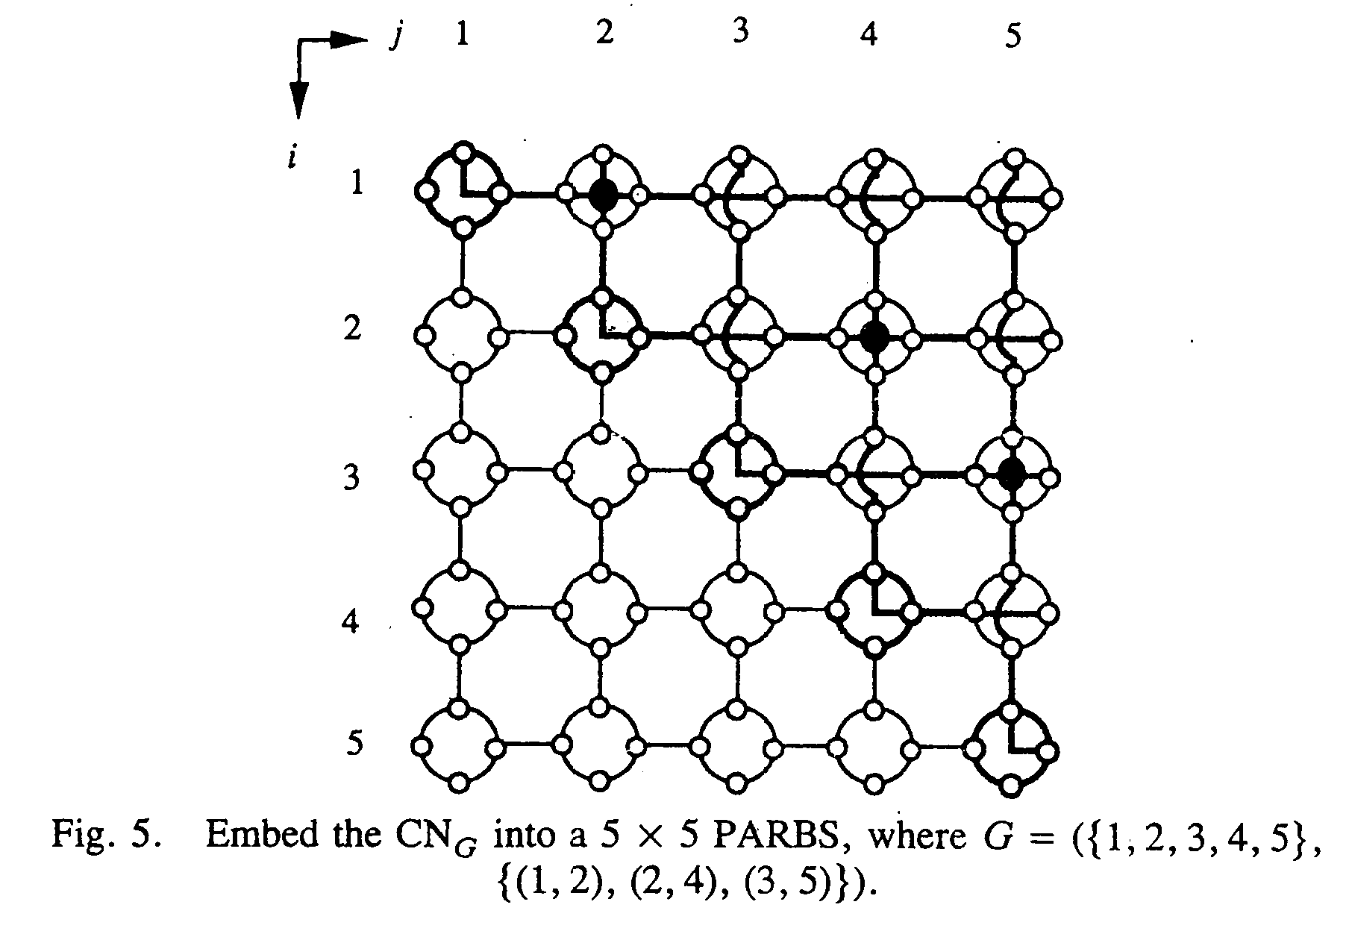
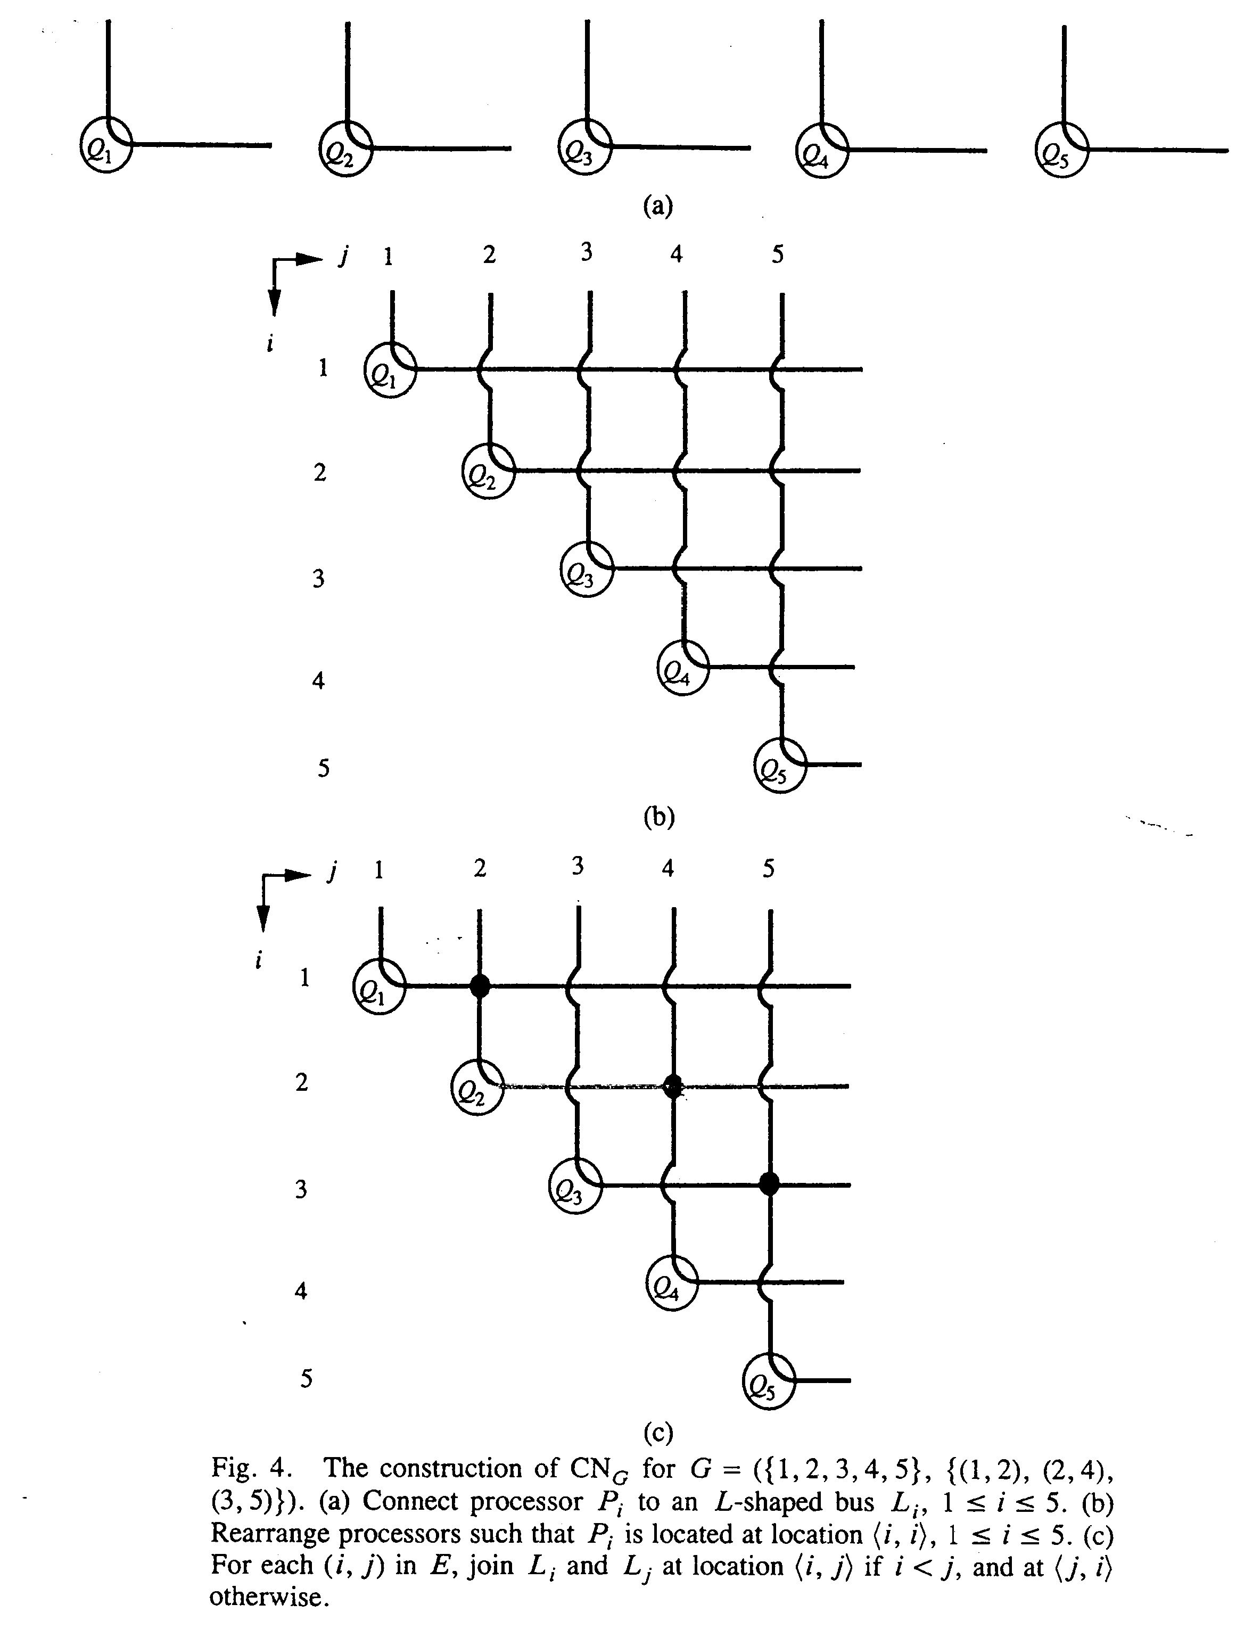
- Constant Time Algorithms for the Transitive Closure Problem
- More Applications
OR(n), AND(n), Connected(n×n), …, Connected Component(n×n×n), Bridge(n×n×(n(n-1)/2)), MST(max{n,m}×max{n,m}×m), Bipartite(n×n×n)
- Concluding Remarks
Created by : Kwo-Tsung Tseng
Date : Aug. 31, 1999

