A Comparison of Two Torus-Based K-Coteries
S. D. Lang and L.J. Mao
Parallel and Distributed Systems, 1998. Proceedings. 1998 International Conference on , 1998 Page(s): 300 –306
Abstract
In this paper, the authors extend a torus-based coterie structure for distributed mutual exclusion to allow k multiple entries in a critical session. Two extensions are proposed, the Div-Torus method and k-Torus. Numerical data suggest that k-Torus is more robust compared to Div-Torus.
- Introduction
- Related Work
- Two k-Coteries
(1) k-Torus, (2) Div-Torus, (?) Div
- Numerical Examples
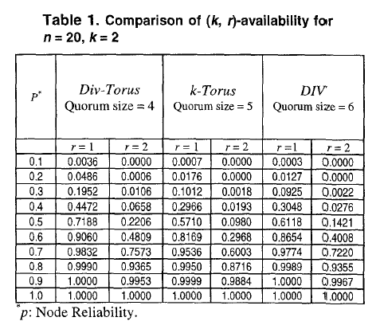
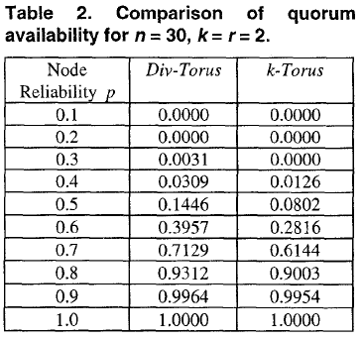
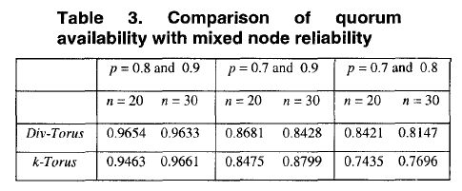
- Conclusions

Created by : Kwo-Tsung Tseng
Date : Jan. 16, 2001

