Broadcasting on Uni-directional Hypercubes
Huang-Ming Huang & Chang-Biau Yang

Abstract
The authors solve the broadcasting problem for the even dimensional uni-directional hypercube (UHC). In the constant evaluation model, the complexity of one of the presented all-port broadcasting trees is n+1, and it is optimal. An all-port fault-tolerant broadcasting tree with height 3/2n + (n mod 4)/2 is also proposed.
- Preliminary
Polarity(B, i) = sign of (-1)^{(bn-1+bn-2+…+b1+b0+i)}
Positive→Out-Port; Otherwise→In-Port.
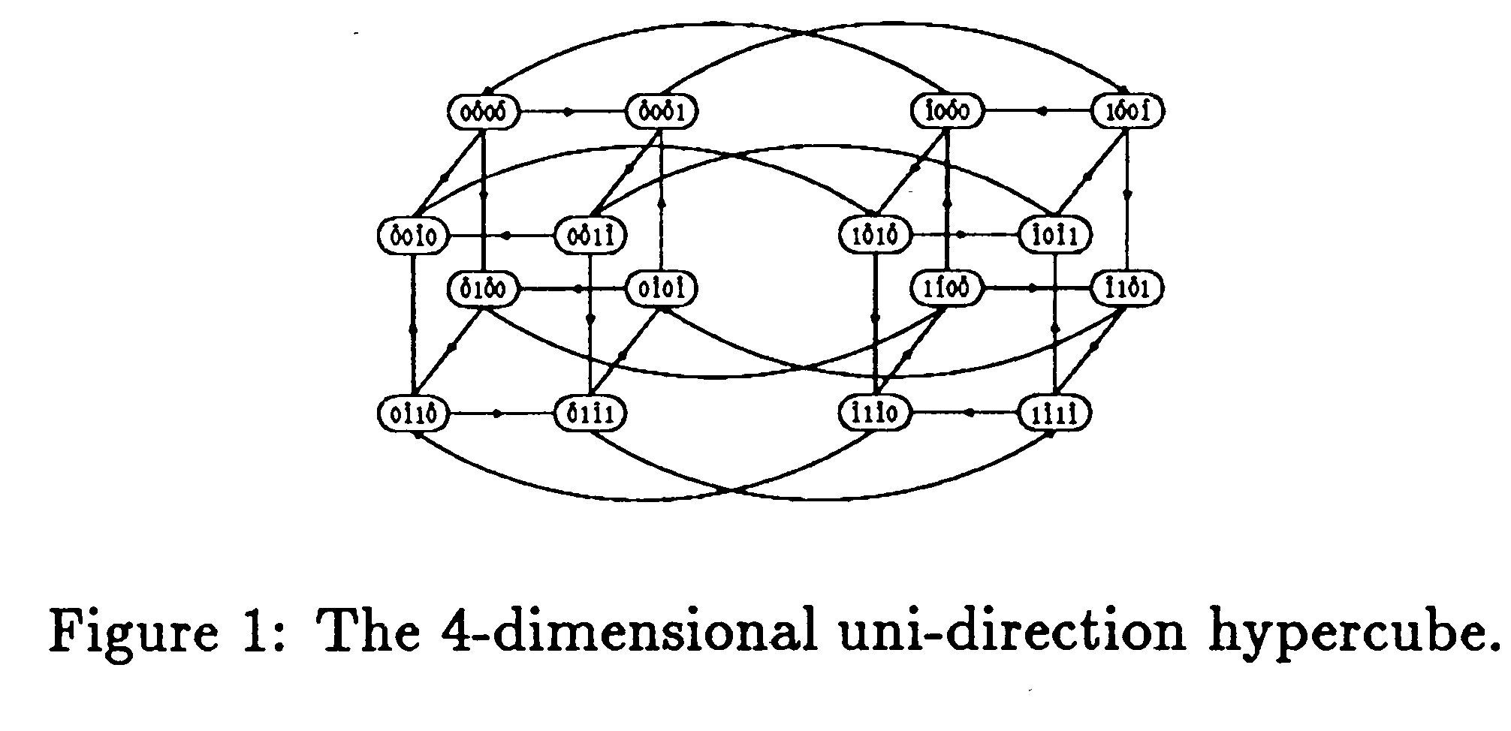
- Node Symmetric Property of UHC
- Broadcasting Trees
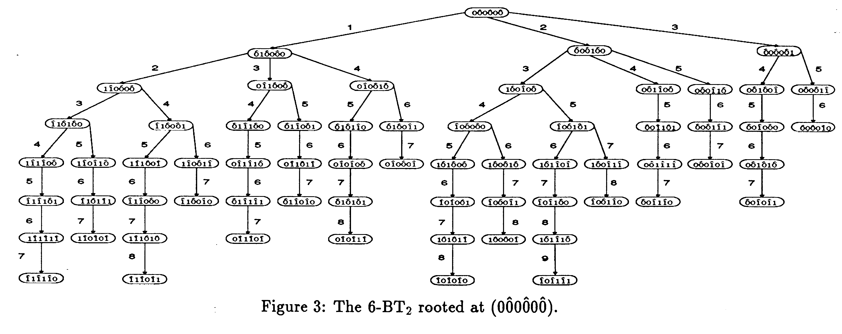
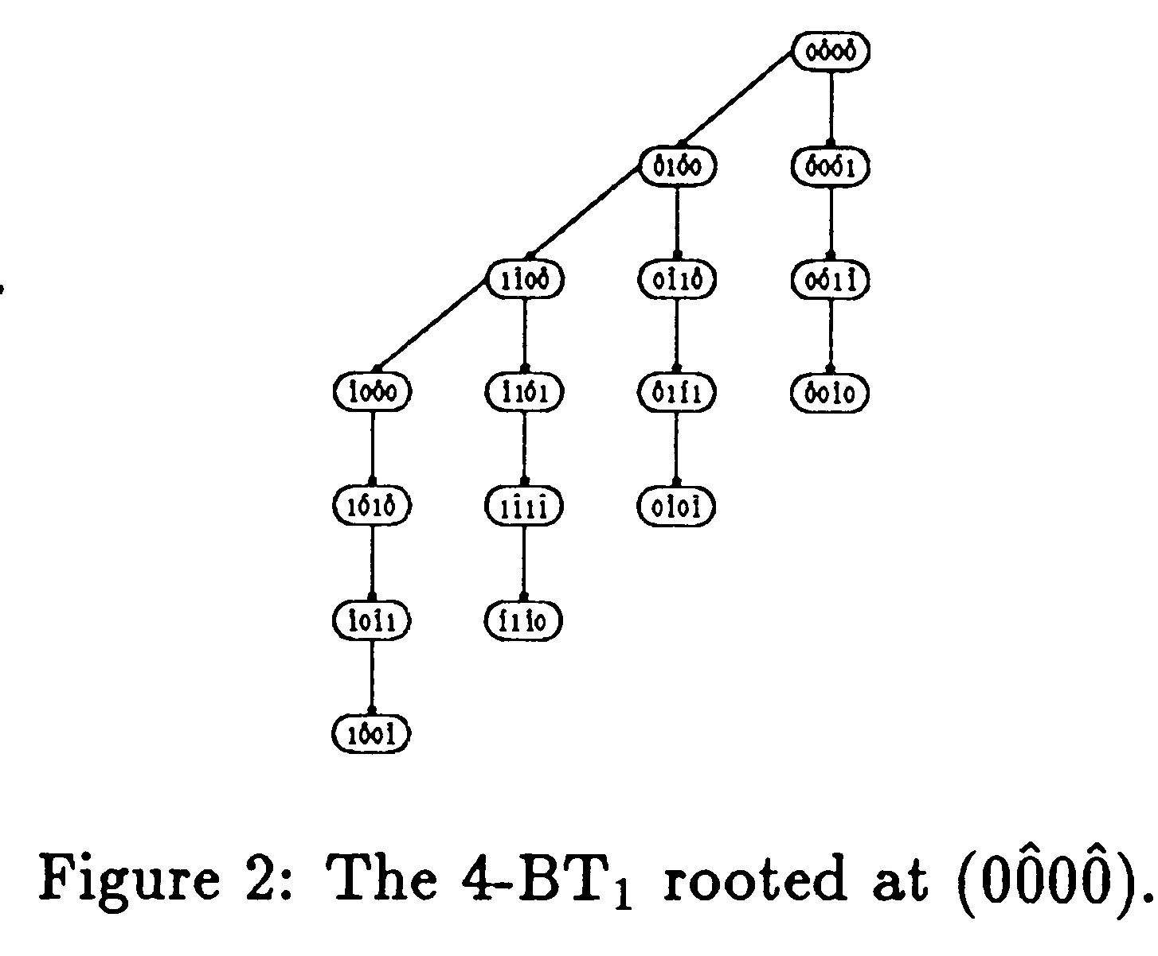
- Constructing Algorithms for the Broadcasting Trees
- Broadcasting in the Odd Dimensional UHC
- A Fault-Tolerant Broadcasting Trees
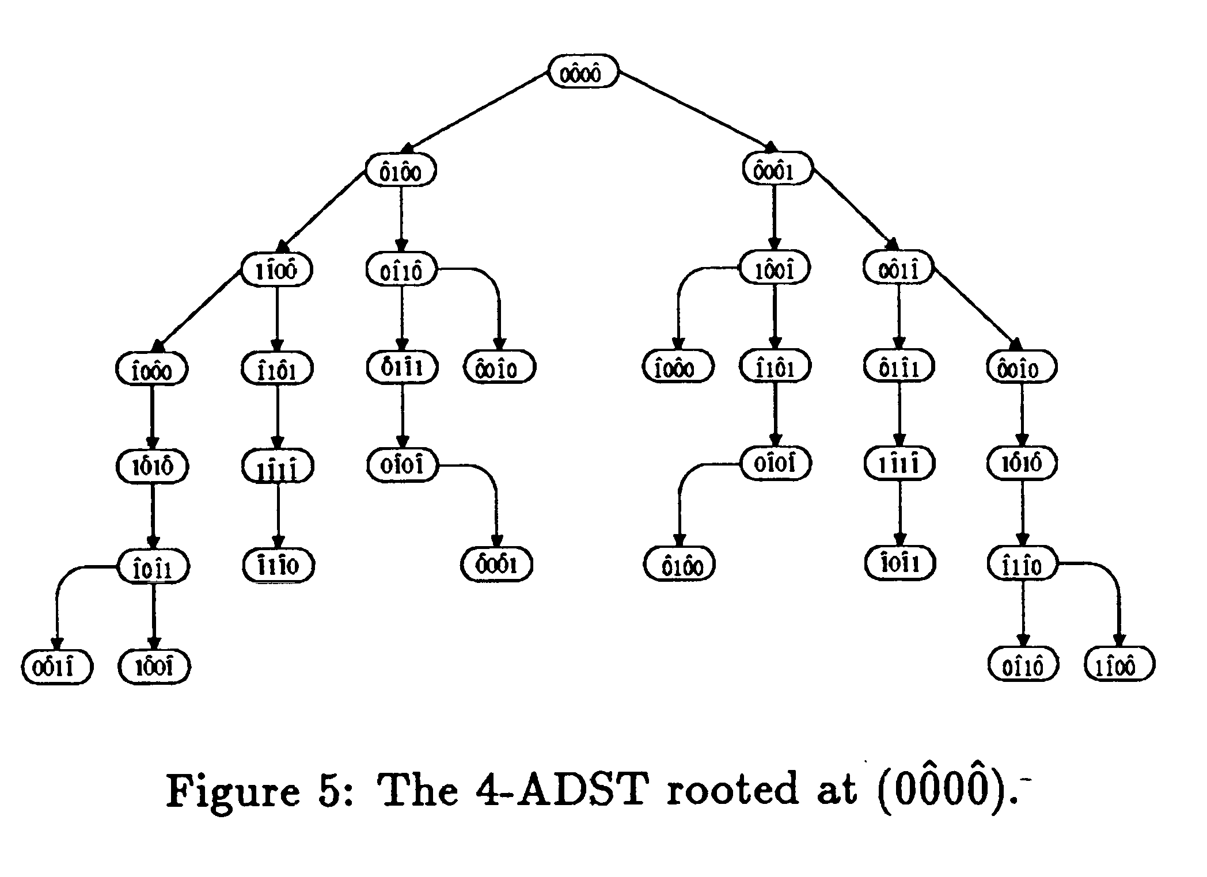
- Performance Analysis
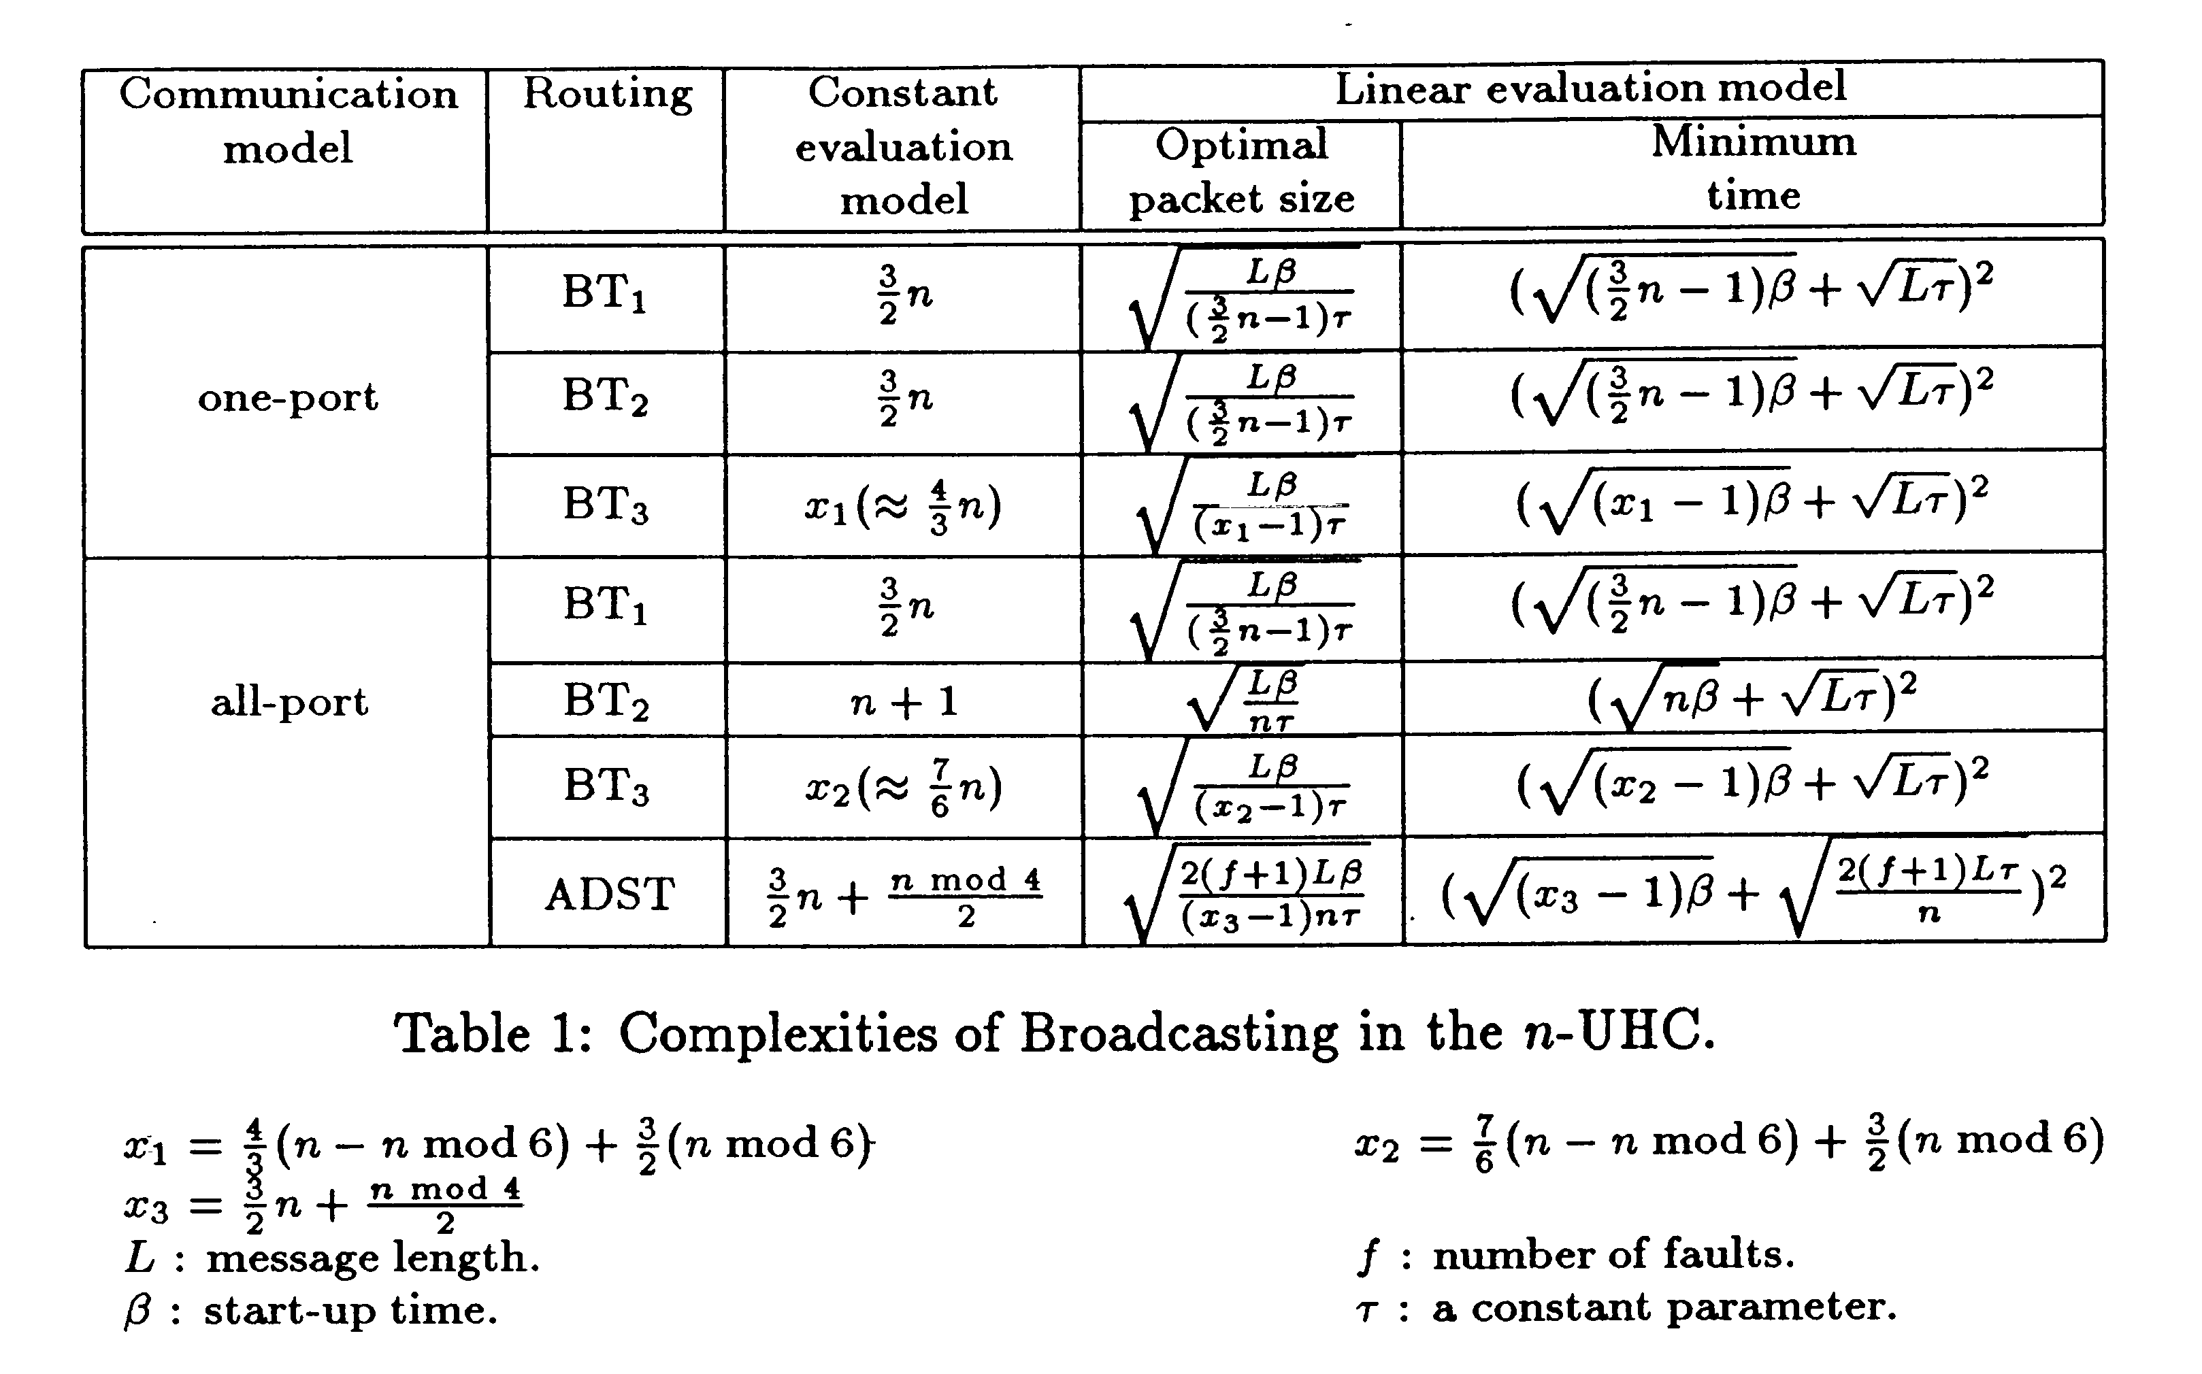
- Conclusions
Created by : Kwo-Tsung Tseng
Date : Dec. 23, 1999

