Region-Based Fractal Image Compression Using Heuristic Search

Lester Thomas and Farzin Deravi
IEEE TRANSACTIONS ON IMAGE PROCESSING, VOL. 4, NO. 6, June 1995 pp.832-833
Abstract
The algorithms described in this paper utilized a novel region-based partition of the image that greatly increases the compression ratios achieved over traditional block-based pa98
rtition.The result show that the region-based system acheives almost double the compression ratio of the simple block-based system at a similar decompressed image quality. For the Lena image, compression ratio of 41:1 can be acheived at a PSNR of 26.56 dB.
Introduction
New Approach
Heuristic Search Algorithms
Simple Heuristic Algorithm
Adaptive Transformation Algorithm
Competitive Algorithm
Summary
Decoding
Results

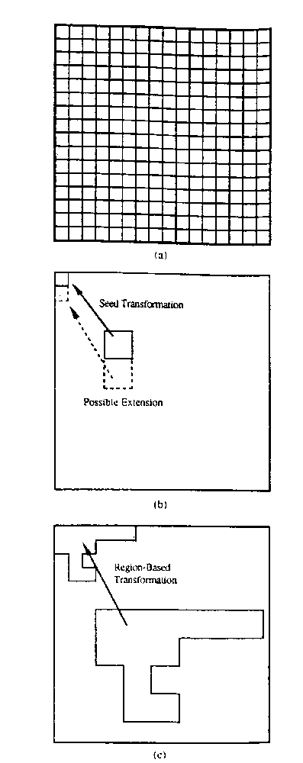

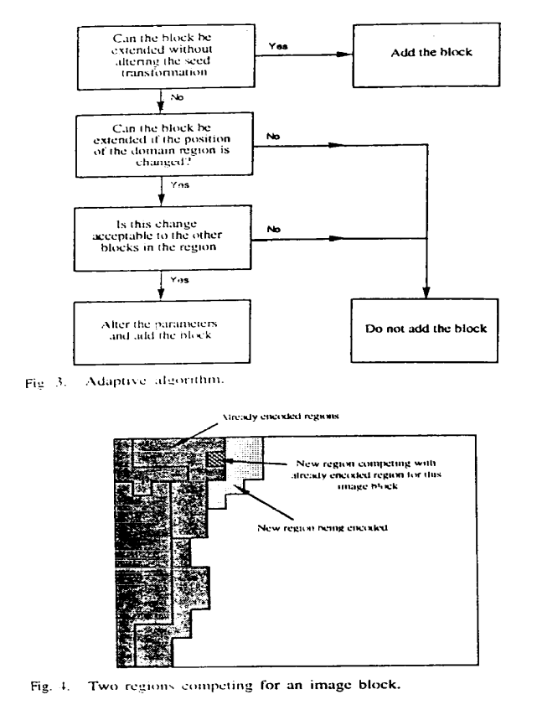

Band
widt
h
FIC-B
FIC-ACP

Transformations
105912 bits
424
99 bits  Shape Inf.  0 bits  8604 bits  Total  105912 bits  51103 bits  Comp. ratio | 19:1  41:1  PSNR  27.86 dB  26.56 dB  Original Seed B  5422 Sec.  2458 Sec. | RegionGrowing  0 Sec.  20 Sec.  Total  5422 Sec.
2478 Sec.

Created by : Kwo-Tsung TsengDate : Apr. 29, 19

