ON DESIGNING COMMUNICATION-INTENSIVE ALGORITHMS FOR A SPANNING OPTICAL BUS BASED ARRAY

CHUNMING QIAO
Electrical and Computer Engineering Department State University of New York at Buffalo, Amhersi, NY 14260
Parallel Processing Letters Vol. 5 No. 3 (1995) 499-511

ABSTRACT

The Reconfigurable Array with Spanning Optical Buses ( or RASOB ) architecture provides flexible reconfiguration and strong connectivities with low hardware and control complexities. We use a parallel implementation of the matrix transposition as well as multiplication algorithms as an example to show how the architectural capabilities can be taken advantage of in designing parallel algorithms.

1. Introduction

2. Architectural

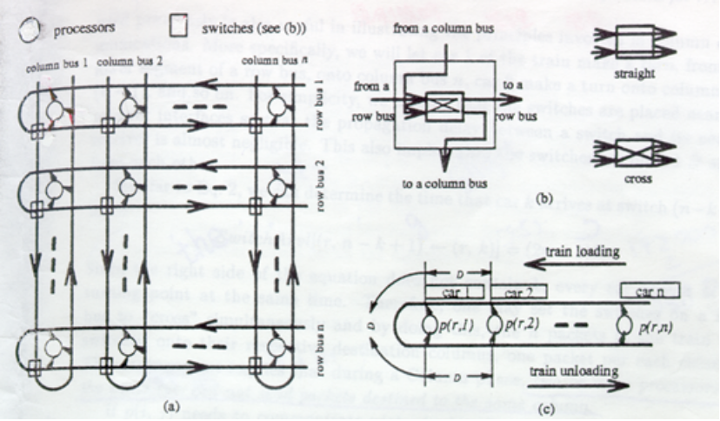

2.1. Software Reconfiguration

RowSend[(r, i) → (r, j)] = (i - 1)D + (n - i)D = (n - 1)D.
RowRec[(r, i) ← (r, j)] = (n - 1)D + (i + j - 1)D = (n + i + j - i)D.

2.2. Hardware Reconfiguration

SwitchArvl[(r, n - k + 1) ← (r, k)] = (2n - 1)D.
ColSend[(i, j) → (r, k)] = (n - k)D + (n - j)D = (2n - j - k)D.
ColRec[(r, k) ← (r, i)] = (4n - i - r)D.

2.3. Connectivity and Complexity

3. Algorithm Development

3.1. Matrix Transposition

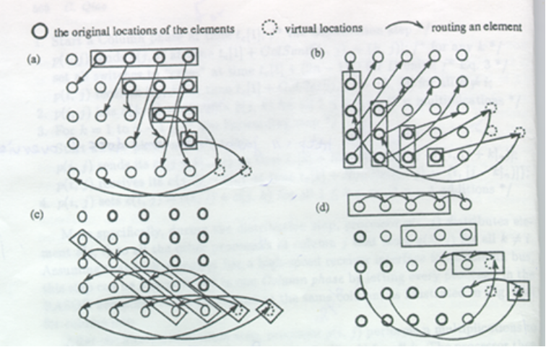

3.2. Matrix Multiplication

4. Concluding Remarks

Created by : Jong-Rong Shi

Date : Oct. 8, 1999

