Work-Efficient Routing Algorithms for Rearrangeable Symmetrical Networks
Hasan Çam and José A.B. Fortes, Fellow, IEEE
IEEE TRANSACTIONS ON PARALLEL AND DISTRIBUTED SYSTEMS, VOL. 10, NO. 7, JULY 1999, pp.733-741

Abstract

1 INTRODUCTION
2 BASIC DEFINITIONS
Definition 2.1 (Permutation matrix, identity permutation matrix, reverse permutation matrix).
Definition 2.2 (Balanced matrix).
As an example, two balanced matrices E and H are shown below. Notice that the matrix [E H] is not balanced.
E = [e₁ e₂ e₃] = 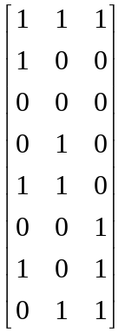 H = [h₁ h₂] = 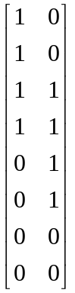
Definition 2.3 (Perfect matching graph of a balanced matrix).
Definition 2.4 (2-coloring).

3 BASIC ALGORITHM

Algorithm COLUMN
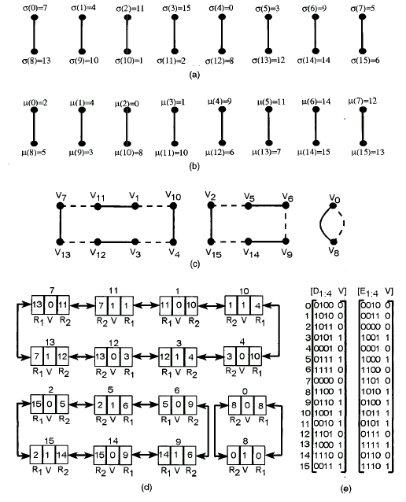
Fig 1. (a) PG_{D}, the perfect matching graph of D_{2:4}. (b) PG_{E}. The perfect matching graph of E_{2:4}. The numbers on an edge refer to the labels of its vertices. (c) PG_{D∪E}, the union of PG_{D} and PG_{E}. (d) All the cycles of
PG_{D∪E} are represented by circular doubly linked lists. The field V of each node contains the integer assigned to it in a 2-coloring of the cycle. R₁ and R₂ are the pointer fields. The number on the top of a node is the node’s label. (e) The matrices [D_{1:4} V] and [E_{1:4} V].

4 A WORK-EFFICIENT ROUTING ALGORITHM FOR BENES NETWORK

Algorithm BENES
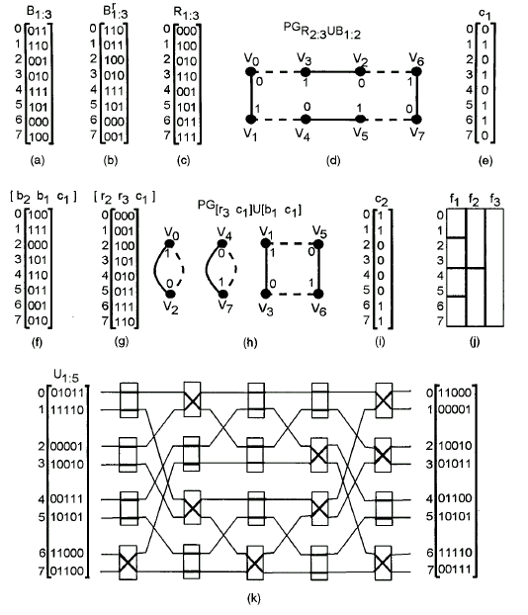
Fig. 2. (a) B_{1:3} = [b₁ b₂ b₃], the binary representation of given permutation b = (0 3 2 1 6)(4 7)(5), (b) B_{1:3}^{r} = [b₃ b₂ b₁], (c) R_{1:3} = [r₁ r₂ r₃], (d) PG_{R2:3∪B1:2}, (e) c₁ obtained from a 2-coloring of PG_{R2:3∪B1:2}, (f) [b₂ b₁ c₁], (g) [r₂ r₃ c₁], (h) PG_{[r3 c1] ∪[b1 c1]}, (i) c₂ obtained from a 2-coloring of PG_{[r3 c1][b1 c1]}, (j) a frame of eight rows and three columns, (k) U_{1:5} = [c₁ c₂ b₁ b₂ b₃] and the Benes network with eight inputs/outputs.

5 CONCLUSIONS
Any previously known algorithm is at least O(Nn²).
But, the work of the parallel routing algorithms presented in this paper is O(Nn).

Created by : Jong-Rong Shi
Date : Jan. 6, 2000

