A Simple Voronoi Diagram Algorithm for a Reconfigurable Mesh

Hossam ElGindy and Lachian Wetherall
IEEE TRANSACTIONS ON PARALLEL AND DISTRIBUTED SYSTEMS, VOL. 8, NO. 11, NOVEMBER 1997

Abstract
In this paper, we introduce a simple and efficient algorithm for computing the Voronoi Diagram for n planar points on a reconfigurable mesh of size O(n) × O(n). The algorithm has a worst case running of O(log n log log n) time. The algorithm exploits the O(1) communication diameter of the reconfigurable mesh model to implement efficient load balancing.

1 INTRODUCTION

2 THE MODEL
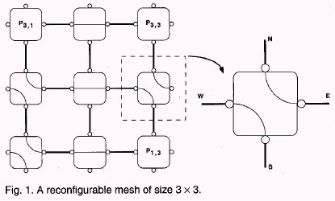
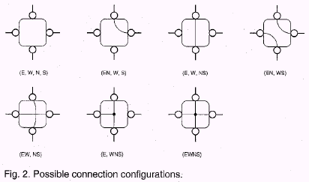

3 THE ALGORITHM
Probe North and South in each region
Compute P, the set of provisional vertices
While |P| > 0 do
Probe each p P to
- find a new edge e (and e’)
OR
- confirm a vertex v (and v’, v’’)
Compute P, the set of provisional vertices
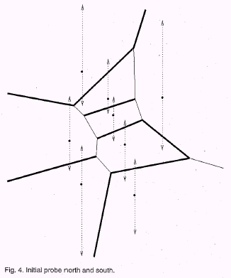
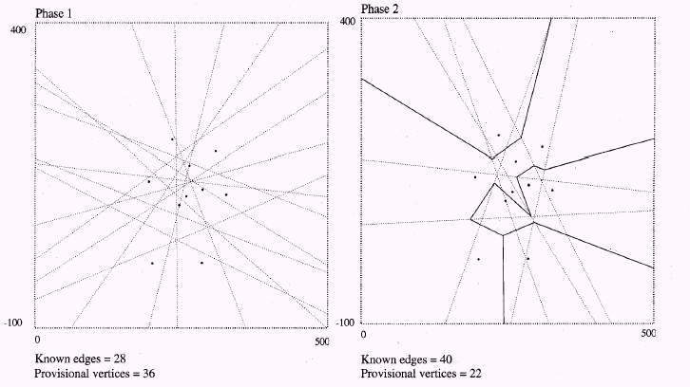
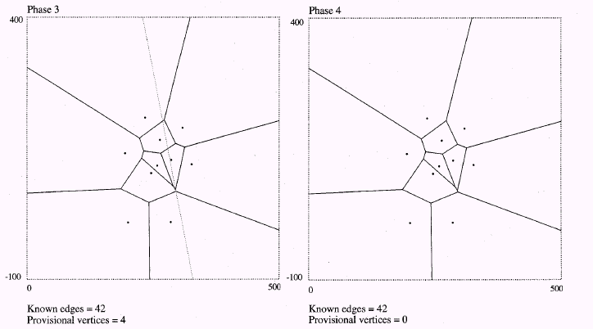

4 CONCLUDING REMARKS

Created by : Jong-Rong Shi

Date : Feb. 25, 2000

