Latin Squares for Parallel Array Access
Kichul Kim, Member, IEEE, and Viktor K. Prasanna, Senior Member, IEEE
IEEE TRANSACTIONS ON PARALLEL AND DISTRIBUTED SYSTEMS, VOL. 4, NO. 4, APRIL 1993

Abstract

INTRODUCTION
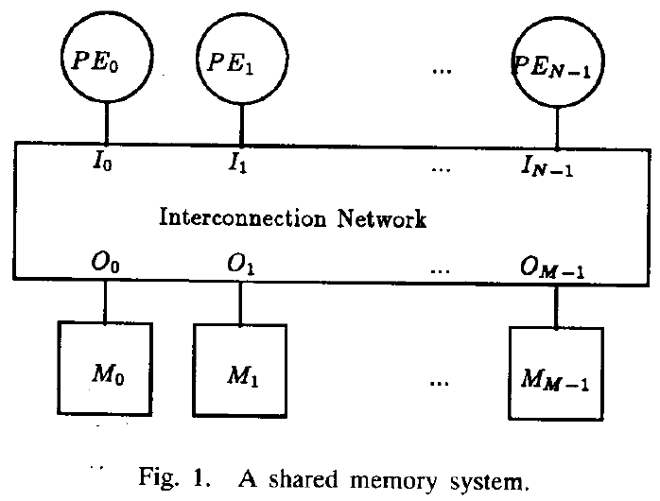
- LATIN SQUARES FOR PARALLEL ARRAY ACCESS
A latin square of order 4 : A = 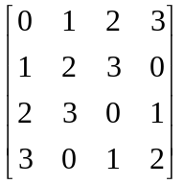
A diagonal latin square of order 4 : B = 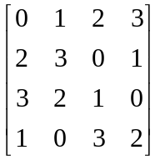
A perfect latin square of order 9 : E = 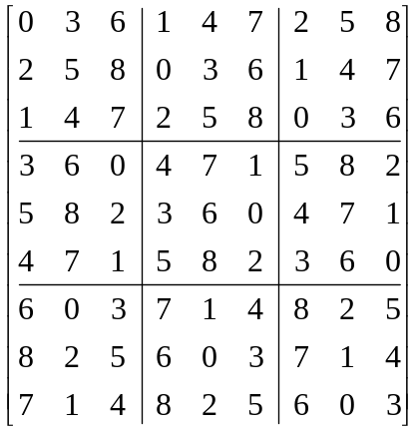
- CONSTRUCTION OF PERFECT LATIN SQUARES
A = 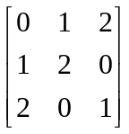 B = 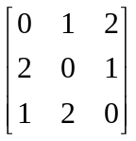
A is orthogonal to the transpose of B and the antitranspose of B.

C=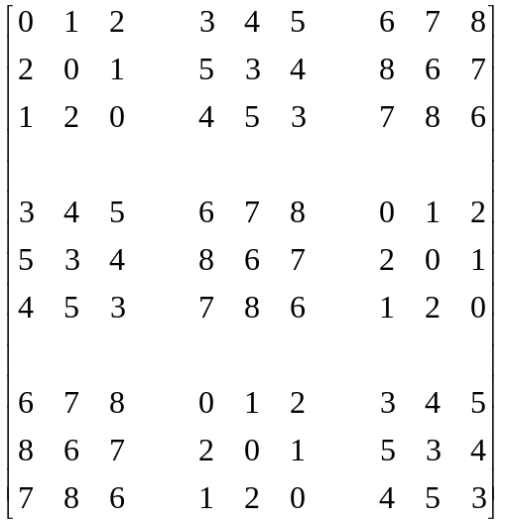P=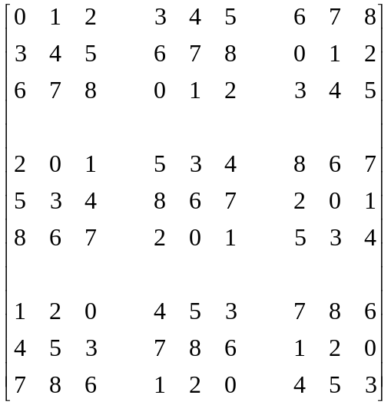

ADDRESS GENERATION

- SELF-ROUTING FOR PERFECT LATIN SQUARES
Benes networks.
- EFFICIENT ACCESS TO THREE-DIMENSIONAL ARRAYS
Skewing scheme Φ : Give an N × N × N array A = (a_{i,j,k}), where N^{1/3} = n = 2^{k}.
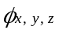 = 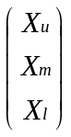 + 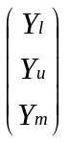 + 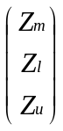
Skewing scheme Ψ : Give an N × N × N array A, where N = 2^{k} .
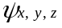 = 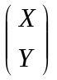 + 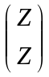

CONCLUSION

Created by : Jong-Rong Shi

Date : Mar. 7, 2000

