Latin Squares for Parallel Array Access
Kichul Kim, Member, IEEE, and Viktor K. Prasanna, Senior Member, IEEE
IEEE TRANSACTIONS ON PARALLEL AND DISTRIBUTED SYSTEMS, VOL. 4, NO. 4, APRIL 1993

Abstract

INTRODUCTION
- LATIN SQUARES FOR PARALLEL ARRAY ACCESS
Latin square.
Diagonal latin square.
Perfect latin square.
- CONSTRUCTION OF PERFECT LATIN SQUARES
Orthogonal :
A=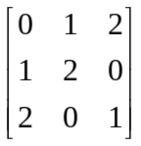 B=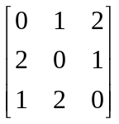 AB^{T} =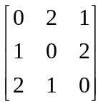=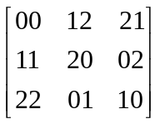
Self-orthogonal latin square : X is orthogonal to the transpose of X.
Doubly self-orthogonal latin square : X is orthogonal to the transpose of X. and to the antitranspose of X.
C=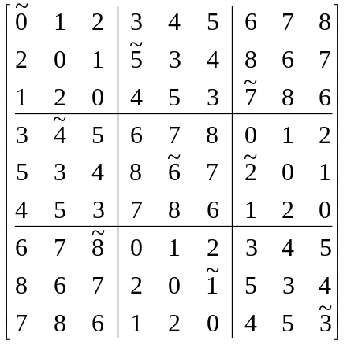P=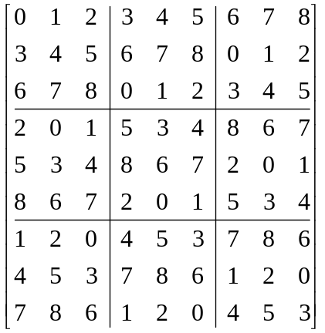

ADDRESS GENERATION
  - when k is even, for all m, 0 ≦ m ≦ k – 1,
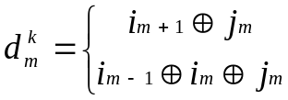
  - when k is odd, we have
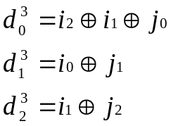
and for all m, 3 ≦ m ≦ k – 1,
Ex :
 | 00 | 01 | 10 | 11
00 | 00 = 0 | 10 = 2 | 11 = 3 | 01 = 1
01 | 01 = 1 | 11 = 3 | 10 = 2 | 00 = 0
10 | 10 = 2 | 00 = 0 | 01 = 1 | 11 = 3
11 | 11 = 3 | 01 = 1 | 00 = 0 | 10 = 2

- SELF-ROUTING FOR PERFECT LATIN SQUARES
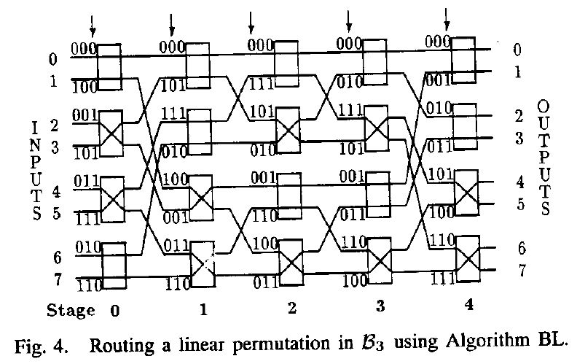
Definition 1 : O = P × I + C.
Definition 2 : O = L × I + C.
P : A permutation matrix.
L : A nonsingular binary matrix.
C : A binary vector.
- EFFICIENT ACCESS TO THREE-DIMENSIONAL ARRAYS
Skewing scheme Φ : 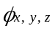 = 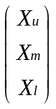 + 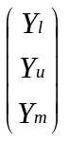 + 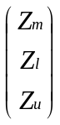
Ex : x = 40, y = 50, z = 60.
X = 101000, Xu = 10, Xm = 10, Xl = 00
Y = 110010, Yu = 11, Ym = 00, Yl = 10

Z = 111100, Zu = 11, Zm = 11, Zl = 00
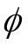_{40,50,60} = 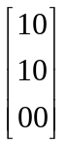 + 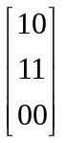 + 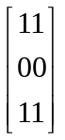 = 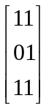 = 110111₂ = 55
Skewing scheme Ψ : 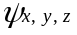 = 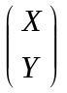 + 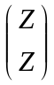
Ex :
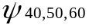 = 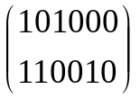 + 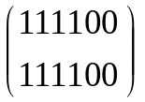 = 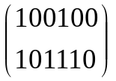

CONCLUSION

Created by : Jong-Rong Shi

Date : Mar. 14, 2000

