Broadcast-Efficient Algorithms on the Coarse-Grain Broadcast Communication Model with Few Channels
Koji Nakano, Stephan Olariu, and James L. Schwing
In Proc. 12th IEEE International Parallel Processing Symposium and 9th IEEE Symposium on Parallel and Distributed Processing (IPPS/SPDP’98), Orlando, Florida, April 1998.

Abstract

1 Introduction
Braodcasting Communication Model (BCM).
BCM(p, k) : p processors and k channels.

2 Off-Line Permutation Routing
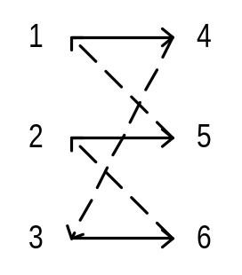
Lemma 2.1 For any p >= 1, a p-regular bipartite graph is always p-edge-colorable.

3 On-Line Permutation Routing

4 Ranking and Sorting on a BCM
4.1 Our Sampling Scheme
Step 1 :
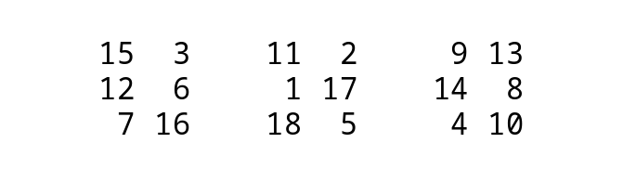
Step 2 :
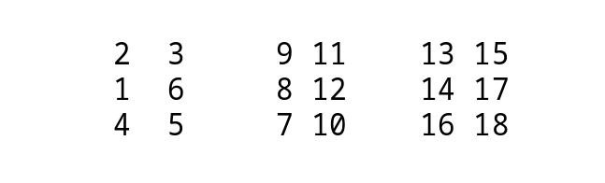
Step 3 :
2, 9, 13, 1, 8, 14, 4, 7, 16
Step 4 :
1, 2, 4, 7, 8, 9, 13, 14, 16
4.2 Our Ranking and Sorting Algorithms

Created by : Jong-Rong Shi
Date : Apr. 18, 2000

