Parallel N-ary Speculative Computation of Simulated Annealing

Andrew Sohn, Member, IEEE
IEEE TRANSACTIONS ON PARALLEL AND DISTRIBUTED SYSTEMS, VOL. 6, NO. 10, OCTOBER 1995

Abstract
Simulated annealing is known to be an efficient method for combinatorial optimization problems. Its usage for realistic problem size, however, has been limited by the long execution time due to its sequence nature.

INTRODUCTION

BINARY SPECULATIVE COMPUTATION
Sequential simulated annealing :
T←T₀ ;initial temperature
for i = 1 to ncity do ;i-loop
for j = 1 to ncity² do ;j-loop
1: △E←evaluate(DATA, i, j) ;Compute △E
2: flagdecide(△E, T_{j}) ;Decide
3: DATA←modify(DATA, flag) ;Modify DATA if OK
T←T*CS ;Lower temperature
Note: flag={OK, NOK} CS=cooling speed.
- GENERALIZED N-ARY SPECULATIVE COMPUTATION
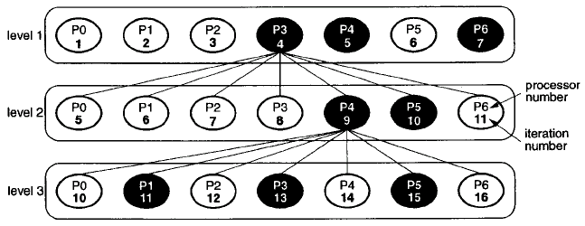
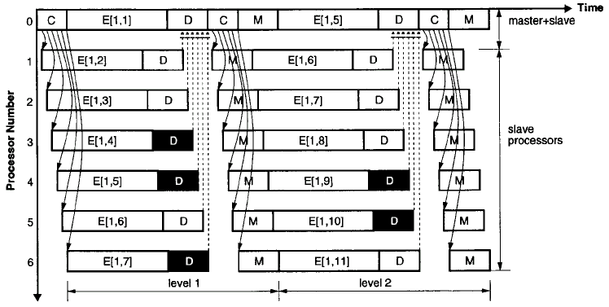

EXPERIMENT RESULTS
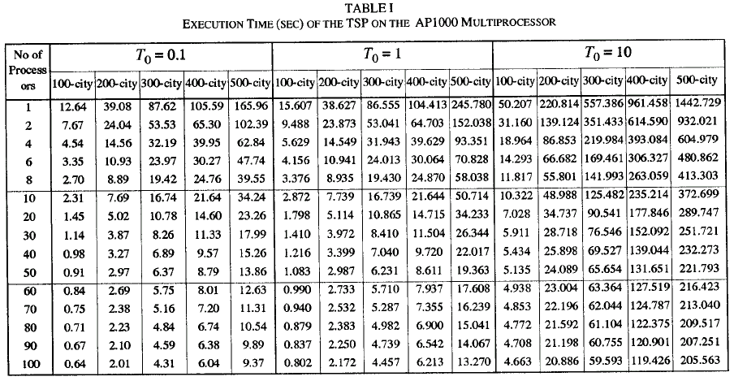
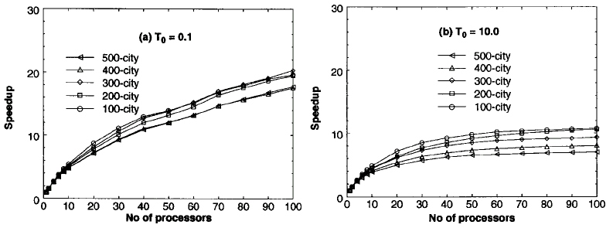

PERFORMANCE EVALUATION AND DISCUSSION
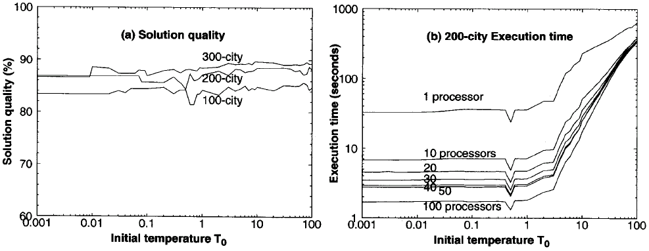

CONCLUSIONS

Created by : Jong-Rong Shi

Date : May 10, 2000

