Progressive Multiple Alignment with Constraints

Gene Myers, Sanford Selznick, Zheng Zhang, and Webb Miller
Proceedings of the first annual international conference on Computational molecular biology , 1997, Pages 220 - 225

Abstract
- Introduction
- Constraints
i_{s} ＜ j_{t}.
i_{s} ≦ j_{t}.
- A Consistency
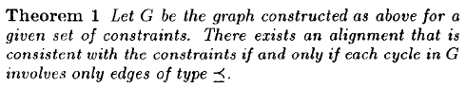
- Transitively Implied Constraints
- Constrained Pairwise Alignment
- Prime Constraints
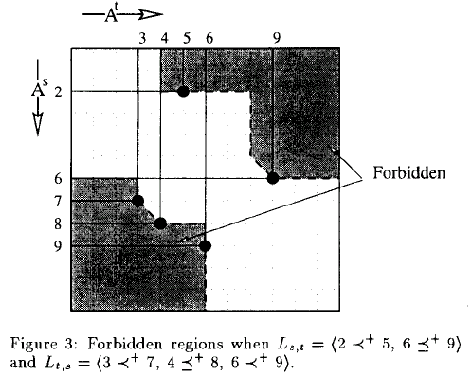
- An O(K+C) Prime Constraint Algorithm
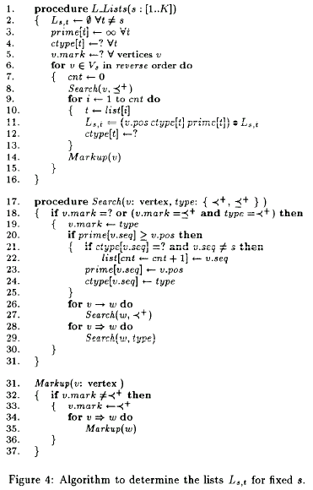
- A Multiple Alignment Algorithm
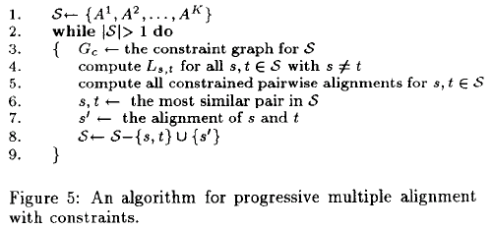
- An Implementation
- An Example

Create by : Jong-Rong Shi

Date : May 31, 2000

