Fast multiple alignment of ungapped DNA sequences using information theory and a relaxation method

Thomas D. Schneider, David N. Mastronarde

Discrete Applied Mathematics 71 (1996) 259-268

Abstract
- Introduction
- Methods

Step: to move one sequence left or right;
Shuffle: a set of steps of one sequence from window_{left} to window_{right};
Pass: a set of shuffles over all sequences;
Run (or alignment).

- cttgatactg
- aattatactg
- ccttttgctg
- agttatgctg
*****
  - n( b, l )
n(A, -2) = 0 n(C, -2) = 0 n(G, -2) = 0 n(T, -2) = 4
n(A, -1) = 0 n(C, -1) = 0 n(G, -1) = 1 n(T, -1) = 3
n(A, 0) = 3 n(C, 0) = 0 n(G, 0) = 0 n(T, 0) = 1
n(A, 1) = 0 n(C, 1) = 0 n(G, 1) = 0 n(T, 1) = 4
n(A, 2) = 2 n(C, 2) = 0 n(G, 2) = 0 n(T, 2) = 2
  - n( l )
n(-2) = n(-1) = n(0) = n(1) = n(2) = 4

f(b, l) = n(b, l) / n(l)
f(A, -2) = 0 f(C, -2) = 0 f(G, -2) = 0 f(T, -2) = 1
f(A, -1) = 0 f(C, -1) = 0 f(G, -1) = 1/4 f(T, -1) = 3/4
f(A, 0) = 3/4 f(C, 0) = 0 f(G, 0) = 0 f(T, 0) = 1/4
f(A, 1) = 0 f(C, 1) = 0 f(G, 1) = 0 f(T, 1) = 1
f(A, 2) = 2/4 f(C, 2) = 0 f(G, 2) = 0 f(T, 2) = 2/4
  - R_{sequence} = 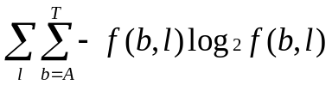
R_{sequence} = 2.315
- Programs
- Results
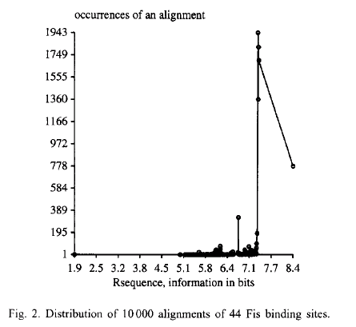
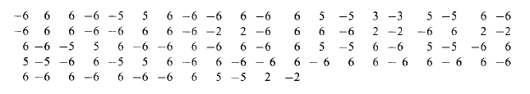
- Discussion

Created by : Chung-Jung Shih

Date : June 21, 2000

