FRAGMENT ASSEMBLY OF DNA

- ACYCLIC SUBGRAPHS
Example :
S = AGTATTGGCAATCGATGCAAACCTTTTGGCAATCACT
w = AGTATTGGCAATC
z = AATCGATG
u = ATGCAAACCT
x = CCTTTTGG
y = TTGGCAATCACT
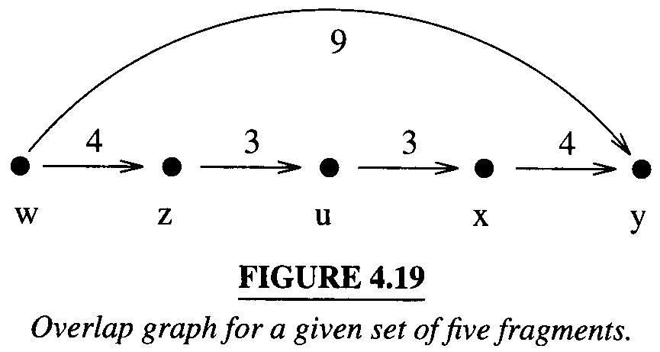
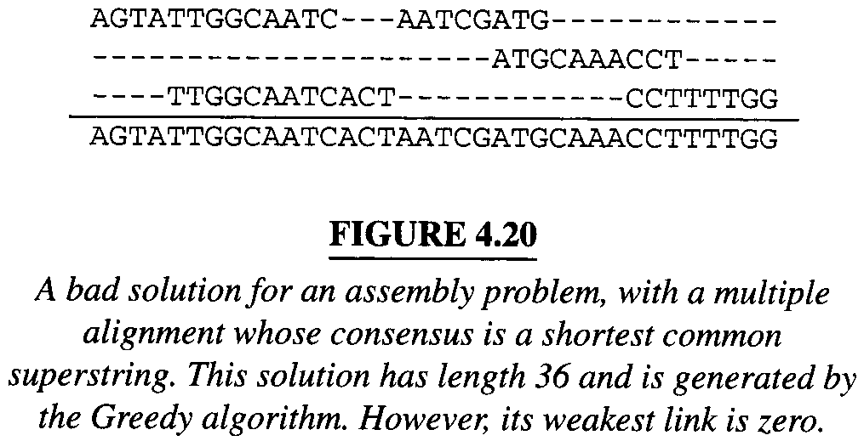
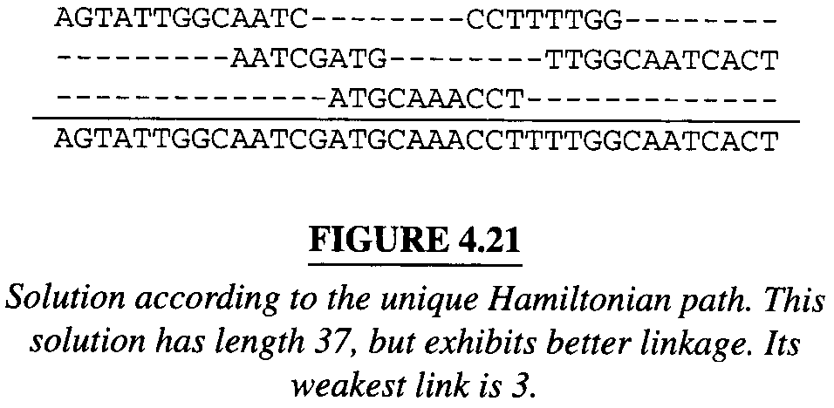

- HEURISTICS
Scoring.
Coverage.
Linkage.
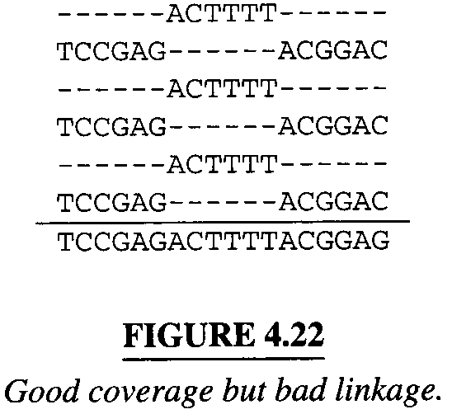

FINDING OVERLAPS
ORDERING FRAGMENTS
ALIGNMENT AND CONSENSUS

Created by : Chung-Jung Shih
Date : Sep. 21, 2000

