FRAGMENT ASSEMBLY OF DNA
- Biological Background
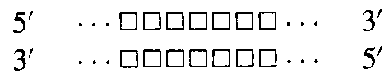
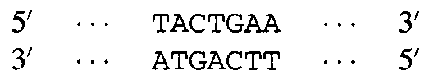

The Ideal Case :
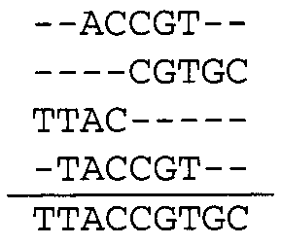

Errors :
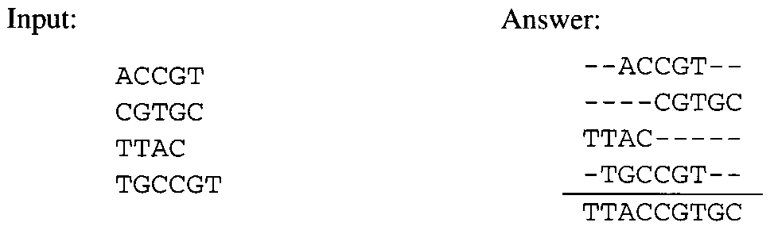

Unknown Orientation
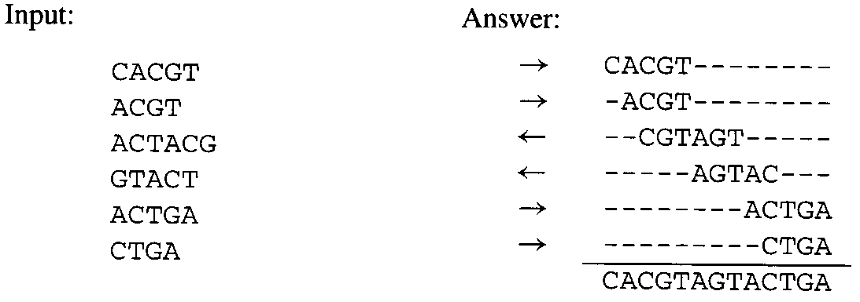
Repeated Regions
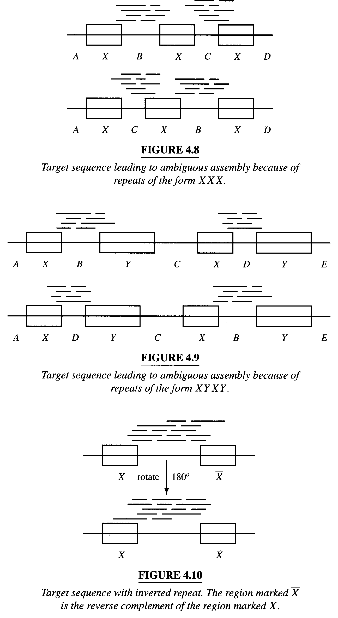
Lack of Coverage :
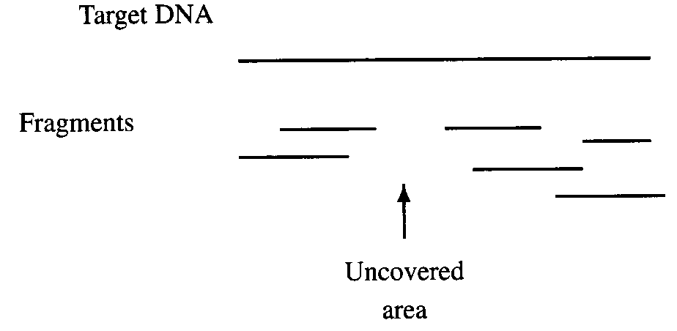

- Models

Shortest Common Superstring

Reconstruction
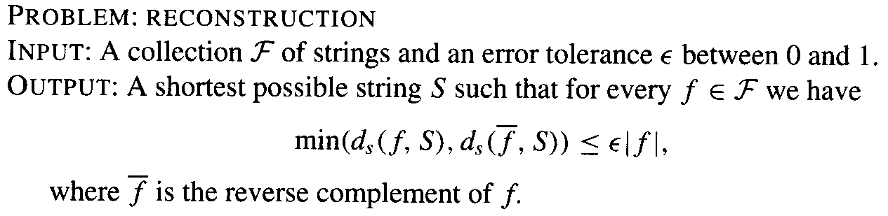

Multicontig
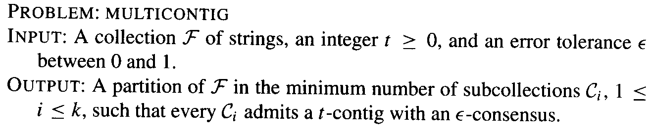

- Algorithms

Overlap Multigraph
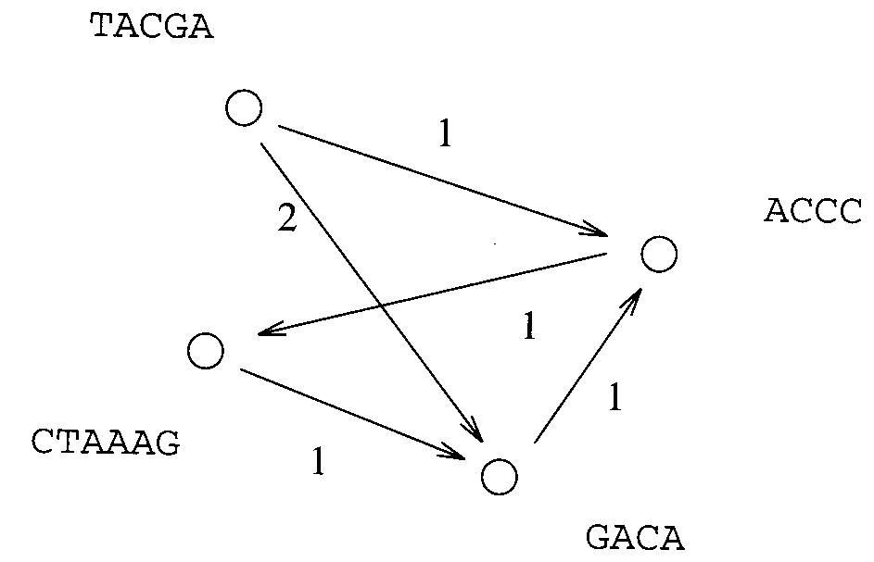

The Greedy Algorithm
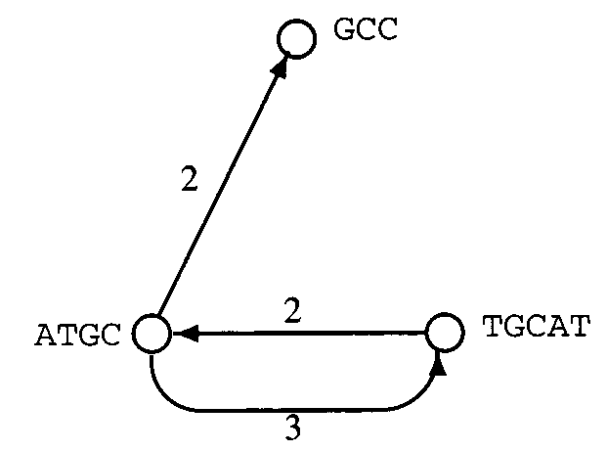

Acyclic Subgraphs
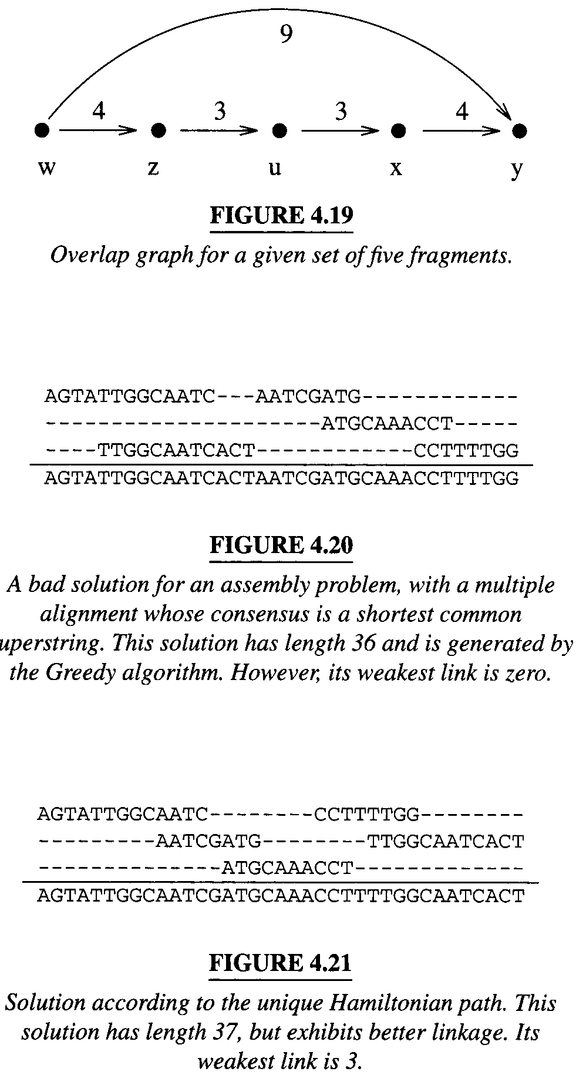
- Heuristics
  - Scoring.
  - Coverage.
  - Linkage.
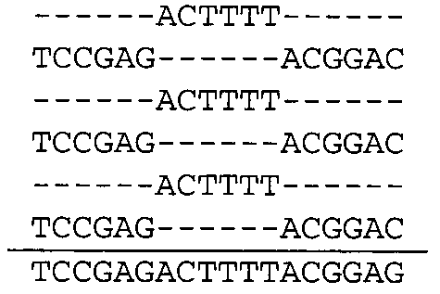

Assembly in Practice

Finding Overlaps

Ordering Fragments

Alignment and Consensus
Ex :
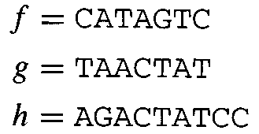
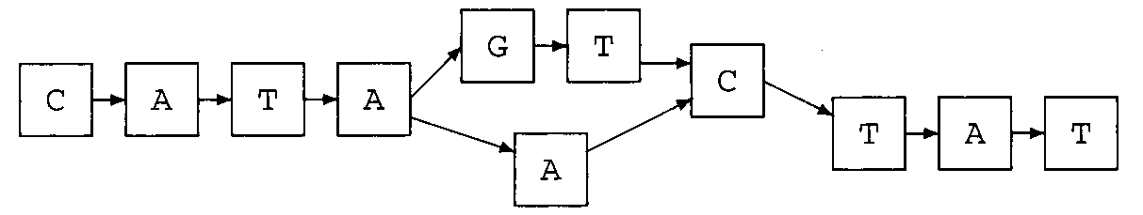

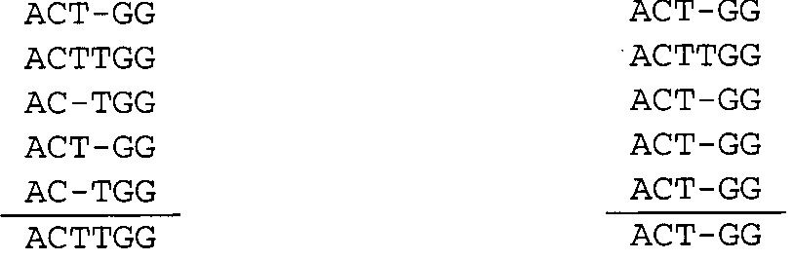

Created by : Chung-Jung Shih
Date : Sep. 26, 2000

