A Method for Constructing Decodable de Bruijn Sequences
Chris J. Mitchell, Member IEEE, Tuvi Etzion, Member IEEE, and Kenneth G. Paterson
IEEE TRANSACTIONS ON INFORMATION THEORY, VOL. 42, NO. 5, SEPTEMBER 1996, pp. 1472-1478

Abstract

INTRODUCTION
Preliminary Definitions and Notation :
v-window sequence.
c-ary punctured de Bruijn sequence of span v.
c-ary doubly punctured de Bruijn sequence of span v.
- AN INTERLEAVING CONSTRUCTION FOR WINDOW SEQUENCES
Definition : If a is a c-ary v-window sequence of period n, then a is said to satisfy Condition A if and only if the following three conditions are met :
- n is even.
- a does not contain the all-zero v-tuple, and
- a contains 0^{v-1} at position 0 ( it may contain other occurrences of 0^{v-1} ).
Construction : d =τ( b^{n/2}, a^{n/2+1} )
Example : Let n = 6, c = 2, and v = 3.
a = ( 0 0 1 0 1 1 ).
b = ( 0 0 0 0 1 0 1 1 ).
d =τ( b³, a⁴ ) =
(0 0 0 0 0 1 0 0 1 1 0 1 1 0 1
0 0 1 0 0 0 1 0 1 1 0 0 0 1
1 1 0 0 1 0 1 0 0 0 0 1 1 0
0 1 1 1 1 ).
d is a binary 6-window sequence of period 48.
A Decoding Algorithm :
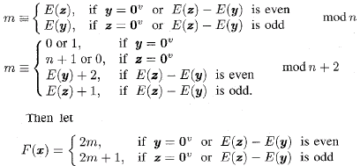
- A RELATED CONSTRUCTION METHOD FOR WINDOW SEQUENCES
Definition :
- 2∣n and 4∤n,
- a does not contain 0^{v} or 1^{v}, and
- a does contain at least one occurrence of 0^{v-1} and at least one occurrence of 1^{v-1}.
Construction : d =τ( b^{n/2}, a^{n/2+2} )
- AN ALTERNATIVE APPROACH FOR EVEN-SIZE ALPHABETS
a is a c-ary span v de Bruijn sequence which ends with 1^{v} and begins with 0^{v}.
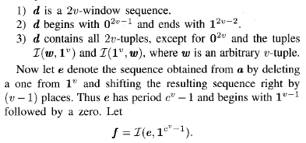
f can be joined into d at position c^{2v} – 2c^{v} – 2v + 2 using Lempel’s cycle joining method.

SUMMARY AND CONCLUSIONS
Created by : Chung-Jung Shih
Date : Nov. 14, 2000

