Edge-Disjoint Hamiltonian Cycles in de Bruijn Networks

Robert Rowley and Bella Bose
Distributed Memory Computing Conference, 1991. Proceedings., The Sixth Page(s): 707 - 709

Abstract
- Introduction
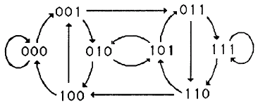
- Preliminaries
p(x) = x³ + x² + 1.
s_{3+i} = -s_{2+i} - s_{i} = s_{2+i} + s_{i} (mod 2).
s₀ = 1 and s₁ = s₂ = 0.
1001110100…
- Constructing Edge-Disjoint Cycles
C₀ = (100, 001, 011, 111, 110, 101, 010).
C₁ = (011, 110, 100, 000, 001, 010, 101).
- Hamiltonian Decompositions
r > 3 :
(101, 010) -> (101, 000), (000, 010).
(101, 010) : 2 edge2.
when r = 2 :
step1 : (10…0, 0…01) -> (10…0, 0^{n}) and (0^{n}, 0…01).
step2 : (01…, 10…) -> (01…, 10^{n-1}), (0^{n}, 1^{n}), (1^{n}, 10…).
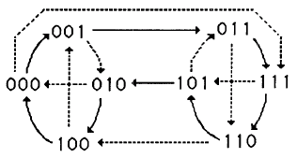
- Concluding Remarks

Created by : Chung-Jung Shih
Date : Dec. 5, 2000

