Maintaining a topological order under edge insertions

Alberto Marchetti-Spaccamela, Umberto Nanni, Hans Rohnert

Information Processing Letters 59 (1996) 53-58

Abstract
- Introduction
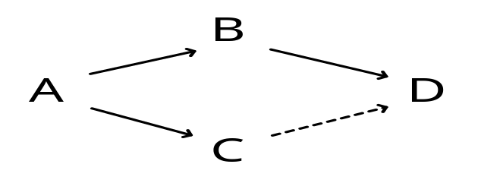
A topological order : ABDC.
ord( A ) = 1 ordInv( 1 ) = A
ord( B ) = 2 ordInv( 2 ) = B
ord( C ) = 4 ordInv( 3 ) = D
ord( D ) = 3 ordInv( 4 ) = C
- The algorithm
Insert ( C, D )
Stage 1 : ABDC
Stage 2 :
for i = ord( v ) to ord( u ) do ie. i = 3 to 4
i = 3 i = 4
L = D ord( ordInv( 4 ) ) = ord( C ) = i – shift = 3
shift = 1 ordInv( i – shift ) = ordInv( 3 ) = ordInv( 4 ) = C
ABDC
ord( A ) = 1 ordInv( 1 ) = A
ord( B ) = 2 ordInv( 2 ) = B
ord( C ) = 3 ordInv( 3 ) = C
ord( D ) = 3 ordInv( 4 ) = C
for all w in L do
ord( D ) = ord( C ) – shift + position of w in L = 4 – 1 + 1 = 4.
ordInv( ord( w ) ) = ordInv( 4 ) = w = D.
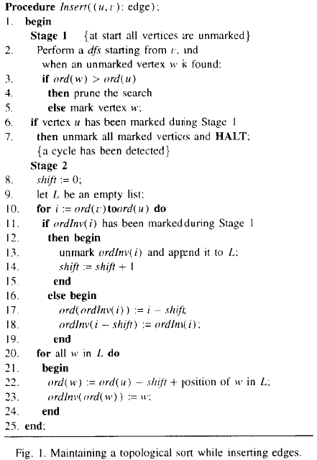
- Experimental results

Created by : Chung-Jung Shih
Date : Dec. 28, 2000

