Repetitive perhaps, but certainly not boring

W. F. Smyth
Theoretical Computer Science 249 ( 2000 ) 343 – 355

Abstract
- Introduction
- (a, r)-avoidance problem.
1904 : (2, 3)-avoidance problem.
1983 : (2, 4)-avoidance problem. Fibonacci string.
1998 : (2, r)-avoidance problem. r ≧ 4. Sturmian string.
(a, r)-avoidance problem for all a ≧ 2 and all r ≧ 3.
- Counting all the tandem repetitions : Θ(n log n). (1981, 1983, 1984)
- Open problem : What is the exact time complexity for the computation of all the Abelian squares in a given string x ?
Lower bound : Ω(n log n). (1997)
1997 : Θ(n²).
- Computing all the coverable substrings of x.
1993 : O(n log n ).
Θ(n log n ).
- Open Problem : What is the exact time complexity for the computation of all the Abelian squares in a given string x?
Ex. abba
- Computing all the repetitive
O(n²). (1998)
Border : Θ(n). (1974)
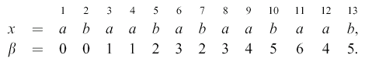
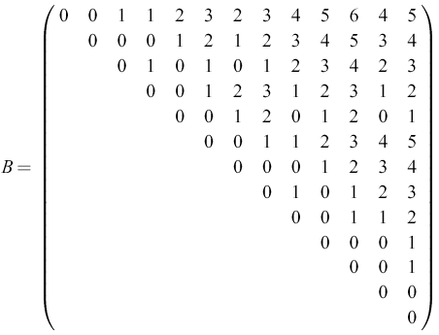
- Tandem repetitive in runs
Fibonacci string :
F₀ = b, F₁ = a; F_{i} = F_{i-1}F_{i-2}, i = 2, 3, …, n.
F₂ = a b
F₃ = a b a
F₄ = a b a a b
…
F₇ = a b a a b a b a a b a a b a b a a b a b a
- Approximate periodicity

- Encoding the output

Created by : Chung-Jung Shih

Date : Jan. 9, 2001

