Profiling Expression Patterns and Isolating Differentially Expressed Genes by cDNA Microarray System with Colorimetry Detection
Jeremy J. W. Chen, Reen Wu, Pan-Chyr Yang, Jane-Yu Huang, Yuh-Pyng Sher, Meng-Hsuan Han, Wei-Chen Kao, Pei-Jung Lee, Trai-Fu Chiu, Fu Chang, Yi-Wen Chu, Cheng-Wen Wu, and Konan Peck
Genomics 51, pp. 313-324, April 20, 1998
- Introduction
- Comparison of Microarray/CD with Northern Dot-Blotting
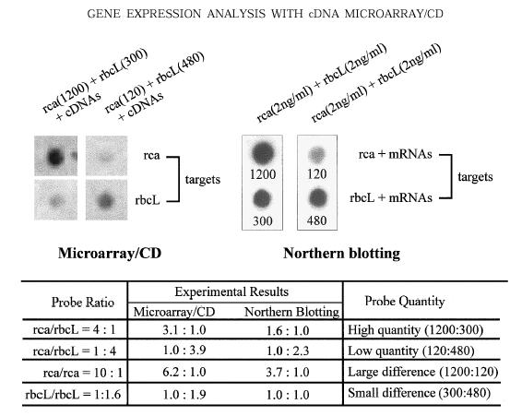
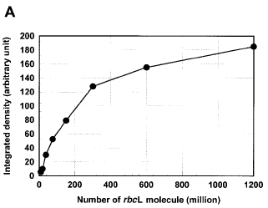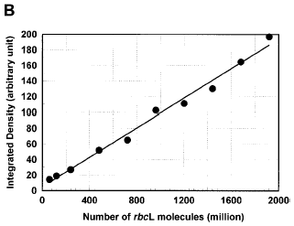

- Isolating Differentially Expressed Genes by Semiquantitative Dual-Color Detection
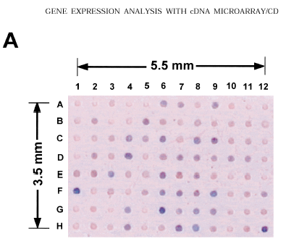

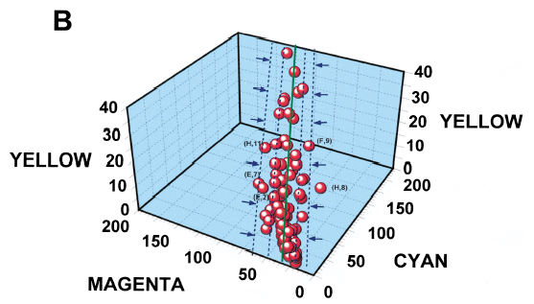

Created by : Meng-I Wu
Date : Apr. 16, 2002

