DNA Solution to the Traveling Salesman Optimization Problem
Jing-Shang Hwu and Rong-Jaye Chen
International Computer Symposium Workshop on Algorithms, pp. 44-50, Dec. 1998
Abstract
In this paper, we propose new molecular solution to a main NP-hard optimization problem: the traveling salesman optimization problem.
- Introduction
- Arithmetic operations with DNA

Level 1 | Level 2 | Level 3
First Operand | Second Operand | NAND | AND | XOR | ADD
UA = 0 | PT = 0 | 1 | 0 | 0 | 0
UA = 0 | AT = 1 | 1 | 0 | 1 | 1
AU = 1 | TA = 0 | 1 | 0 | 1 | 1
AU = 1 | TP = 1 | 0 | 1 | 0 | 10

Table 1: The truth table encoding

Example: 1001+ 0101=1110

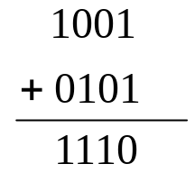

First Operand Strand | Second Operand Strand |  | Unique Output
1001 | 0101 |  | 1110
5'-AUUAUAAU | 3'-PTATPTAT | 3'-TAATPTAT | 5'-AUUAUAAU
 | 3'-PTATPTTP | 3'-TAATPTTP | 3'-TAATPTTP
 | 3'-PTATTAAT | 3'-TAATTAAT
 | 3'-PTATTATP | 3'-TAATTATP
 | 3'-PTTPPTAT | 3'-TATPPTAT
 | 3'-PTTPPTTP | 3'-TATPPTTP
 | 3'-PTTPTAAT | 3'-TATPTAAT
 | 3'-PTTPTATP | 3'-TATPTATP

Table 2: Example of an ADD operation

- 1001+0101=1110

First Operand Strand (1001)
5'-AUUAUAAU-GCCG
+
Second Operand Strands (0101)
3'-PTATPTAT-CGGC-UAAUUAAU-CCGG | 3'-TAATPTAT-CGGC-AUAUUAAU-CCGG
3'-PTATPTTP-CGGC-UAAUAUUA-CCGG | 3'-TAATPTTP-CGGC-AUAUAUUA-CCGG
3'-PTATTAAT-CGGC-UAAUAUAU-CCGG | 3'-TAATTAAT-CGGC-AUAUAUAU-CCGG
3'-PTATTATP-CGGC-AUUAUAUA-CCGG | 3'-TAATTATP-CGGC-AUUAUAUAUA-CCGG
3'-PTTPPTAT-CGGC-AUUAUAAU-CCGG | 3'-TATPPTAT-CGGC-AUUAUAUAAU-CCGG
3'-PTTPPTTP-CGGC-AUUAAUUA-CCGG | 3'-TATPPTTP-CGGC-AUUAUAAUUA-CCGG
3'-PTTPTAAT-CGGC-AUUAAUAU-CCGG | 3'-TATPTAAT-CGGC-AUUAUAAUAU-CCGG
3'-PTTPTATP-CGGC-AUAUUAUA-CCGG | 3'-TATPTATP-CGGC-AUUAAUUAUA-CCGG

= Output 5’-AUUAUAAU-GCCG
3’-TAATPTTP-GCCG-AUAUAUUA-CCGG
1 1 1 0

- ((1001 + 0101) + 0001) + 0001) = 10000
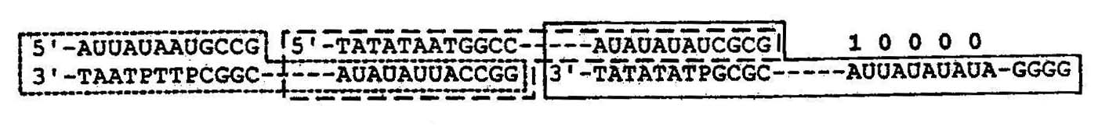

- The traveling salesman problem
  - Algorithm
  - Generate all possible paths through G and compute the weight of paths.
  - Keep only those paths that begin with V_{start} and end with V_{start}.
  - Keep only those paths that enter exactly n vertices.
  - Keep only those paths that enter all of the vertices of G at least once.
  - Compare the weight of the satisfied paths and find out the minimum.
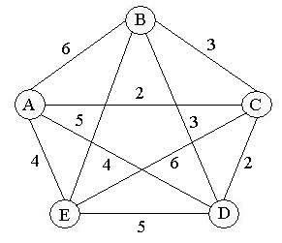
Figure 3: A weighted complete graph with 5 vertices

- for common edges
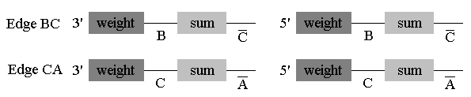

(2) for particular starting vertex A

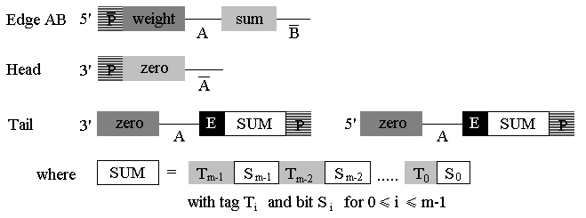

- Path with even edges
Ex: A→B→A
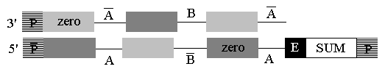

- Path with odd edges
Ex: A→B→C→A
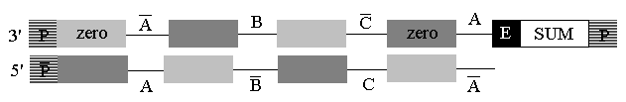

Figure 6: Path generation

(1) Path with even
Ex: A→B→A
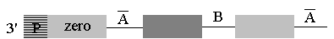

and

will be amplified

(2) Path with odd edges
Ex: A→B→C→A
Only

Figure 7: The result of adding primer
Created by : Meng-I Wu
Date : May 2, 2002

