Optimal 1-fair alternators
Shing-Tsaan Huang, Bau-Wen Chen
Information Processing Letters, Vol. 80, pp. 159-163, 2001
Abstract
This paper proposes a general approach to design the optimal 1-fair alternators. Adopting this approach, we have demonstrated two optimal 1-fair alternator designs: one for hypercubes and the other for D×D meshes with odd D.
- Introduction
- The optimal design for binary hypercubes
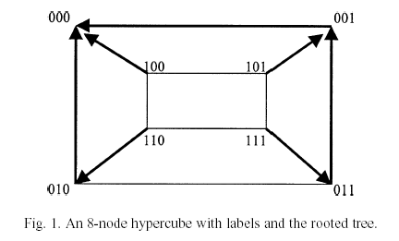

- The optimal design for D×D meshes
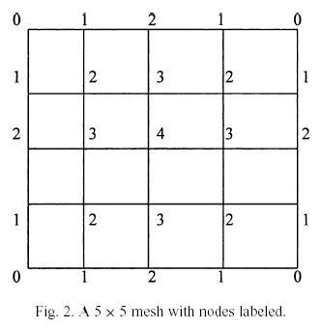

Created by : Meng-Yi Wu
Date : May 30, 2002

