Graph-Based Induction
Takashi Matsuda, Hiroshi Motoda and Takashi Washio

Abstract
- GBI
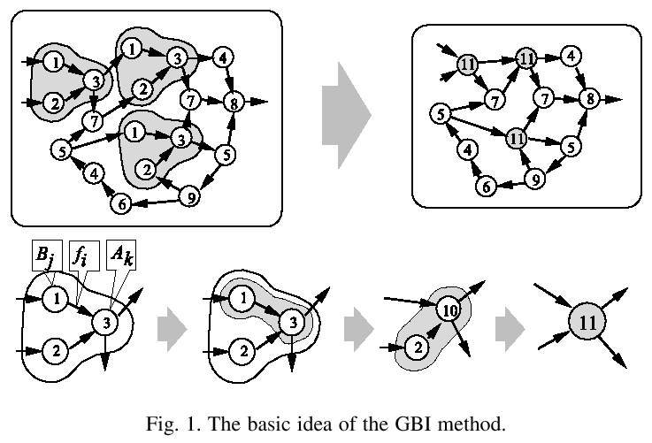
GBI(G)
Selection of pair nodes (A_{k}, f_{i}, B_{j})
Chunk the pair nodes into one node: c
C:=C ∪ {c}
G_{c}:=contracted graph of G
While termination condition not reached
C:=C ∪ GBI(G_{c})
end_while
Output C

- Example
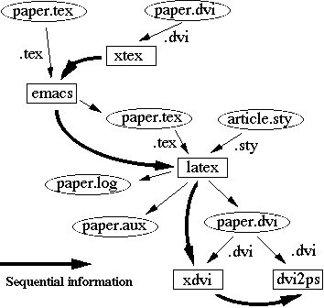
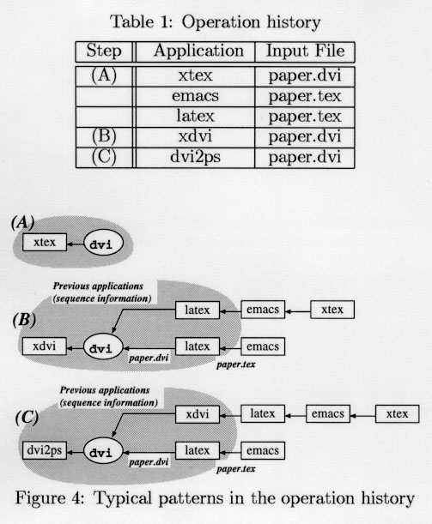
Created by : Meng-Yi Wu
Date : Sept. 5, 2002

