TreeGeneBrowser: phylogenetic data mining of gene sequences from public databases
Ingrid B. Jakobsen, Jennifer A. Saleeba, Michael Poidinger and Timothy G. Littlejohn
Bioinformatics, Vol. 17, No. 6, pp. 535-540, Feb. 2001
Abstract
- Introduction
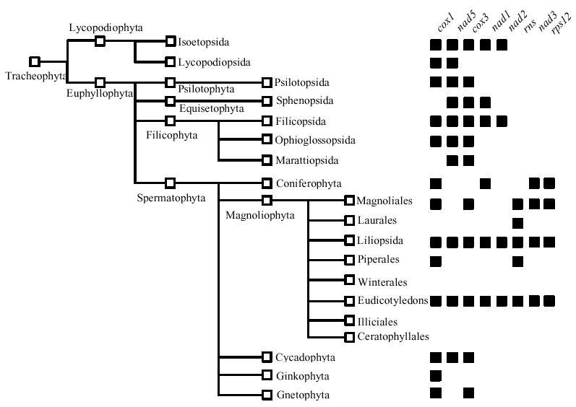

Fig. 1 User tree with contracted nodes and gene scoring. Tree showing several taxonomic nodes contracted to rank class. The edited user tree shown has Tracheophyta as the root node and tips shown as open boxes. On the right, the observed distribution of the eight high-scoring GOBASE genes among the tips is shown by solid boxes.

- Algorithm

Method | Algorithm
Equal taxon weighting (1991) | 1/k * 1/m…  k, m, …: number of children at each node between root and tip
Vane-Wright (1991) | 1/(2*n)  n: number of nodes between root and tip
May (1990) | 1/(k + m + …)  k, m, …: number of children at each node between root and tip
Pairwise unique (1991) | U_{i} + U_{j} + 1  U_{i}, U_{j}: number of unique nodes for tip i, j respectively
Pairwise shared (1991) | 1/S_{ij}  S_{ij}: number of shared nodes for tip i and j

- Result

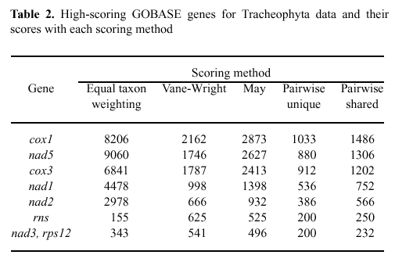
Created by : Meng-Yi Wu
Date : Oct. 16, 2002

