A Data Mining Approach Based on Machine Learning Techniques to Classify Biological Sequences
M. Maddouri , M. Elloumi
Knowledge-Based Systems 15 (2002) 217~223
Abstract
Data mining approaches can be helpful to analyze primary structures in order to extract useful knowledge.
- Introduction
This approach uses four steps.
1.Construct the set of the discriminant substring, called ‘discriminant descriptor’ (DD), associated with each family of primary structures.
2.Construct a context which is a table of examples vs attributes.
3.Extract knowledge from the context and represent it by production rules.
4.Use these production rules to do classification of primary structures.
- Definitions and notations
Let f₁, f₂ ,…, f_{n} be families of strings and x be a substring of a string of f_{i} , 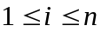.

1. The substring x is discriminant between f_{i} and 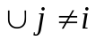 f_{j} .
2. A discriminant x is minimum.
3. DD, denoted by 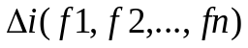, the set of discriminant and minimum substirngs. And k-DD
4. 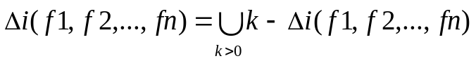
5. A context is a triplet (F ,, R) , where F = 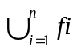 , 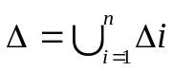 , R is a binary relation defined between F and such that (w , s )R , w F and s , when the string w contains the substring s.
- Approach
Let f₁ = {cabbdbea , eacdabaea} , f₂ = {bedeabbad , daaadbbd}.
1.Construction of the DDs

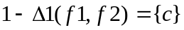 and 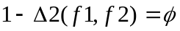
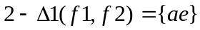 and 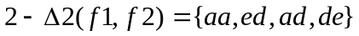
and 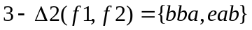
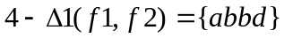 and 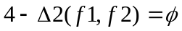

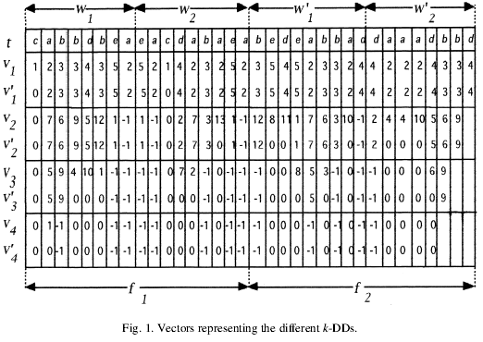

2.Construction of the context
Construct a matrix R , of size 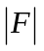x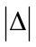 , such that R[ i, j ] = 1 if the 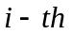string of F contains the 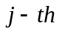 substring of else R[ i ,j] = 0.
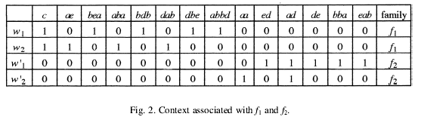

3.Induction of rules
Use a punishment/award algorithm to computes rules weights by using string whose families are known.
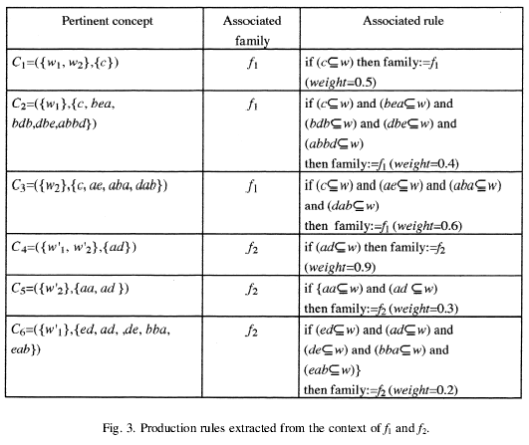
During the classification process, we use the applicable rule having the greatest weight.
4.Classification of primary structures

4.Coclusion
Mining biological data can help biologists to do classification in biological sequences. And this approaches give such explanation and, hence, can be helpful to improve biologists know-how and knowledge.

Created by : Yi-Yao Huang
Date : Nov. 14, 2002

