Optimal Spliced Alignment of Homologous cDNA to Genomic DNA Template
Jonatham Usuka , Wei Zhu and Volker Brendel
Bioinformatics Vol. 16 no.3 2000 Pages 203-211
Abstract
We designed a novel algorithm that produces the optimal spliced alignment of a genomic DNA with a cDNA or EST based on scoring for both sequence matching and intrinsic splice site strength.
- Introduction
We already have many algorithm, compare with cDNA and cognate gene. In the simplest, unambiguous case, the alignment will consist of (1) perfectly matching segments corresponding to the exons, and (2) deletions in cDNA corresponding to the introns in the genomic template.
In practice, matching may be less than perfectly matching, due to either sequencing error or matching of genomic sequence with non-cognate cDNA.
- System and methods
Input : nucleotide sequence G₁G₂…G_{n} of length N,
cDNA or EST nucleotide sequence C₁C₂…C_{m} of length M
Output : state sequence Q=q₁,q₂,…,q_{L} with associated output 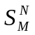, such that the joint probability P(Q, ) is maximal over all possible Q and .
Then P= max{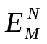,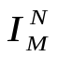}
Where 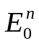=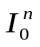=1,
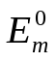=1, 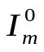=0, n=0,1,…,N m=0,1,…,M,
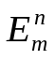=max{max{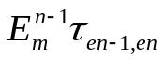,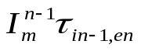}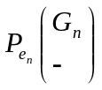 ,
max{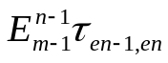,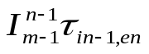}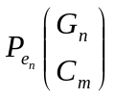 ,
max{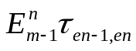,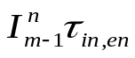}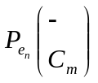}
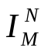=max{,} , n=1,2,…N , m=1,2,..M
Wight in the exon states e_{n} are set to
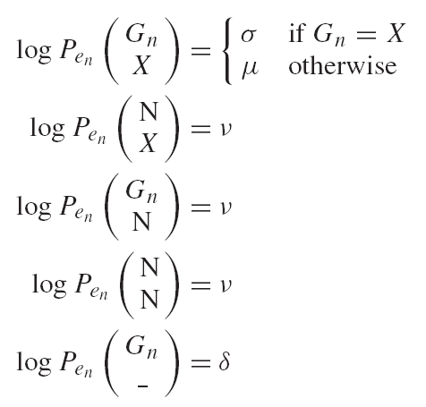
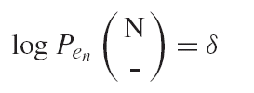
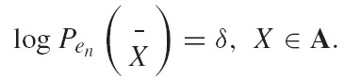
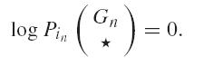
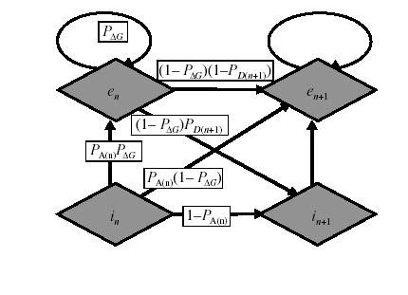
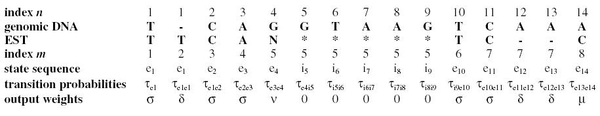

- Improvement
- Limitation on the maximal lengths of the genomic DNA and cDNA depend on the memory of the CPU.

- Minimal intron length-
To avoid solutions with unacceptably small intron assignment, the algorithm was modified to include a ‘short intron penalty’.

- Scoring the alignment
The program score each predicted exon separately by tallying up the output weight corresponding to the alignment of exon and cDNA. Only matches and the penalties for gaps in the genomic DNA are counted.

Created by :
Date : Nov 29, 2002

