Performance-Guarantee Gene Predictions via Spliced Alignment

Andrey A. Mironov,Michael A. Roytberg, Pavel A. Pevzner,and
Mikhail S. Gelfand

GENOMICS 51, pp 332–339 (1998)
1.Introduction

PROCRUSTES uses similarity-based approach to gene recognition

2. Spliced Alignment

- The spliced alignment algorithm explores all possible exon assemblies and finds a chain of exons with the best fit to a related target protein.
- candidate exons ➔further filtration➔considers all possible chains of candidate exons and finds a chain with the maximum global similarity to the target protein

3.Filtration

(1) 1 exon per 14 nucleotides ( weak filtration)
(2) 1 exon per 33 nucleotides (moderate filtration)
(3)1 exon per 100 nucleotides ( strong filtration).

4. Target Selection

(1)Standard database search tools such as BLASTX can be used to identify useful targets which can subsequently be retrieved from the databases by, NCBI Entrez browser
(2)If no relatives were found, you may use statistics-based gene recognition programs.

5. Input and Output

(1) Input one genomic DNA sequence and one or several protein sequences
(2) Output the amino acid sequence of the predicted protein and the alignment between the predicted and target proteins

WWW Server Input:

(1)Genomic Sequence(2)Target Sequence(3)Alignment parameters(4)Filtration parameter(5)True gene structure (test mode).

WWW Server Output.
(1)Exon map(2)List of exons(3)Translated protein(4)Spliced alignment

The message "structure not found" means that all spliced alignments for the given target have negative scores. This means that either the target is too distant or not related at all, or the FILTRATION parameter is too high, or the source sequence does not contain a complete gene corresponding to the given target.

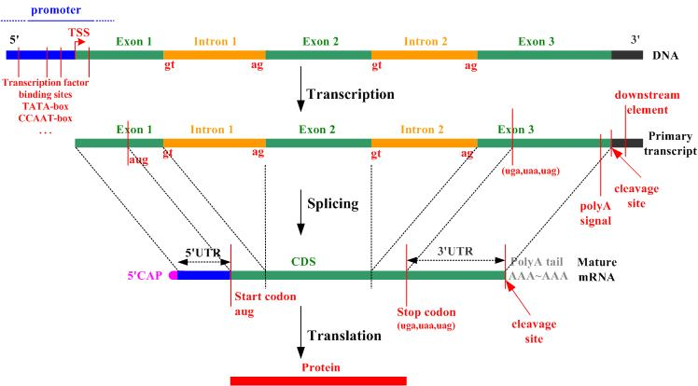

Created by : Wei-Tin Liu
Date : Nov.29 , 2002

