Finding Motif by ACO

- Motif
Given： a set of N sequences S₁, …, S_{n} and the length k of the motifs.
Problem： find all sets of substrings s₁, …, s_{n}, each of length k, such that the score is maximum.
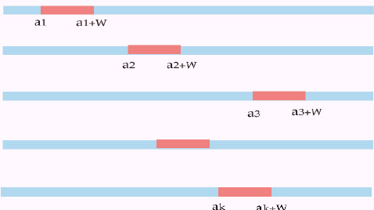
S₁：ACGTCAGTCGATTGACGACATGATCATGCAC
S₂：AGTAGTACGACATGCTCGACGATGGACTGAAGT
S₃：GATGAGTCGAAGTCATGATGGATGTGAGCCAA
S₄：GAAGAAGACATGCTCCTAGTGACGTGACGG

s₁：ACGACATGAT
s₂：ACGACATGCT
s₃：AAGTCATGAT
s₄：AAGACATGCT
- ACO (Ant Colony Optimization) Algorithm
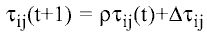…. (1)
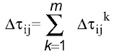…. (2)
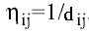 …. (3)
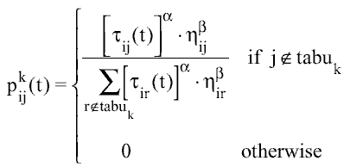…. (4)
- Method
S₁：ACGTCAGTCGATTGACGACATGATCATGCAC
S₂：AGTAGTACGACATGCTCGACGATGGACTGAAGT
S₃：GATGAGTCGAAGTCATGATGGATGTGAGCCAA
S₄：GAAGAAGACATGCTCCTAGTGACGTGACGG
Score function： 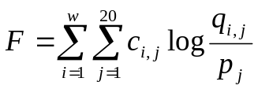
1.motif：AAGACATGCT
s₁：ACGACATGAT
s₂：ACGACATGCT
s₃：AAGTCATGCT
s₄：AAGACATGCT
score = 18.519
Created by: Ying-Jer Liao
Date: Dec. 13, 2002

