Matrix Decomposition
on the Star Graph

Abdel-Elah Al-Ayyoub, Khaled Day
IEEE Transactions on Parallel and Distributed Systems,
Vol. 8, No. 8, Aug. 1997, p.803-812

Target
To compute LU decomposition of a matrix, use Gaussian elimination with pivoting by broadcasting.

Cyclic matrix distribution on the star graph
Goal: Load-balancing + effective row/column broadcasting

- Mapping:
G_{n} (p₁p₂…p_{n}) = 1 , if n=1
= (p_{n}-1)(n-1)! + G_{n-1}(q₁q₂…q_{n-1}) , o.w.

- Star cyclic matrix distribution:
SCMD(a_{i,j}) = v
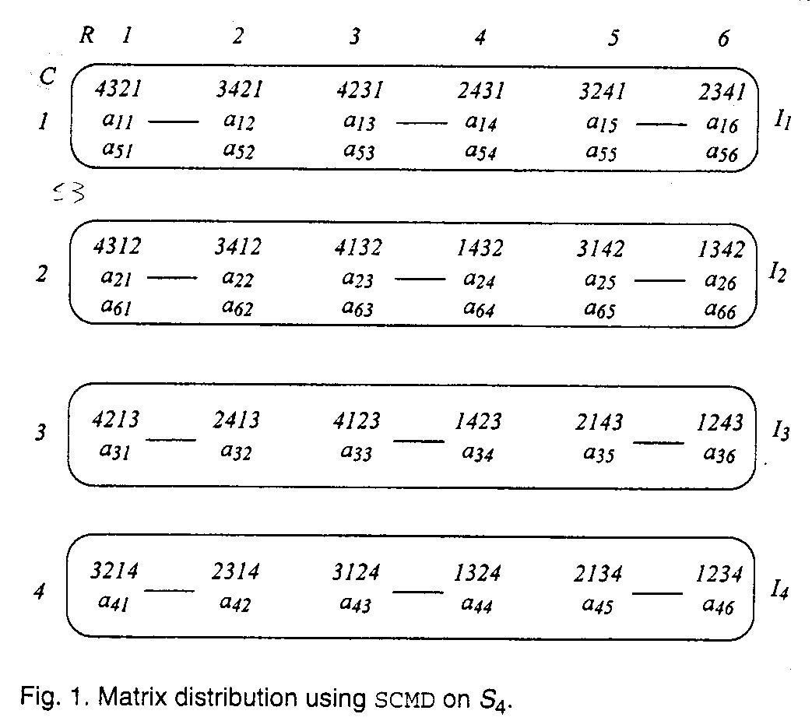
v∈I_{R} , R=[(i-1) mod n]+1, and G_{n-1}(v)=C, C=[(j-1) mod (n-1)!]+1
- Linear array cyclic matrix distribution
LCMD(a_{i,j}) = v
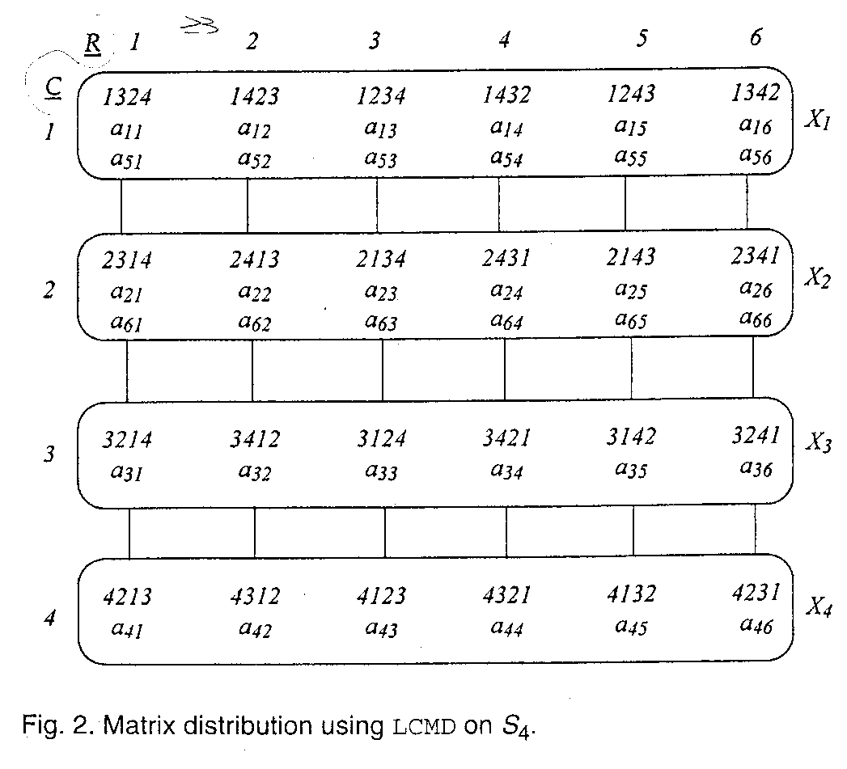
v∈X_{R} , R=[(i-1) mod n]+1, and G_{n-1}(v^{(n)})=C, C=[(j-1) mod (n-1)!]+1

LU decomposition
Pivoting(partial or complete): exchange-max + switch rows or/and columns
Broadcast pivots in linear array + Compute multipliers
Broadcast multipliers in substar + Elimination

Performance
Computation time (Matrix size is N*N):
Sequential: O(N³)
Parallel(#nodes is P): O(N³/P)

Communication time (almost same number of nodes):
Hypercube: O(Nlogn!)
Mesh: O(N(n!)^{1/2})
Star graph: O(Nn)

Note: use all-port broadcasting

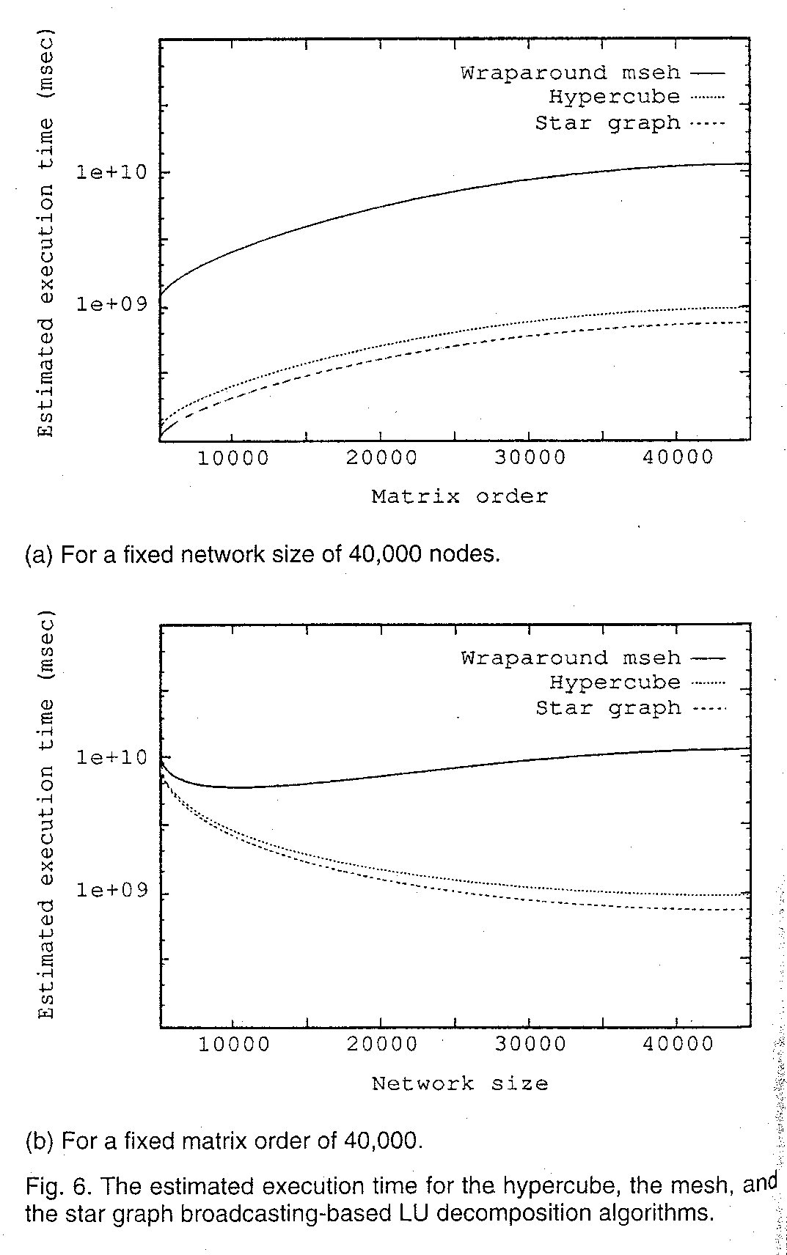
Created by : Seng-I Yeh
Date : Dec. 17, 1999

