Sorting n Numbers on n×n Reconfigurable Meshes with Buses

Madhusudan Nigam & Sartai Sahni
Journal of Parallel and Distributed Computing 23, 37-48 (1994)

1. Target:
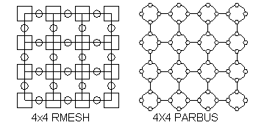
Sort n elements on n×n RMESH and PARBUS in O(1) time.
2. Sort methods
(1) column sort:
used to sort a r×s matrix where r≧2(s-1)² and r mod s = 0
step 1,3,5,7 : sort column
step 2 : transpose
step 4 : untranspose
step 4’: undiagonalize (condition changes to r≧s(s-1) )
step 6 : shift r/2
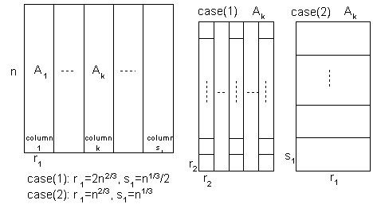
step 8 : unshift r/2

(2) rotate sort:
sort a M×N matrix

procedures:balance(v,w) {operate on vxw matrix}
sort columns downward
ratate each row k, k mode w position right
sort columns downward end;
unblock {operate on entire mesh}
ratate each row k, k*N^{1/2} mod N position right
sort columns downward end;
shear {operate on entire mesh}
sort even rows to the right , sort odd rows to the left
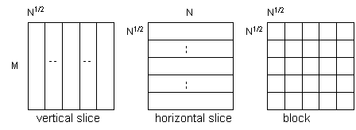
sort columns downward end;

step 1: balance each vertical slice
step 2: unblock the mesh
step 3: balance each horizontal slice as if it were a N×N^{1/2} mesh lying on its
side
step 4: unblock the mesh
step 5: shear three times
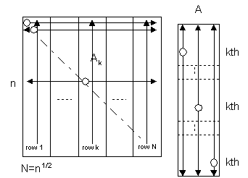
step 6: sort rows to the right

(3) combined sort:
first 3 steps of iterative shear sort + last 4 steps of ratate sort
to sort N×N matrix

step 1: sort each N^{3/4}×N^{3/4} blocks
step 2: shift row k, k*N^{3/4} positions to the right
step 3: sort columns downward
step 4: balance each horizontal slice as if it were a N×N^{1/2} mesh lying on its
side
step 5: unblock the mesh
step 6: shear three times
step 7: sort rows to the right

3. Basic operation
(1) sort one column/row
on RMESH use ranking algorithm of Jenq and Sahni [4,5], need 6
broadcasts.
on PARBUS use prefix sum algorithm of [11], need 2 or 12
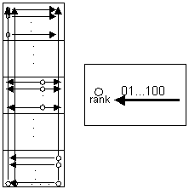
broadcasts in this case.
(2) broadcast data to desired position

4. Numbers of broadcast
 | column sort |  | rotate sort | combined sort
RMESH | 139 |  | 120 | 118
PARBUS | 75 | 59 | 81 | 77

5. Sort N^{k} numbers on a (k+1) dimensional RMB with N^{k+1} processors in O(1) time

Created by : Seng-I Yeh
Date : Sep. 21, 1999

