A Comparative Study of Five Parallel Genetic Algorithms Using the Traveling Salesman Problem
L. Wang, A. A. Maciejewski, H. J. Siegel, V.P. Roychowdhury
Proceedings of the First Merged International Parallel Processing Symposium, 1998. IPPS/SPDP 1998.
and Symposium on Parallel and Distributed Processing 1998
pp. 345-349
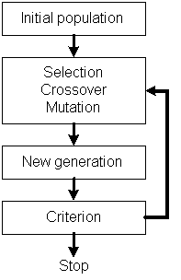
- GA
It’s one of the evolutionary computing.
- Coding
- Fitness function
- Population size

-> Searching building blocks.

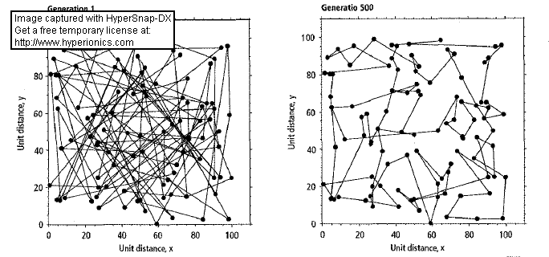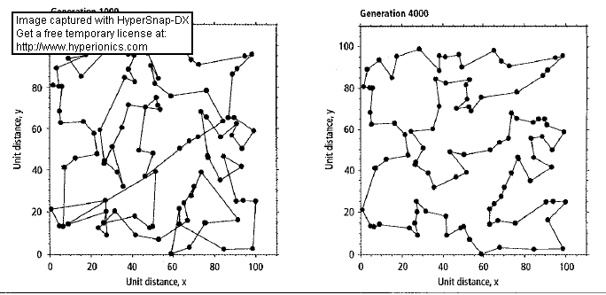
- SGA
- Modified heuristic crossover (random 1/2)
Parents: 123-(10)-4-(30)-56, 164-(15)-23-(20)-5
->3421…
- 2-opt (random 1/4)
…abcd…. -> …acbd…, if dist(a,b)+dist(c,d) > dist(a,c)+dist(b,d)
- or-opt (rest)
123abc45 -> 1abc2345, if dist(3,a)+dist(c,4) > dist(1,a)+dist(c,2)
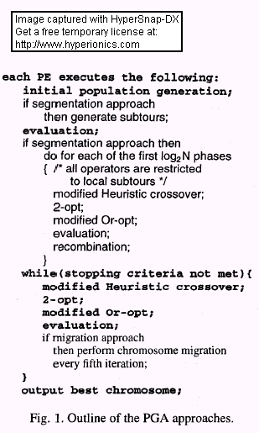
- PGA
  - Independent
  - Partitioned
  - Migration
  - Segmentation
  - Segmentation-migration

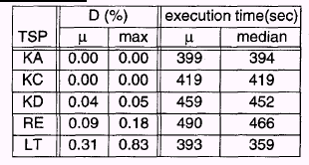
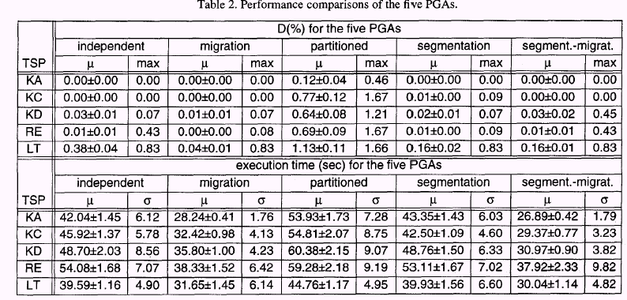
Created by : Seng-I Yeh

Date: Apr. 26, 2000

