NSYU Business App – Screen-by-Screen Guide
Oct 30, 2026 · @Mohd

Overview
This app is one place for a small shopkeeper to keep a customer and supplier ledger (khata), make bills, and track stock. Amounts are in rupees (₹) with Indian digit grouping, for example ₹1,53,058. The business shown in the screenshots is NSYU (8800503662), and a dropdown next to the name switches businesses.
Main tabs (bottom bar)
Tab | What it does
Ledger | Customer and supplier balances, dues, payments
Bill | List of all bills, and the cart to create a new bill
Catalog / Inventory | Product list with stock, price, margin
More | Account, Profile, Help, Settings, Bills, Stock Management, Auto Reminder
On a phone the bar reads Ledger, Bill (Bills), Catalog, More. On the tablet view, Inventory is a full-width table and the bar reads Ledger, Bill, Inventory.
Colour rules used everywhere
Colour | Meaning
Red | Unpaid, Due, amount you will get, bill given
Amber | Partial payment
Green | Paid, Received, main buttons and header
Customers appear as coloured circles with their first initial.

1. Ledger (home screen)
The Ledger screen shows how much money customers owe the shop: ₹1,53,058 across 195 accounts in the screenshot, all in red as "You Get".
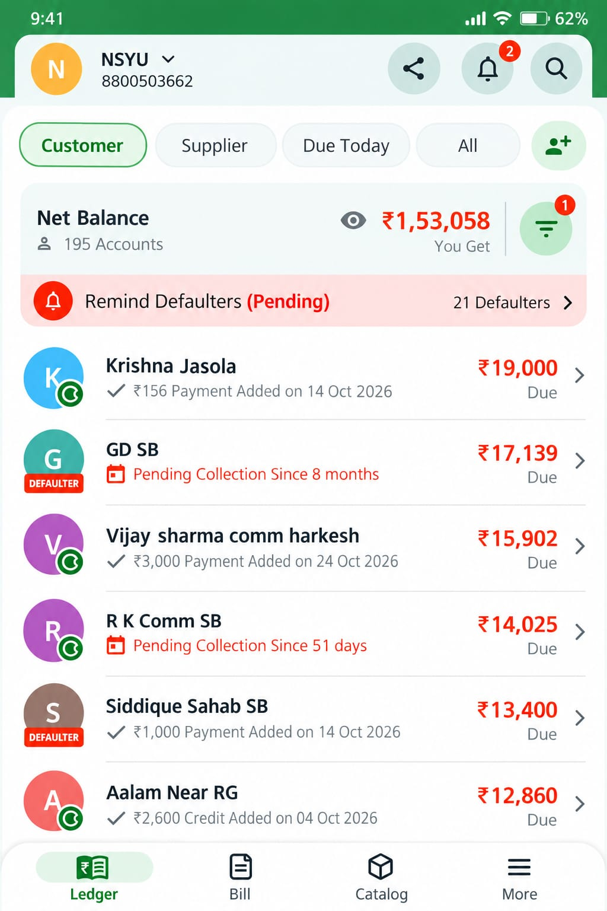
Top area
- Business name with a dropdown (NSYU, 8800503662) on the left.
- Share, Notifications (red badge with 2) and Search icons on the right.
- Filter chips: Customer, Supplier, Due Today, All, and a button to add a new contact.
Net Balance card
- Label "Net Balance" with the account count (195 Accounts).
- An eye icon hides or shows the amount.
- Big red amount with the words "You Get".
- A filter button with a badge (1 active filter).
Remind Defaulters banner
A red strip reading "Remind Defaulters (Pending)" with "21 Defaulters" and an arrow. It opens the bulk reminder flow.
Customer rows
Customer | Due | Subtitle shown
Krishna Jasola | ₹19,000 | ₹156 Payment Added on 14 Oct 2026
GD SB (Defaulter) | ₹17,139 | Pending Collection Since 8 months
Vijay sharma comm harkesh | ₹15,902 | ₹3,000 Payment Added on 24 Oct 2026
R K Comm SB | ₹14,025 | Pending Collection Since 51 days
Siddique Sahab SB (Defaulter) | ₹13,400 | ₹1,000 Payment Added on 14 Oct 2026
Aalam Near RG | ₹12,860 | ₹2,600 Credit Added on 04 Oct 2026
Each row has a coloured initial avatar, the name, a subtitle, and the due amount in red with "Due" below it. A red DEFAULTER tag sits on the avatar of defaulters, and a small green round badge on some avatars. Tapping a row opens that customer's ledger.

2. Customer ledger (transaction timeline)
Opening a customer shows every bill and payment in date order, with the current total due at the top. In the screenshot, Krishna Jasola owes ₹19,000.
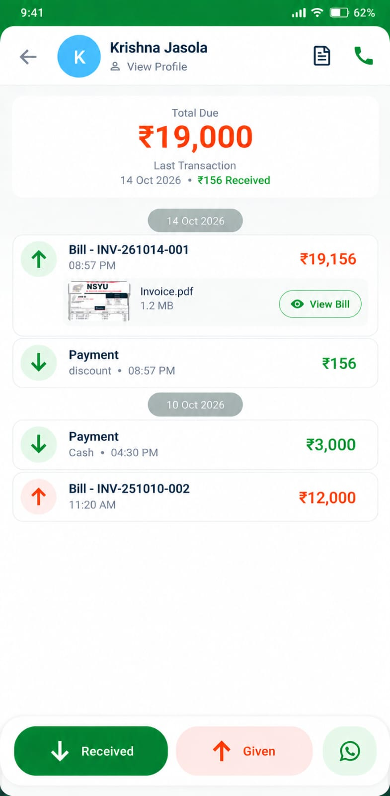
Header and summary
- Back arrow, avatar, name, and "View Profile".
- A bill-list icon and a green call icon on the right.
- Card: "Total Due" in large red, and "Last Transaction: 14 Oct 2026 • ₹156 Received".
Timeline entries
Date | Entry | Amount | Notes
14 Oct 2026 | Bill - INV-261014-001, 08:57 PM | ₹19,156 (red, up arrow) | Attached Invoice.pdf (1.2 MB) with a "View Bill" button
14 Oct 2026 | Payment, discount, 08:57 PM | ₹156 (green, down arrow) | Discount given on the bill
10 Oct 2026 | Payment, Cash, 04:30 PM | ₹3,000 (green, down arrow)
10 Oct 2026 | Bill - INV-251010-002, 11:20 AM | ₹12,000 (red, up arrow)
Date chips (grey) separate the days. A bill raises the due and shows a red up arrow; a payment lowers it and shows a green down arrow.
Bottom actions
- Green "Received" button for money taken from the customer.
- Light-red "Given" button, shown in red like the bill entries.
- WhatsApp button to message the customer.

3. Add transaction (amount entry)
Tapping Received or Given opens a simple entry screen where the amount is typed on a built-in calculator keypad. In the screenshot, Krishna Jasola's due is ₹4,510 and the amount entered is ₹2,222.
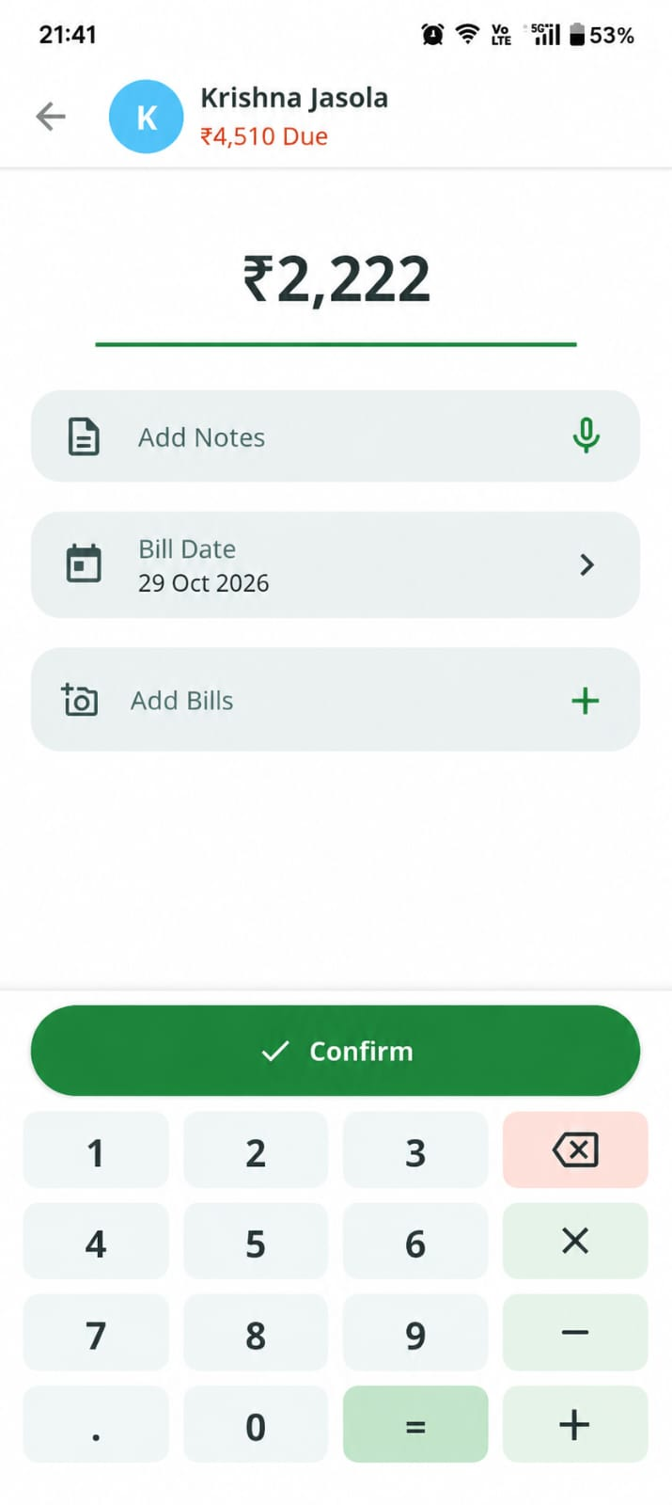
- Header: back arrow, customer avatar and name, and the current due in red.
- Amount: large number with a green underline, updated as keys are pressed.
- Add Notes: text field with a green microphone icon for voice input.
- Bill Date: date picker, set to 29 Oct 2026 in the screenshot.
- Add Bills: attach a photo or file of the bill with a "+" button.
- Keypad: digits 0-9 and a decimal point, plus ×, −, +, = for quick calculation, and a red backspace key.
- Confirm: full-width green button with a tick that saves the entry.

4. Bills list
The Bills screen lists all 125 bills, newest first, and each card shows who the bill is for, the bill number and date, the item count, a status pill and the amount.
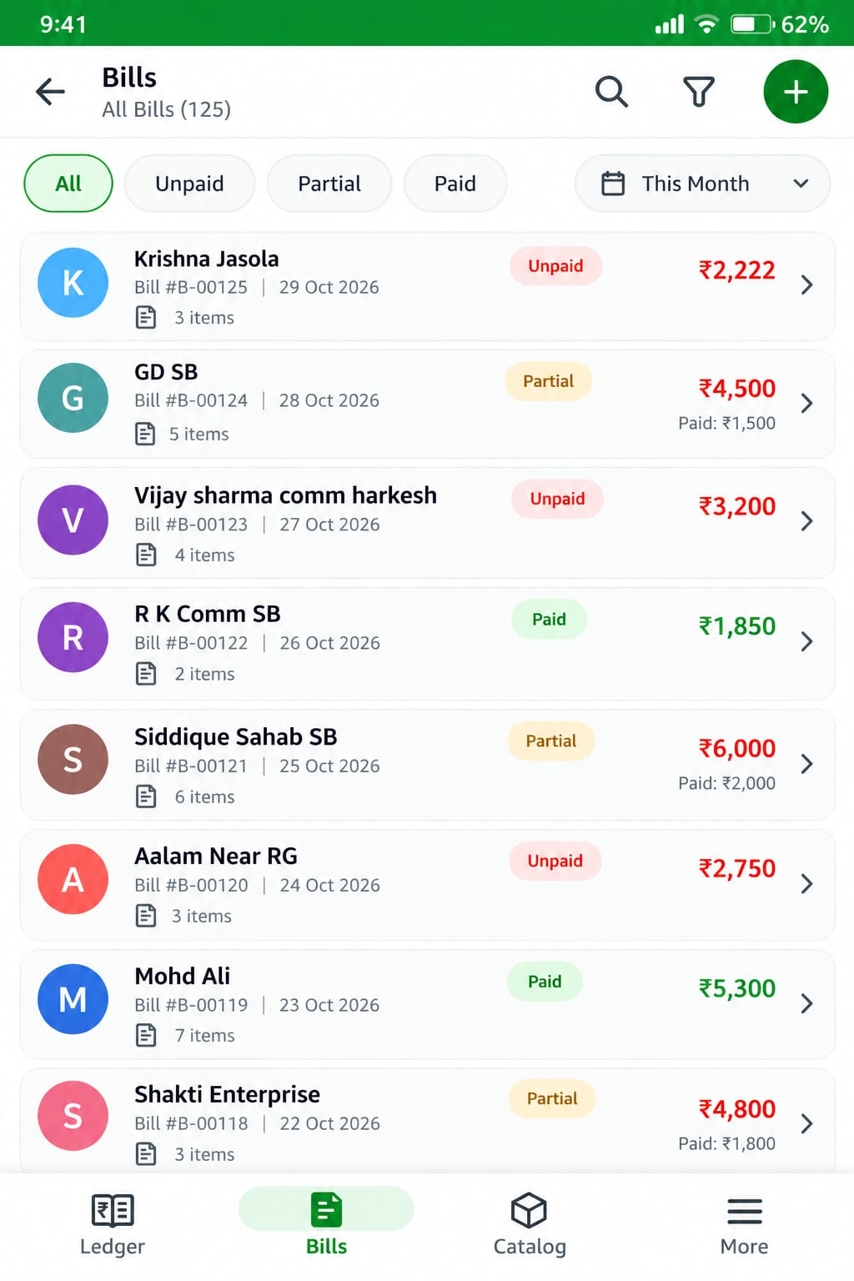
Top bar and filters
- Title "Bills - All Bills (125)" with Search, Filter and a green "+" button to create a new bill.
- Status chips: All, Unpaid, Partial, Paid.
- Date dropdown, set to "This Month".
Bills shown in the screenshot
Customer | Bill no. | Date | Items | Status | Amount
Krishna Jasola | #B-00125 | 29 Oct 2026 | 3 | Unpaid | ₹2,222
GD SB | #B-00124 | 28 Oct 2026 | 5 | Partial | ₹4,500 (Paid ₹1,500)
Vijay sharma comm harkesh | #B-00123 | 27 Oct 2026 | 4 | Unpaid | ₹3,200
R K Comm SB | #B-00122 | 26 Oct 2026 | 2 | Paid | ₹1,850
Siddique Sahab SB | #B-00121 | 25 Oct 2026 | 6 | Partial | ₹6,000 (Paid ₹2,000)
Aalam Near RG | #B-00120 | 24 Oct 2026 | 3 | Unpaid | ₹2,750
Mohd Ali | #B-00119 | 23 Oct 2026 | 7 | Paid | ₹5,300
Shakti Enterprise | #B-00118 | 22 Oct 2026 | 3 | Partial | ₹4,800 (Paid ₹1,800)
Unpaid is red, Partial is amber and Paid is green. Partial bills also show "Paid: ₹..." under the amount. The bottom bar here reads Ledger, Bills (active), Catalog, More.

5. Customer profile and bills
Tapping the Bill tab and then a customer opens a profile with four tabs. In the screenshot, Krishna Jasola (8800123456) has 5 bills worth ₹12,450, of which ₹7,940 is paid. The red arrow in the image shows the move from the Bills list on the left to the profile on the right.
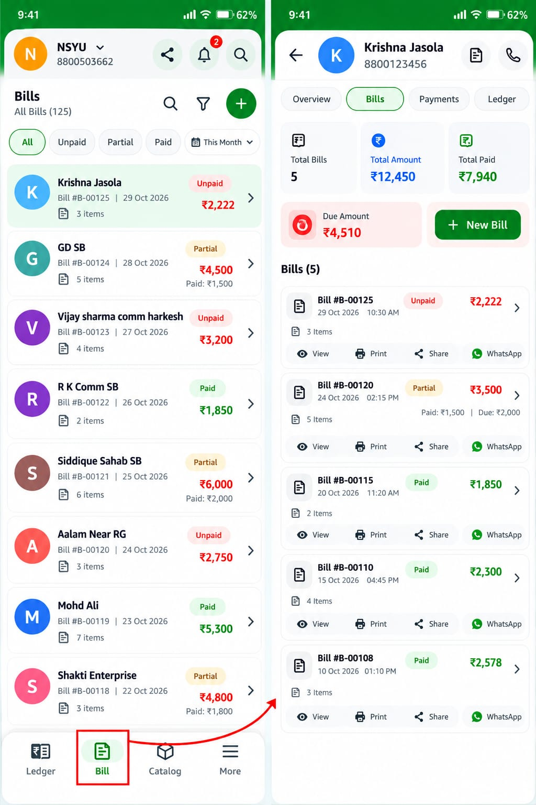
Header and tabs
- Back arrow, avatar, name and phone number, with a bill icon and a call icon.
- Tabs: Overview, Bills (selected), Payments, Ledger.
Summary cards
Card | Value
Total Bills | 5
Total Amount | ₹12,450
Total Paid | ₹7,940
Due Amount (red) | ₹4,510
A green "+ New Bill" button sits next to the Due Amount card.
Bills (5) for this customer
Bill no. | Date and time | Items | Status | Amount
#B-00125 | 29 Oct 2026, 10:30 AM | 3 | Unpaid | ₹2,222
#B-00120 | 24 Oct 2026, 02:15 PM | 5 | Partial | ₹3,500 (Paid ₹1,500, Due ₹2,000)
#B-00115 | 20 Oct 2026, 11:20 AM | 2 | Paid | ₹1,850
#B-00110 | 15 Oct 2026, 04:45 PM | 4 | Paid | ₹2,300
#B-00108 | 10 Oct 2026, 01:10 PM | 3 | Paid | ₹2,578
Every bill card has four quick actions: View, Print, Share and WhatsApp.

6. Cart and Create Bill
The Cart screen is where a bill is made: pick a customer, add products with quantity and price, and see the grand total. In the screenshot the cart has 3 items for a grand total of ₹1,956.
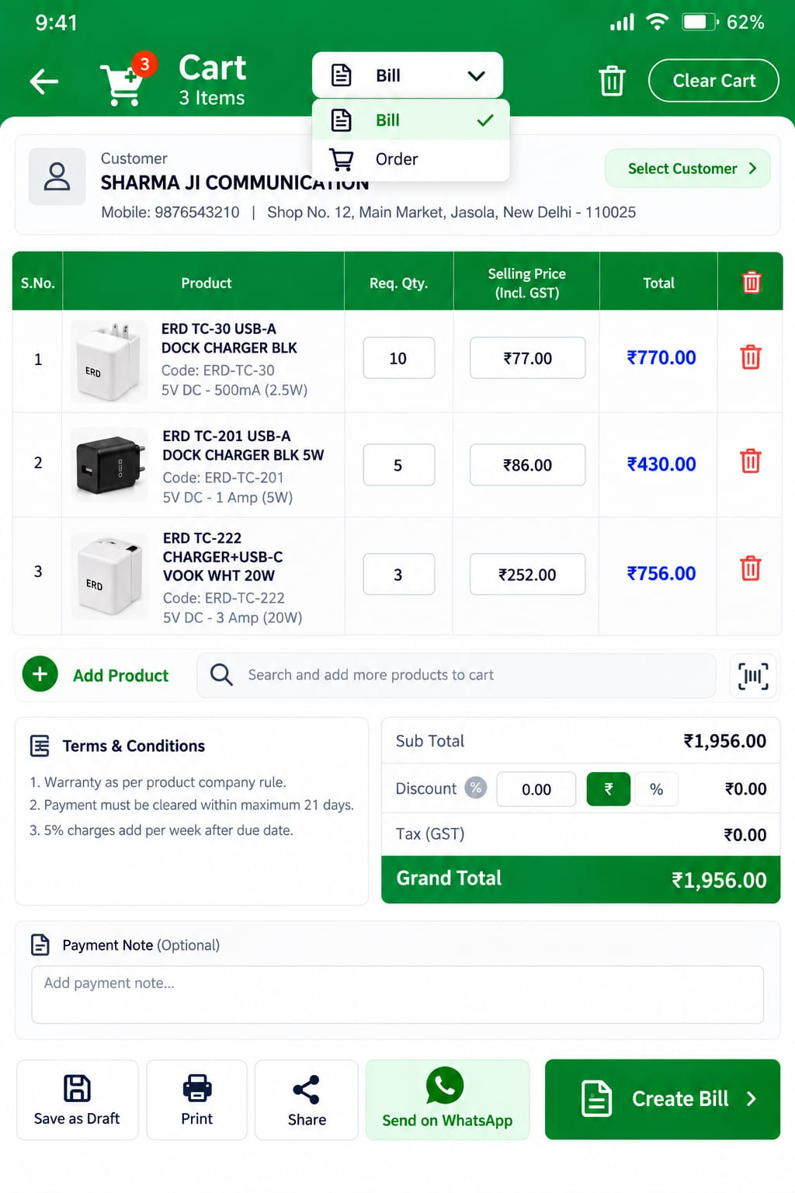
Header
- Back arrow, cart icon with a count badge (3), and "Cart - 3 Items".
- Mode dropdown with two choices: Bill (selected) and Order.
- Trash icon and a "Clear Cart" button.
Customer card
Shows the customer name (SHARMA JI COMMUNICATION), mobile (9876543210) and shop address (Shop No. 12, Main Market, Jasola, New Delhi - 110025), with a "Select Customer" button to change it.
Items table
No. | Product | Code | Spec | Req. Qty | Selling price (incl. GST) | Total
1 | ERD TC-30 USB-A Dock Charger BLK | ERD-TC-30 | 5V DC - 500mA (2.5W) | 10 | ₹77.00 | ₹770.00
2 | ERD TC-201 USB-A Dock Charger BLK 5W | ERD-TC-201 | 5V DC - 1 Amp (5W) | 5 | ₹86.00 | ₹430.00
3 | ERD TC-222 Charger+USB-C Vook WHT 20W | ERD-TC-222 | 5V DC - 3 Amp (20W) | 3 | ₹252.00 | ₹756.00
Quantity and selling price are editable boxes, and each row has a red delete icon. Under the table are a green "Add Product" button, a search box ("Search and add more products to cart") and a barcode scan button.
Terms, totals and notes
- Terms & Conditions: 1) warranty as per product company rule, 2) payment must be cleared within maximum 21 days, 3) 5% charges add per week after due date.
- Sub Total ₹1,956.00. Discount box (0.00) with a ₹ / % switch. Tax (GST) ₹0.00. Grand Total ₹1,956.00 in a green bar.
- Payment Note (optional) text box.
Bottom buttons
Save as Draft, Print, Share, Send on WhatsApp, and the main green "Create Bill" button.

7. Inventory (Catalog)
The Inventory screen is a full-width table of all 125 products with stock, price, margin and selling price on one row. It is shown here in tablet (landscape) layout.
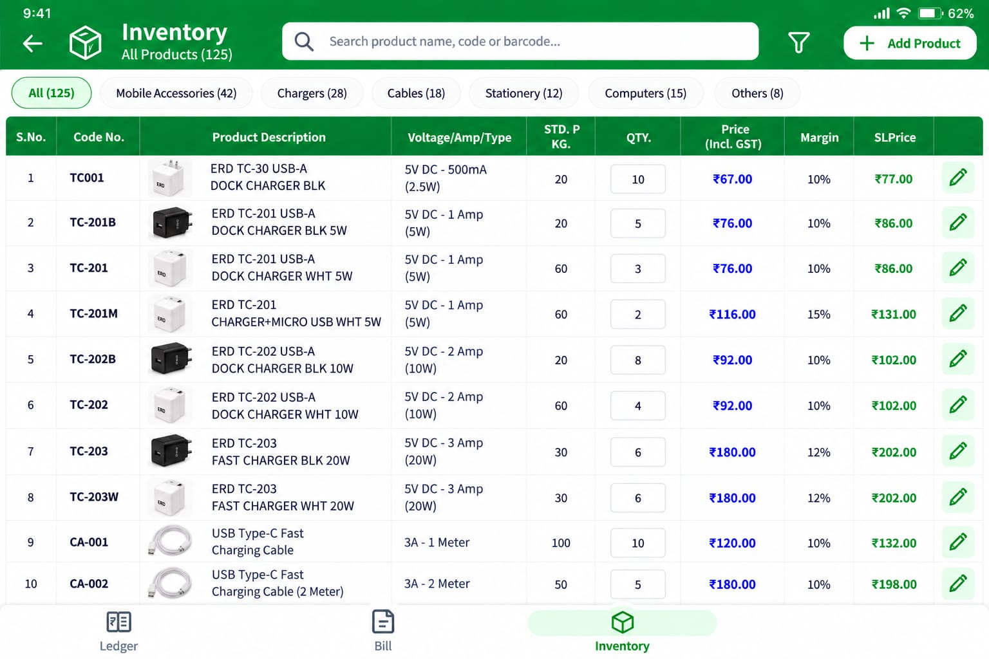
Header and categories
- Back arrow, box icon, "Inventory - All Products (125)", a search box (name, code or barcode), a filter icon and a white "+ Add Product" button.
- Category chips with counts: All (125), Mobile Accessories (42), Chargers (28), Cables (18), Stationery (12), Computers (15), Others (8).
Table columns
S.No, Code No., Product Description (with photo), Voltage/Amp/Type, STD. P KG, QTY (editable box), Price (Incl. GST), Margin, SL Price, and a green pencil button to edit.
First 10 products in the screenshot
No. | Code | Product | Voltage / type | STD. P KG | Qty | Price (incl. GST) | Margin | SL Price
1 | TC001 | ERD TC-30 USB-A Dock Charger BLK | 5V DC - 500mA (2.5W) | 20 | 10 | ₹67.00 | 10% | ₹77.00
2 | TC-201B | ERD TC-201 USB-A Dock Charger BLK 5W | 5V DC - 1 Amp (5W) | 20 | 5 | ₹76.00 | 10% | ₹86.00
3 | TC-201 | ERD TC-201 USB-A Dock Charger WHT 5W | 5V DC - 1 Amp (5W) | 60 | 3 | ₹76.00 | 10% | ₹86.00
4 | TC-201M | ERD TC-201 Charger+Micro USB WHT 5W | 5V DC - 1 Amp (5W) | 60 | 2 | ₹116.00 | 15% | ₹131.00
5 | TC-202B | ERD TC-202 USB-A Dock Charger BLK 10W | 5V DC - 2 Amp (10W) | 20 | 8 | ₹92.00 | 10% | ₹102.00
6 | TC-202 | ERD TC-202 USB-A Dock Charger WHT 10W | 5V DC - 2 Amp (10W) | 60 | 4 | ₹92.00 | 10% | ₹102.00
7 | TC-203 | ERD TC-203 Fast Charger BLK 20W | 5V DC - 3 Amp (20W) | 30 | 6 | ₹180.00 | 12% | ₹202.00
8 | TC-203W | ERD TC-203 Fast Charger WHT 20W | 5V DC - 3 Amp (20W) | 30 | 6 | ₹180.00 | 12% | ₹202.00
9 | CA-001 | USB Type-C Fast Charging Cable | 3A - 1 Meter | 100 | 10 | ₹120.00 | 10% | ₹132.00
10 | CA-002 | USB Type-C Fast Charging Cable (2 Meter) | 3A - 2 Meter | 50 | 5 | ₹180.00 | 10% | ₹198.00
The bottom bar in this view reads Ledger, Bill, Inventory (active). The SL Price is the selling price: the cart uses ₹77.00 for TC-30 and ₹86.00 for TC-201 BLK, the same as the SL Price here.

8. More menu
The More tab opens a bottom sheet over the Ledger screen with seven shortcuts in a grid of round green icons.
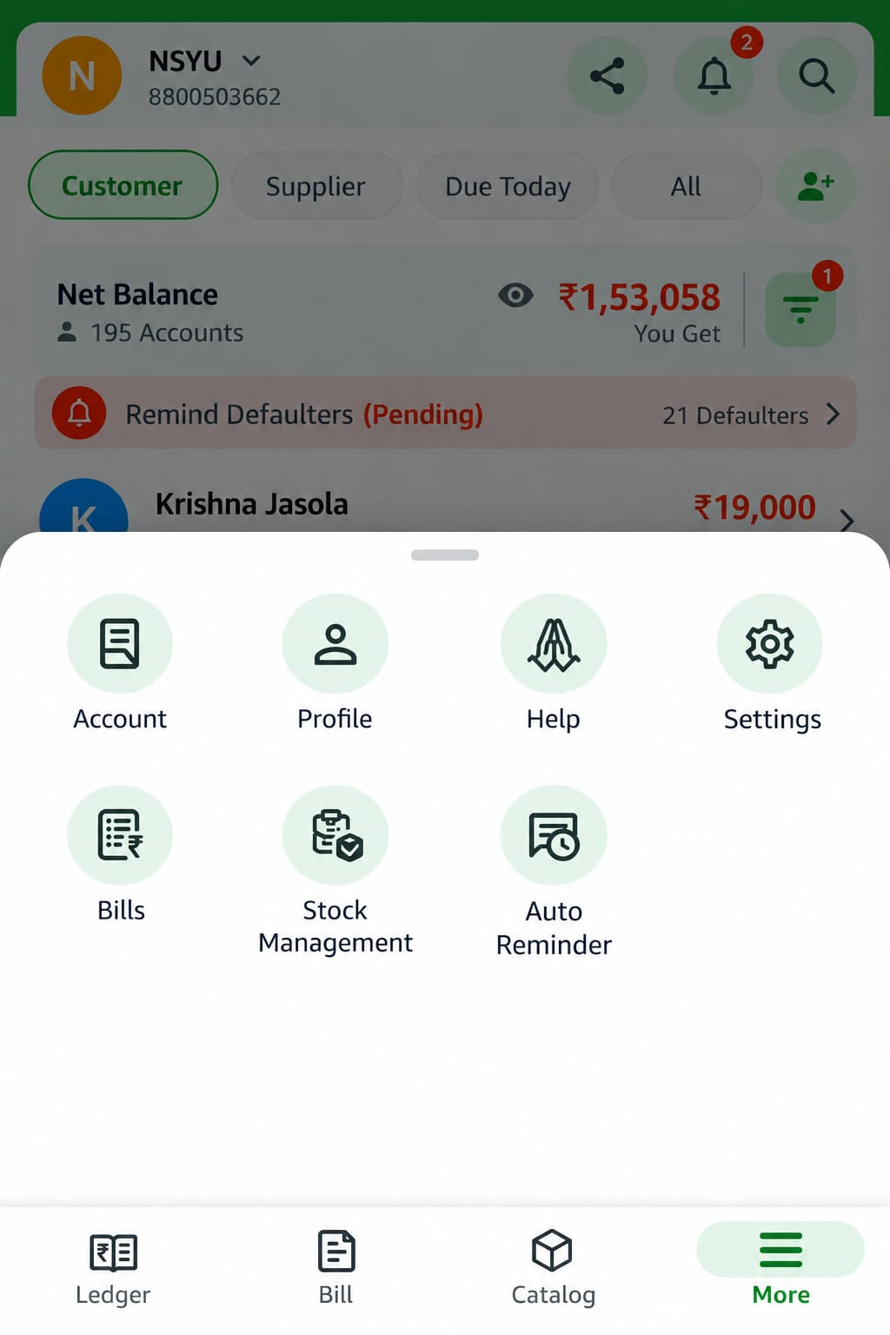
Row | Shortcuts
First row | Account, Profile, Help, Settings
Second row | Bills, Stock Management, Auto Reminder
Bills opens the Bills list from section 4. The bottom bar shows More as the active tab.

9. Typical flow and points to check
A day-to-day use of the app follows the steps below, based on the screens above.
- Open Ledger and check Net Balance, Due Today and the Remind Defaulters banner.
- To sell, open Bill, choose Bill or Order mode, select the customer, add products and tap Create Bill.
- The bill appears in the Bills list and in the customer's ledger with its invoice PDF.
- When money comes in, open the customer, tap Received, enter the amount, date and note, and tap Confirm.
- Use View, Print, Share or WhatsApp on any bill, and WhatsApp or call on the customer.
Numbers that match across screens
- Krishna Jasola's profile: ₹12,450 total bills minus ₹7,940 paid gives the ₹4,510 due, which also shows in the Add transaction header.
- The five bills in his profile add up to ₹12,450.
- Cart: ₹770 + ₹430 + ₹756 gives the ₹1,956 grand total.
- Bill #B-00125 (₹2,222) matches the amount typed on the Add transaction screen.
Numbers that do not match (worth confirming)
- The Ledger and the customer ledger show ₹19,000 due for Krishna Jasola, but his profile shows ₹4,510 due.
- The four timeline entries in his customer ledger (bills of ₹19,156 and ₹12,000, payments of ₹156 and ₹3,000) work out to ₹28,000, not ₹19,000.
- Bill #B-00125 appears in the Bills list and profile but not in his customer ledger timeline.
- The bottom bar says "Bill" on some screens and "Bills" on others, and the third tab is "Catalog" on the phone but "Inventory" on the tablet.

