**Stage1:Data Collection**

* The provided information is manually entered into a spreadsheet and stored in CSV file format with the name raw_yield_data.csv
* The data represents a 10 different persons with their age, weight, height, grip strength and the person has frailty or not(Y,N).

**Stage 2 : Data Processing**

* In the given raw data,there is no there is no need to remove or clean to proceed to further analysis.But just in case of large data I have omitted NA values using na.omit() function.
* Here i have added two more columns namely Body Mass Index(BMI) and Frailty. Binary for further analysis.
* BMI =(Weight/Height^2)*703 and for Frailty.binary Y=1 and N=0.

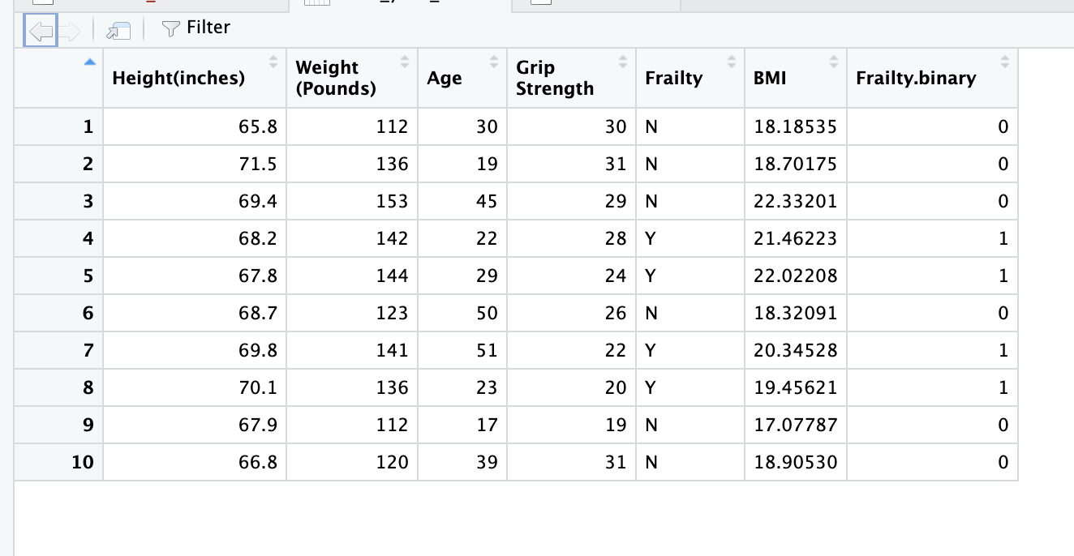

**Stage3: Data Analysis**

* Here I have used plot, barplot, pairs, ggplot, ggplot2 for data visualization analysis.
* The below plot represents the line plot for BMI for the given 10 persons.

* Normally to be a healthy person one should have a BMI in between 18.5 to 24.9. If a person has BMI < 18.5 then the person is underweight, similarly if BMI > 24.9 then person is overweight and if BMI > 39.9 then the person is obese.
* lbl <- c(0,18.5,24.9,39.9,Inf)

cols <- c("darkred","darkgreen","red","green")[findInterval(clean_yield_data$BMI, vec=lbl)]

barplot(BMI,col = cols)

barplot (Frailty.binary)

clean_yield_data %>%

ggplot2::ggplot(aes(x = factor(Age), y = BMI,fill=BMI > 18.5)) +

geom_bar(position = "dodge",

stat = "identity")+

scale_fill_manual(values = c("#C00000","#004C99"),

labels=c('TRUE'='>18.5','FALSE'='<18.5'))+

labs(fill='BMI')

clean_yield_data %>%

ggplot2::ggplot(aes(x = factor(`Grip Strength`), y = BMI,fill=BMI > 18.5)) +

geom_bar(position = "dodge",

stat = "identity")+

scale_fill_manual(values = c("#C00000","#004C99"),

labels=c('TRUE'='Good','FALSE'='Underweight'))+

labs(fill='BMI')

* So the blue color represents the person is in good condition. Whereas red color implicates that the person is underweight.

**

**ggplot(clean_yield_data,aes(x = factor(Age), y = `Grip Strength`)) + geom_bar(stat = "identity")**

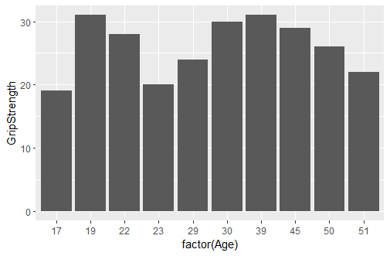

**ggplot(clean_yield_data, aes(x = factor(Age), y = Frailty.binary)) + geom_bar(stat = "identity")**

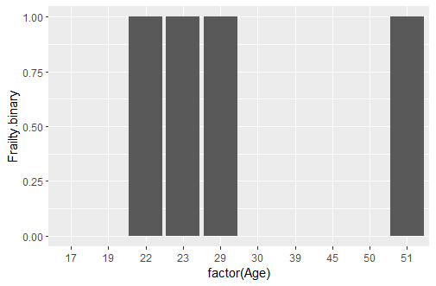

**ggplot(clean_yield_data, aes(x = BMI, y = Frailty.binary)) + geom_bar(stat = "identity")**

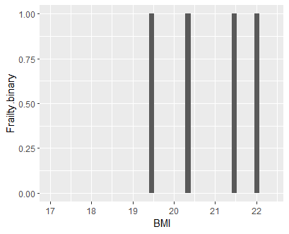

**pairs(~Age+`Grip Strength`,data = clean_yield_data, col = "darkred")**

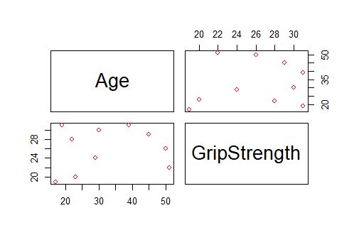

**pairs(~BMI+`Grip Strength`,data = clean_yield_data, col = "darkred")**

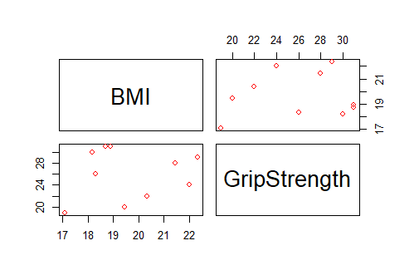

t_test_BMI_Frailty <- with(clean_yield_data, t.test(clean_yield_data$BMI ~ clean_yield_data$Frailty))

capture.output(t_test_BMI_Frailty, file = "Desktop/Spring'23/PDS/Assignment1/Question1_project/results/test_results_BMI_Frailty.txt")

t_test_Age_Frailty <- with(clean_yield_data, t.test(clean_yield_data$Age ~ clean_yield_data$Frailty))

capture.output(t_test_Age_Frailty, file = "Desktop/Spring'23/PDS/Assignment1/Question1_project/results/test_results_Age_Frailty.txt")

t_test_GripStrength_Age <- with(clean_yield_data, t.test(clean_yield_data$`Grip Strength`, clean_yield_data$Age))

capture.output(t_test_GripStrength_Age, file = "Desktop/Spring'23/PDS/Assignment1/Question1_project/results/test_results_GripStrength_Age.txt")

t_test_BMI_Age <- with(clean_yield_data, t.test(clean_yield_data$BMI, clean_yield_data$Age))

capture.output(t_test_BMI_Age, file = "Desktop/Spring'23/PDS/Assignment1/Question1_project/results/test_results_BMI_Age.txt")

